**CURSORIUM RENTALIS**

**A WEBSITE TO RENT A BIKE**

**A PROJECT REPORT**

*Submitted by*

**Piyush Sankhala 205119065**

*In partial fulfillment in the award of degree of*

**MASTER OF COMPUTER APPLICATIONS**



**NATIONAL INSTITUTE OF TECHNOLOGY**

**TIRUCHIRAPPALLI**

**JULY 2020**

**COMPUTER APPLICATIONS**

**BONAFIDE CERTIFICATE**

Certified that this project report CURSORIUM RENTALIS is the bonafide work of Piyush Sankhala who carried out the project under my supervision. This is to further certify to the best of my knowledge, that this project has not been carried out earlier in this institute and the university.

Signature

Dr.U. Vignesh Sir

*Certified that the above project has been duly carried out as per the norms of the college and statutes of the university.*

Signature

(Dr. ALPHONSE P J A)

HEAD OF THE DEPARTMENT

**ACKNOWLEDGEMENT**

I wish to express my profound and sincere gratitude to Dr.U.Vignesh who guided me into the intricacies of this project Cursorium Rentalis-Online Bike rental system.

.

I am highly grateful to our team who evinced keen interest and invaluable

support in the progress and successful completion of my project work.

I am indebted to our team for their constant encouragement, co-operation and

help, Words of gratitude are not enough to describe the accommodation and

fortitude which they have shown throughout my endeavor.

**TABLE OF CONTENTS**

Chapter Title Page no.

1. INTRODUCTION 5.

2. METHODOLOGY 8

3. ER-DIAGRAM 10

4. SYSTEM REQUIREMENT 11

5. FLOW CHART 12

6 CODE AND OUTPUT 15

7. FUTURE SCOPE 17

8. REFERENCE 18

Chapter 1

INTRODUCTION

A bike rental business rents out bicycles for short periods of time, usually for a few hours. Most rentals are provided by bike shops as a sideline to their main businesses of sales and service, but some shops specialize in rentals.

Bicycle rental shops primarily serve people who do not have access to a vehicle, typically travelers and particularly tourists. Specialized bicycle rental shops therefore typically operate at beaches, parks, or other locations that tourists frequent. In this case, the fees are set to encourage renting the bikes for a few hours at a time, rarely more than a day.

While renting a bike or scooter by the traditional way we have to go to the place manually and then book the vehicle for rent. This consumes a lot of time and there might as well be a possibility that the vehicle that we want might not be available and then going all the way to the shop would be just a waste of time and energy.

So, to overcome this problem, we have come up with the idea of online bike rental system. Using this system, we can book a bike or scooter for rent from our respective places and also, we can check for the availability of the required vehicle. This would save our time and energy.

Chapter 2

METHODOLOGY

This chapter describes the different fact-finding techniques that were used for achieving the

goals and objectives of the project such as Population of the study, Data Collection and

Analysis, system analysis, system design and implementation, Testing and validation

2.1 Data Collection and Analysis

This research was carried out using both qualitative and quantitative method since the

researcher was interested to obtain a well detailed data/information on the study. It provided

the researcher with firsthand information about the study since it shows how things begun.

The researcher used the following Data collection techniques: interviews, Observations.

2.2 Interviews

The researcher used interview technique while collecting data. This involved an interviewer

and a respondent. This technique helped the researcher to obtain accurate information since

there was direct interaction with the respondent and he/she was provided with relevant

information.

The collected data was inspected, transformed, and modeled with the goal of highlighting

useful information, suggesting conclusions, and supporting decision in making the system

requirements specification document that was used as an input in designing the system.

2.3 Observations

Observation as a method of data collection was used. In this aspect, the researcher used an

unstructured observation in order to identify physical social problem of bike rental such

as wastage of time, about data safety.

After gathering all the requirements from the stakeholders using all the above data

collection techniques, the gathered requirements were analyzed and validated to review

stakeholders’ information which was not always 100% accurate.

2.4System analysis

In Analysis the current system was studied in detail, its loopholes identified and different data

was collected in order to come up with a system that covers these loopholes.

Here, data collection techniques such as Interviews and Observations were used. Data

collection techniques looked at analysis and comparison of other working systems and

critique of the current method by reviewing the possible requirements.

2.5System design and Implementation

2.5.1 System design

In the design phase the informational, functional, and network requirements identified

during the initiation and planning phases will be converted into unified design

specifications that will be used to script programs during the implementation phase.

The design tools to be used were entity relationship diagram (was used in describing

the relationships between entities), flow charts (was used to show the flow of events

and how the processes are executed) and the following tools will be used: SQL to

design the database, HTML to make the interface, authenticate user and make a

connection to database. CSS to describe the presentation of a document and Bootstrap

to add forms, buttons, navigation and other interface components to the web pages.

2.5.2 Data Storage

We used php scripting language and SQL. It is simple, lightweight and makes it extremely easy for developers to create a local web server for testing and deployment purposes. It is used to manage record tables in the SQL which contain the database.

2.5.3 Interface and Authenticate user

The technology which was used to design Graphical User Interface is the HTML

which is on client-side programming to help the operation to be performed on client’s

machine; Bootstrap is used to add forms, buttons, navigation and interface

components to the web pages. CSS was also used as style sheet language for

describing the presentation of a document written in a markup language.

In the system Bootstrap is used which is a free and open source web application

framework. It is a set of components that helps us to develop websites faster and easier.

2.6System Testing and Validation

Researchers have carried out unit testing and also have carried out integration testing and full

end to end system testing to ensure that few or no bugs found a place in the deployed

application.

Unit testing: This was done at the module level where basic components of the

software was tested to verify its functionality.

Integration testing: This was used to test the combined modules as a group to identify

defects in the interfaces between integrated components.

System testing: The complete integrated system was tested to verify whether all

components work efficiently and effectively as a whole.

Chapter 3

ER-DIAGRAM

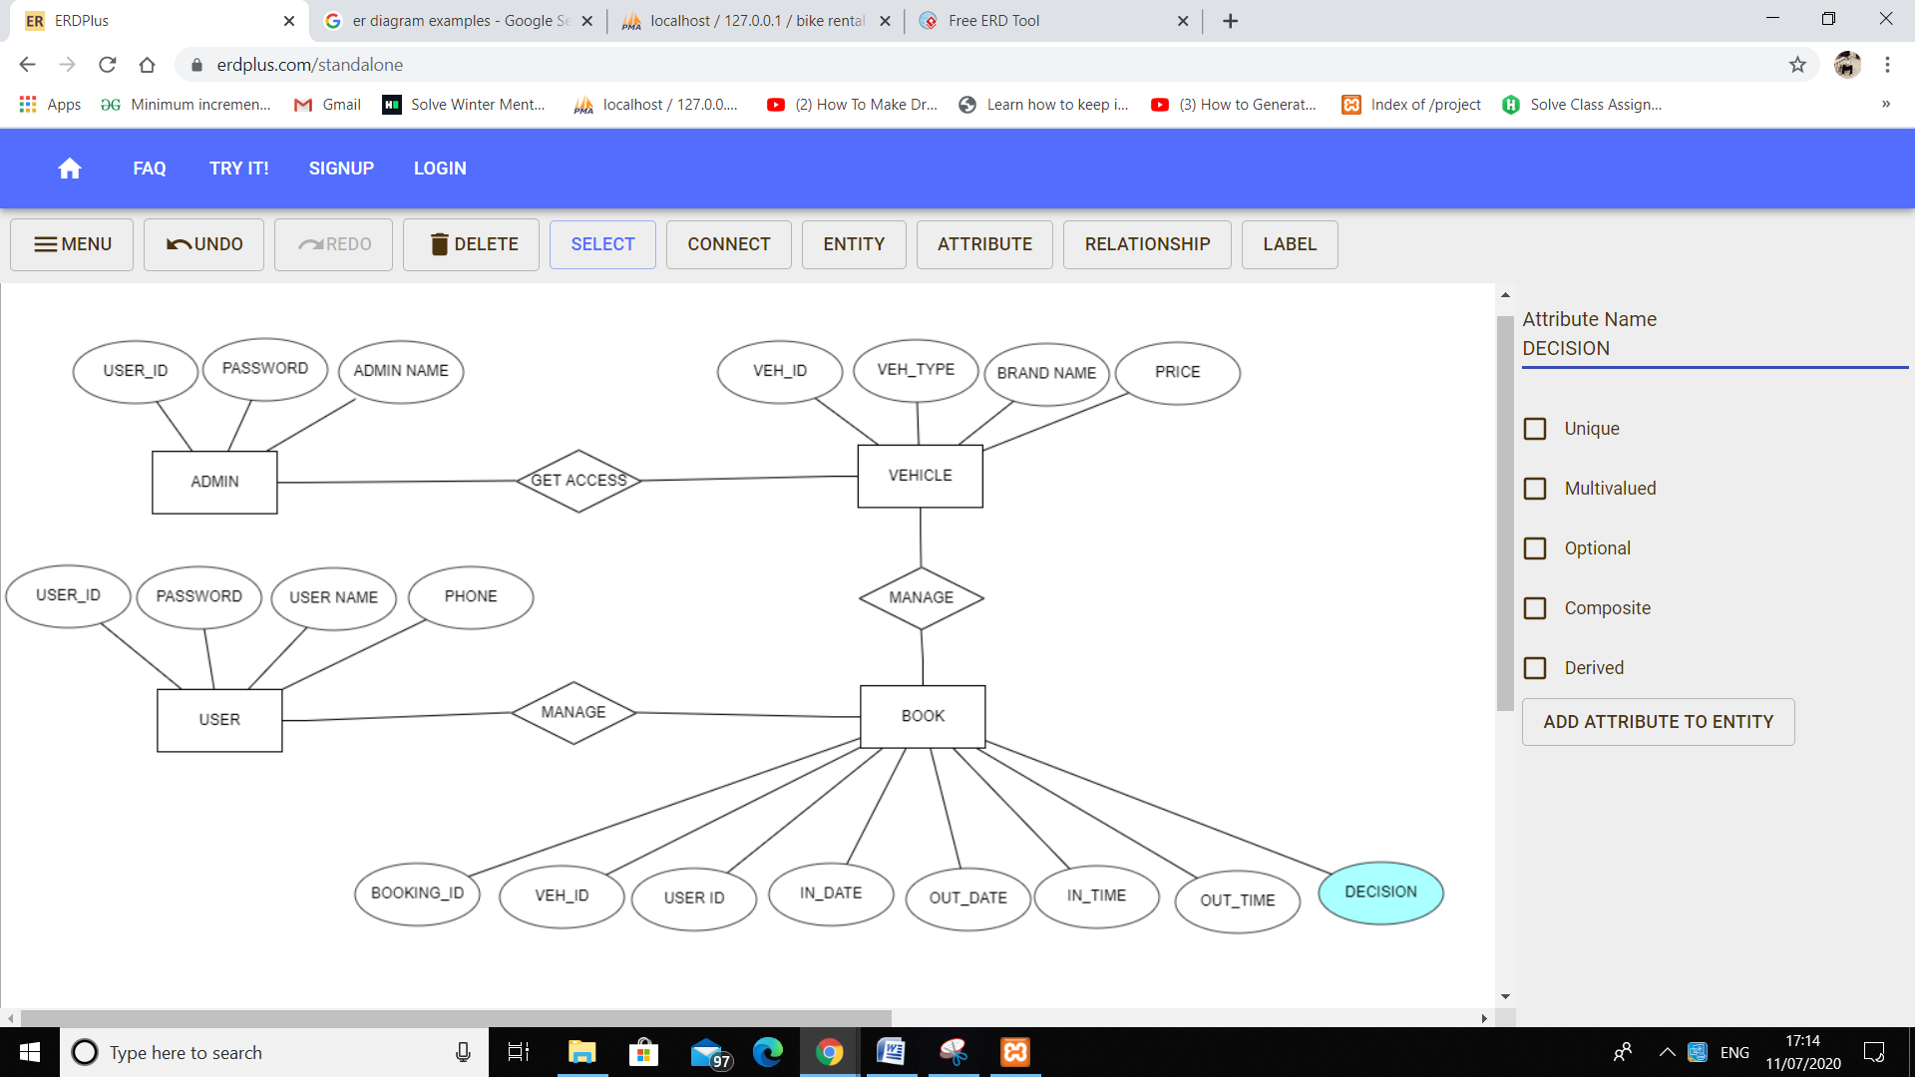

Chapter 4

SYSTEM REQUIREMENTS

For the application to run on computer, the device is expected to meet the following system

Requirements:

Minimum Hardware Requirements

1. Processor speed - 1.6GHZ
2. Memory of user PC - 512MB RAM
3. Disk Space of user PC - 5GB
4. Memory of server Pc - 8GB
5. Bandwidth (network connection) -15Mbps
6. Disk space of server - 200GB
7. Web Browser with working internet connection - Best works in Chrome, Firefox latest versions

A fast processor is required because there is need to handle large amounts of data queries. 8

GB memory is required on the server for faster performance because it runs many processes

simultaneously, while the memory in the computer should be relatively fast so as to run the

processes required. 200 GB storage capacity in the server hard disk is necessary for storage

of huge amounts of data while the disk space in a user computer should be modest enough.

Good network connection is vital because the application is majorly internet based and there

is need for faster communication and retrieval of information.

Minimum Software Requirements

1. Operating System for PC Windows 7, 8.1,10, linux, Mac
2. Database Management System SQL
3. Browser Opera, Chrome, IE, Mozilla Firefox

It shows the software requirements for the web application that define the prerequisites

needed for the optimal functioning of the web application. Each of the following operating

system can handle the application, windows 7, windows 8, windows 8.1, Linux, those

operating systems were chosen because they are affordable and readily available. SQLite3

was used in the development of the databases and is relatively cheap, easy to use and

scalable. Browsers: any browser including opera, Google chrome, Microsoft Internet explorer

and Mozilla Firefox.

Chapter 5

Flowchart of admin panel

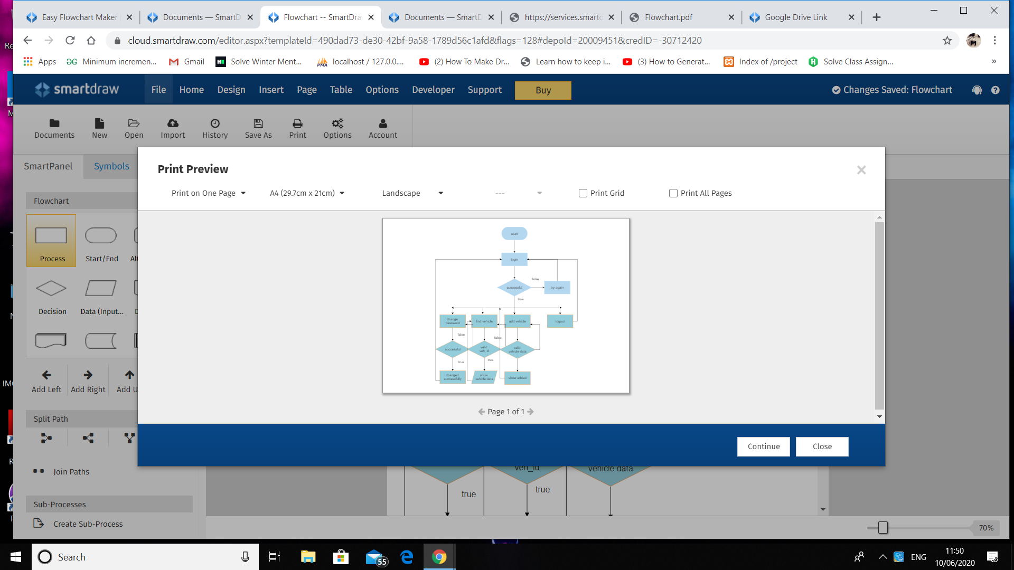

Fowchart of user panel

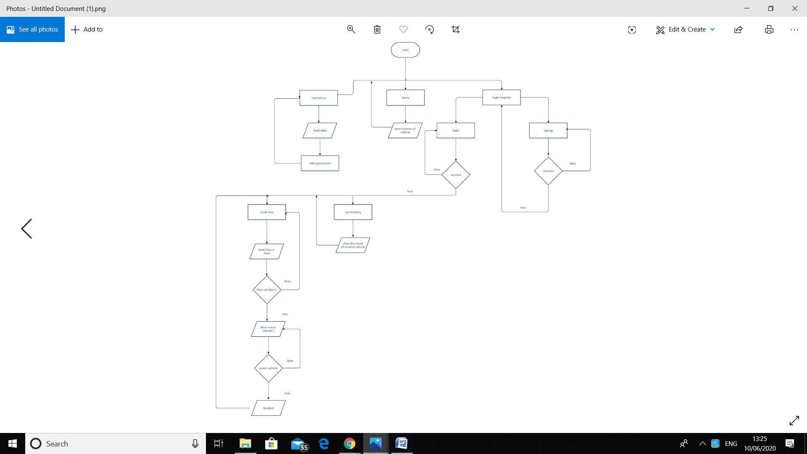

Chapter 6

Admin panel code

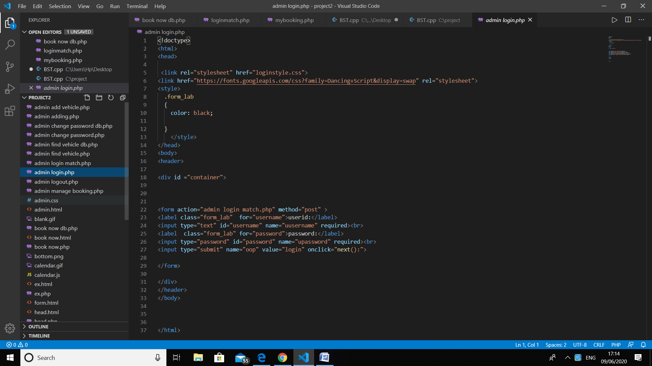

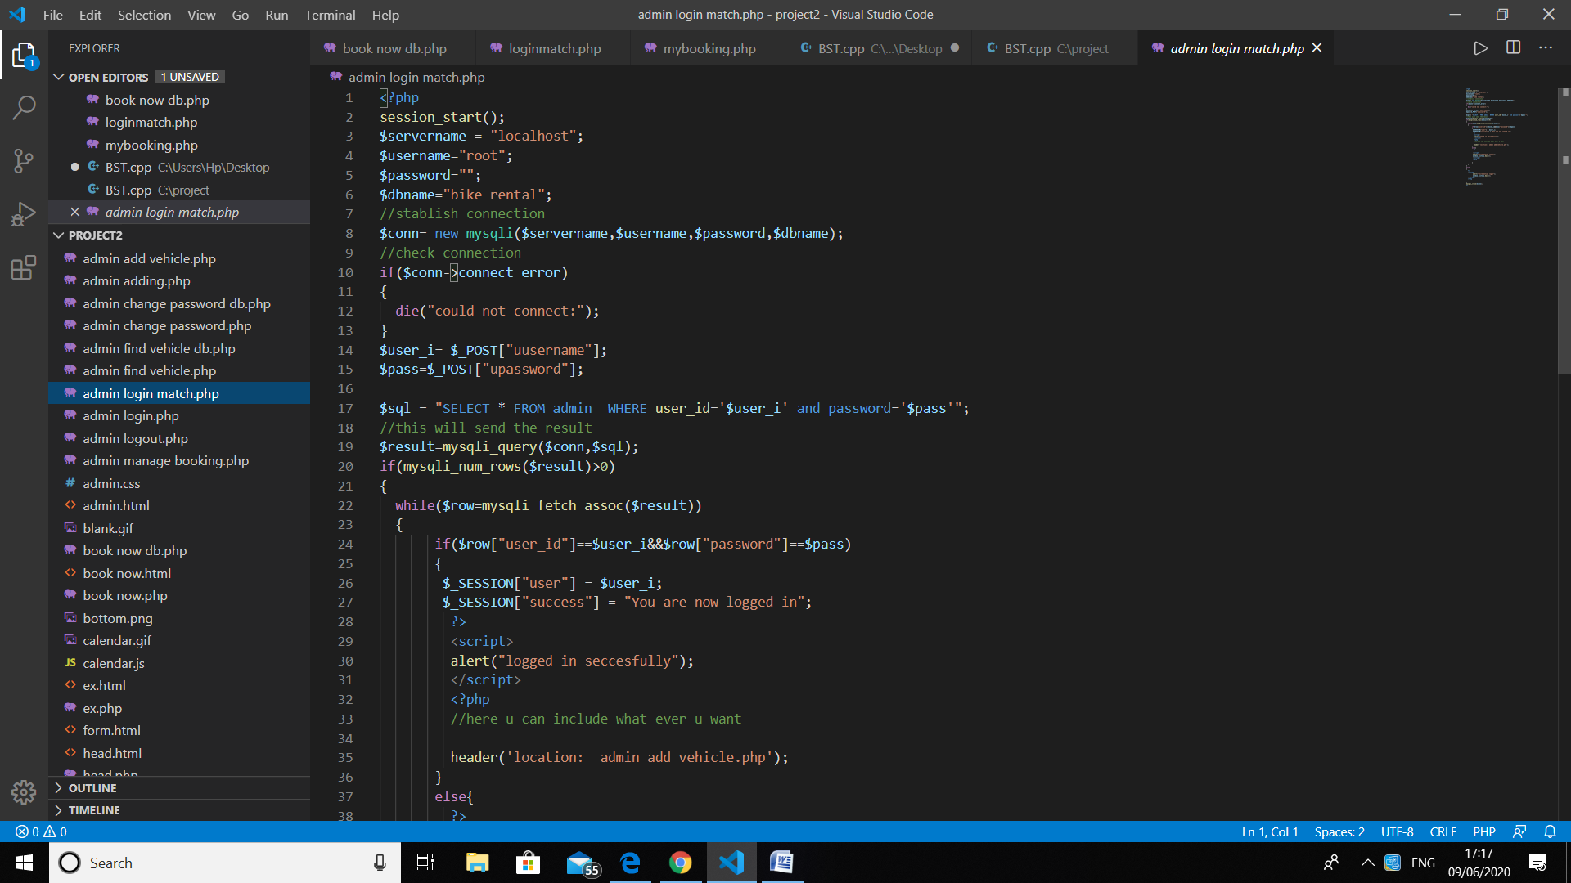

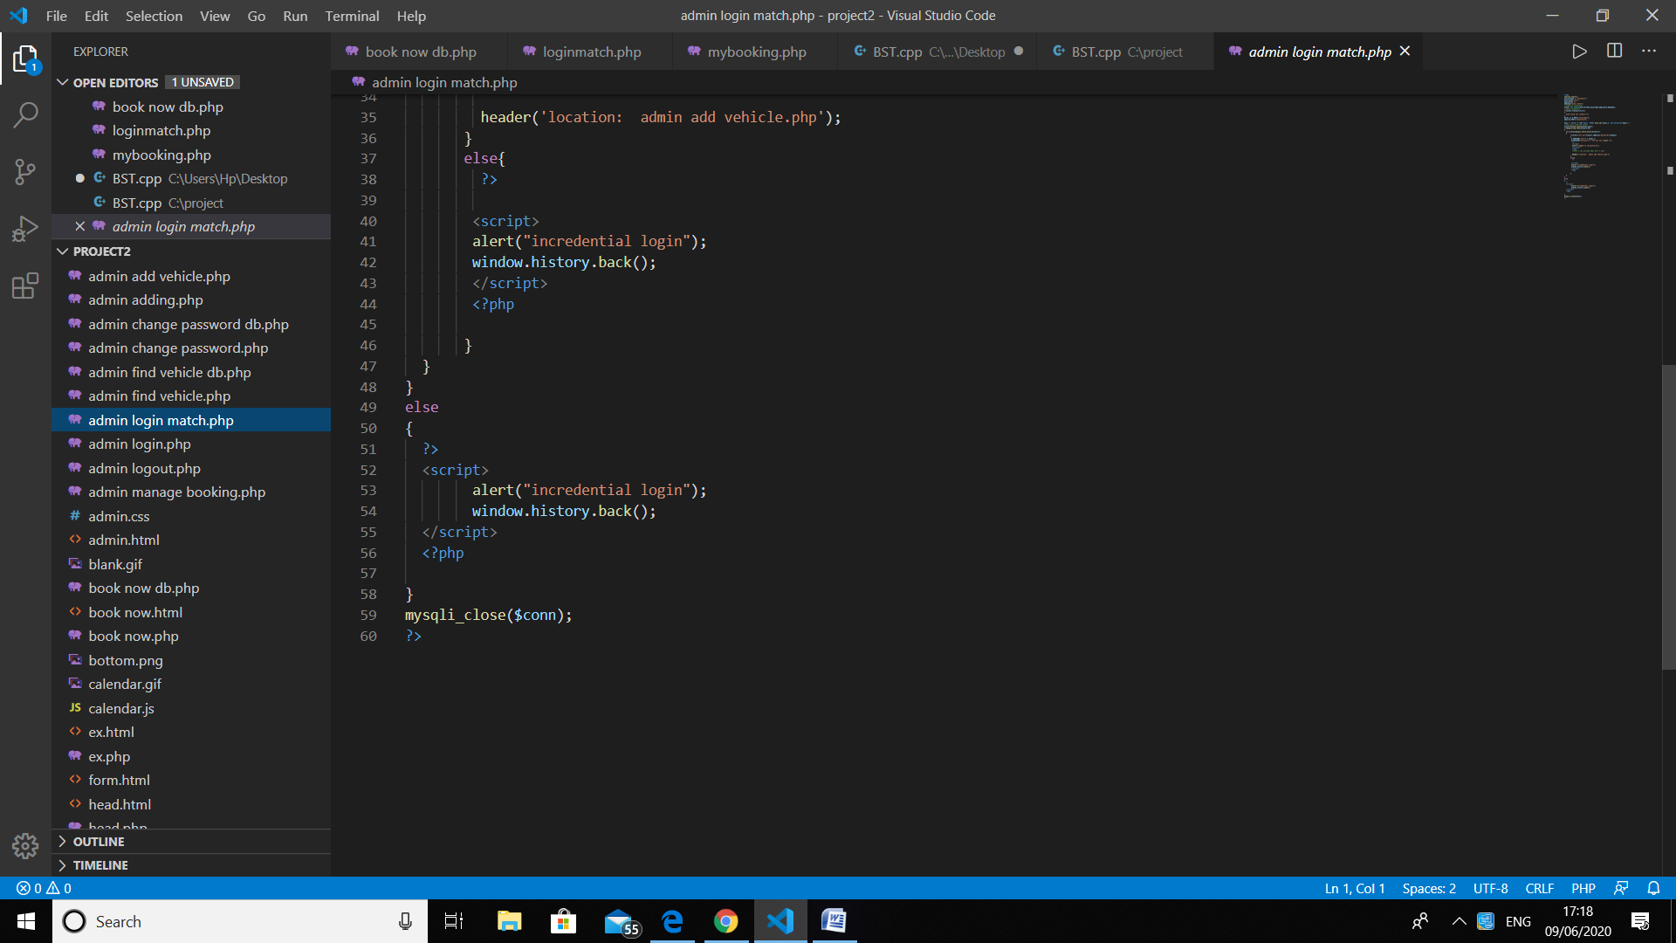

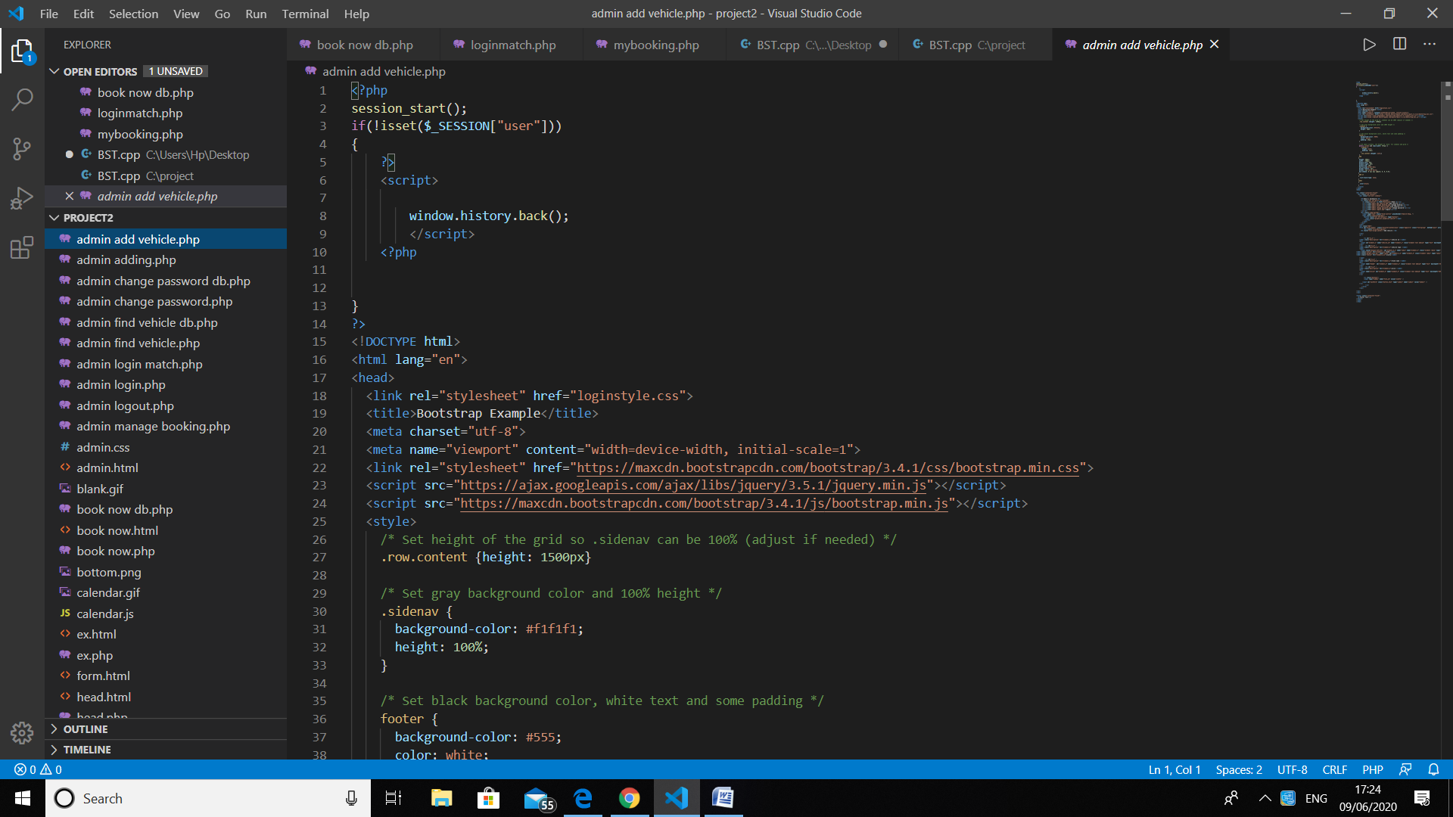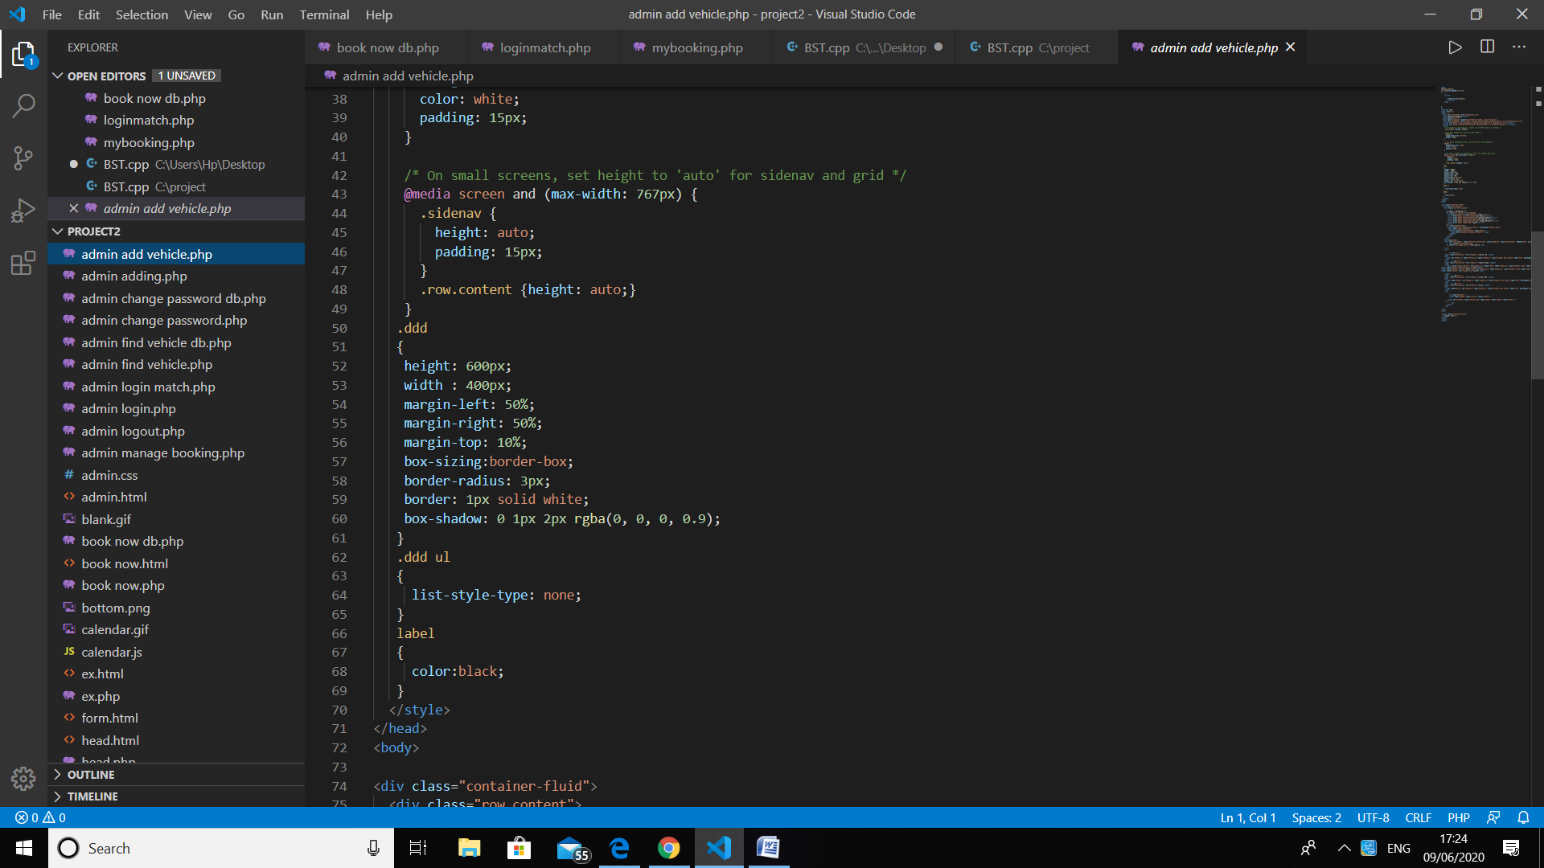

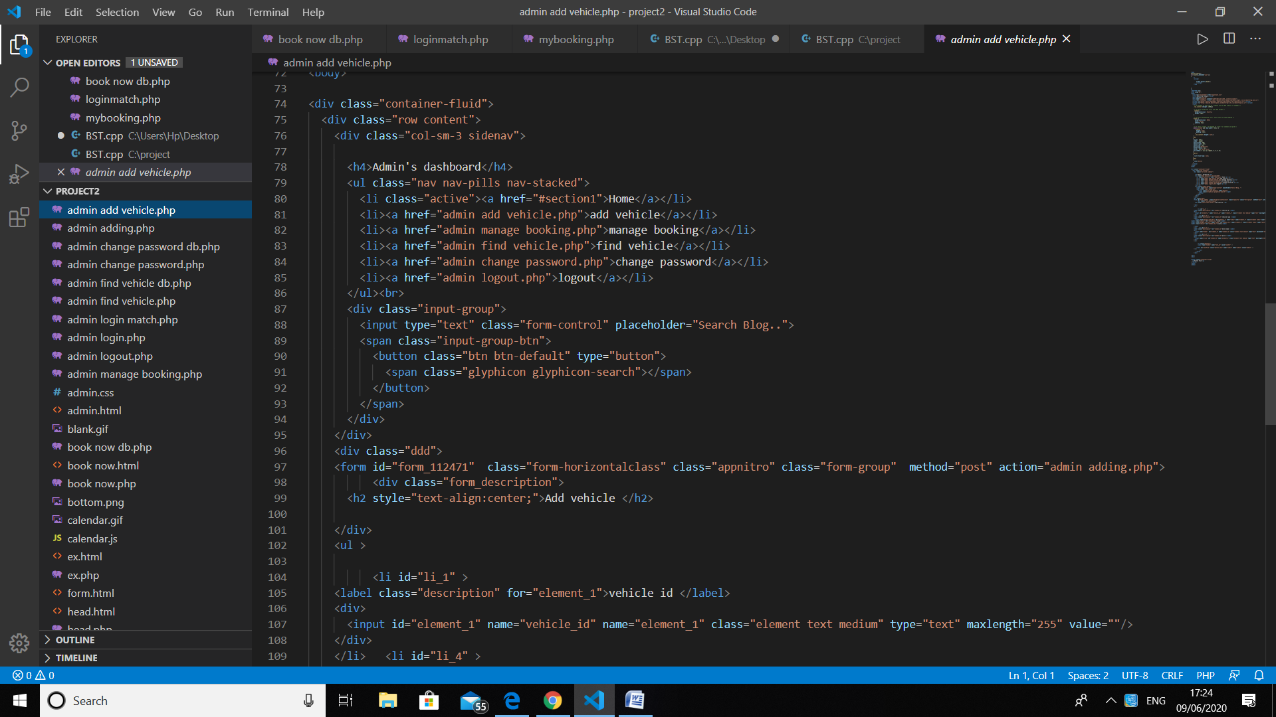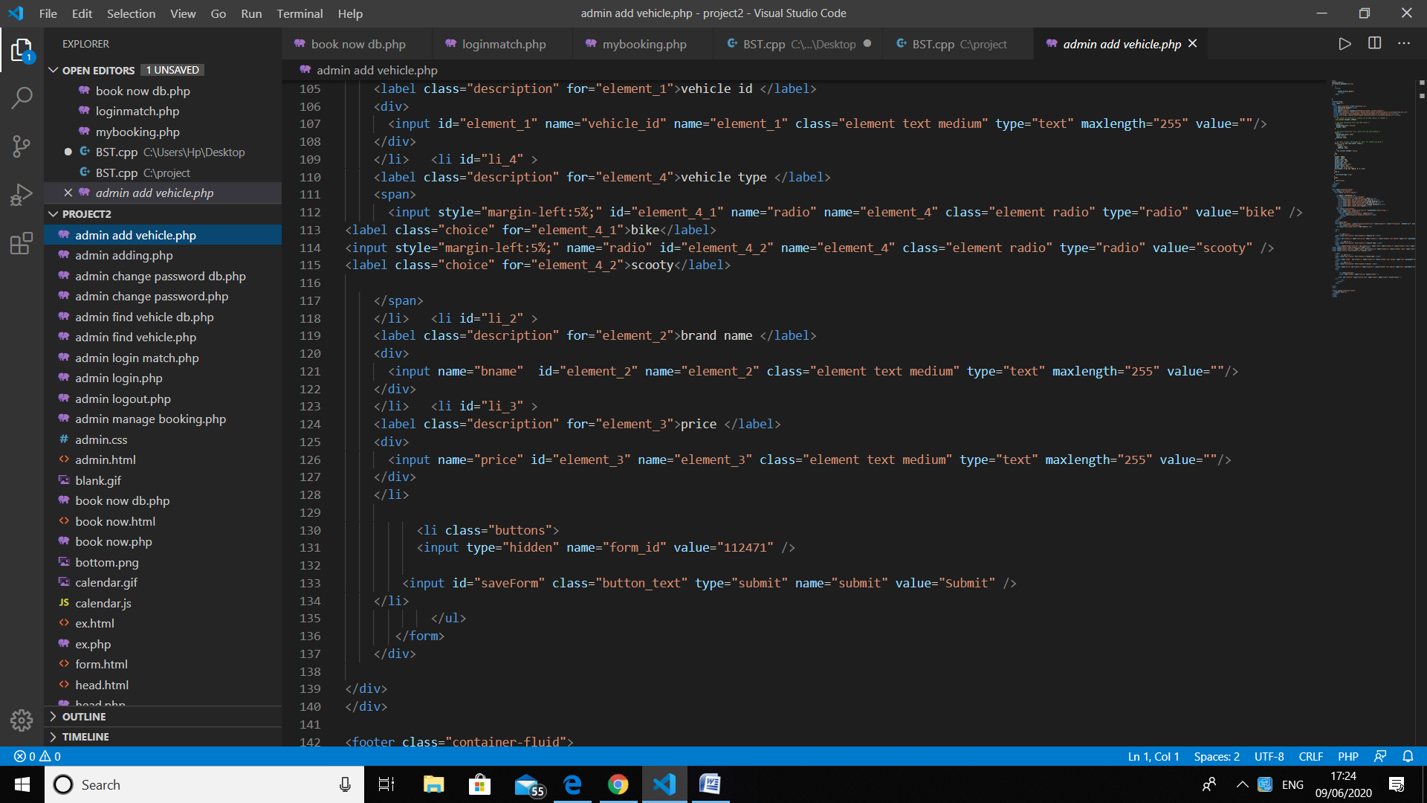

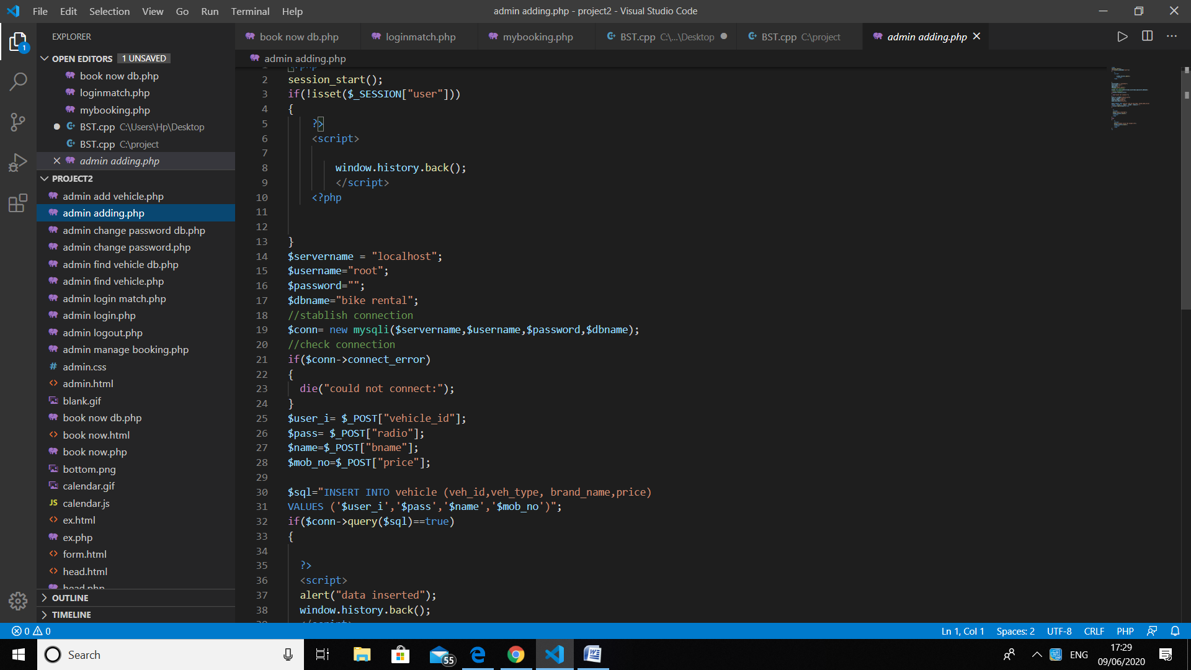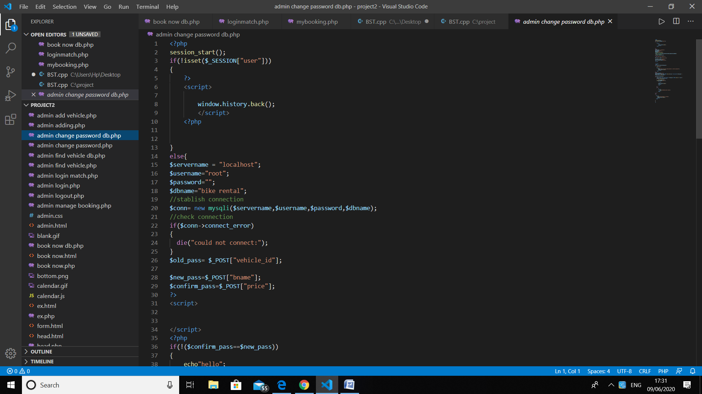

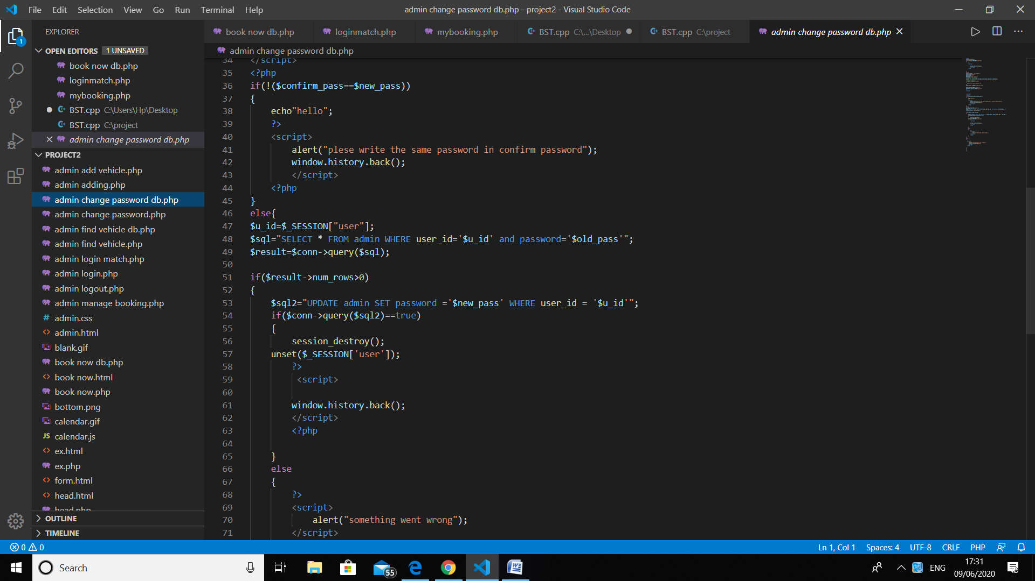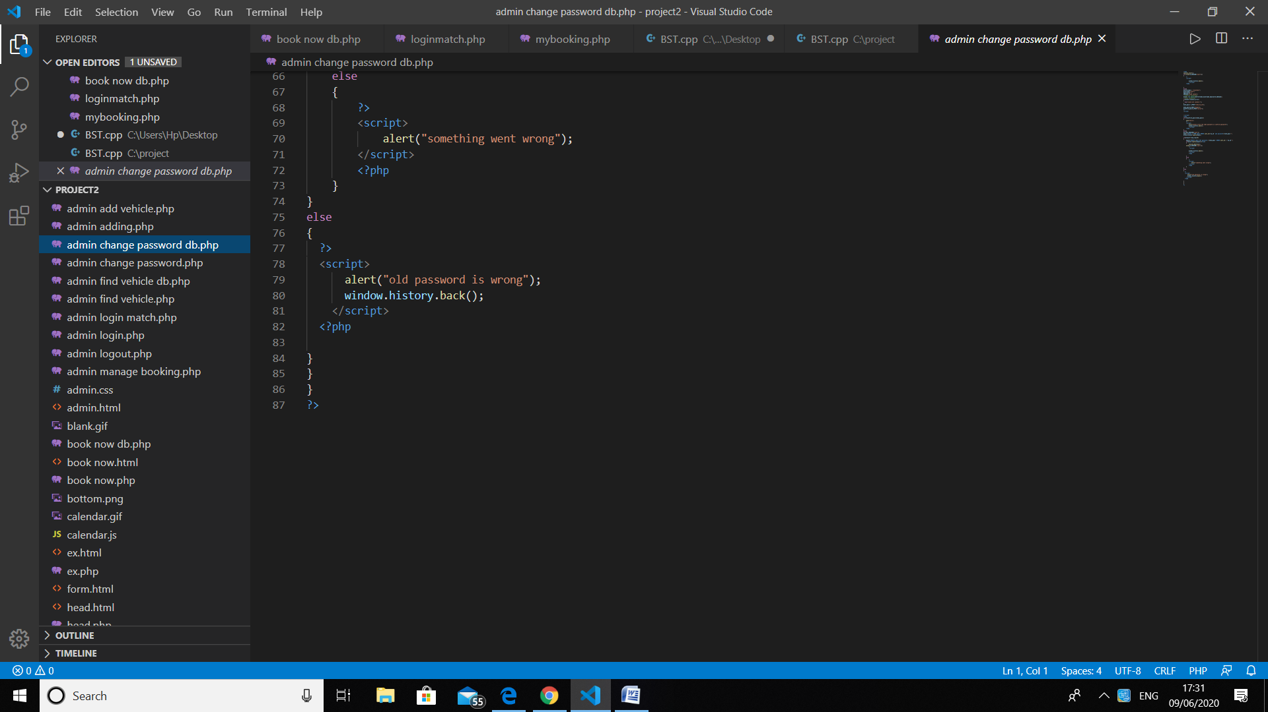

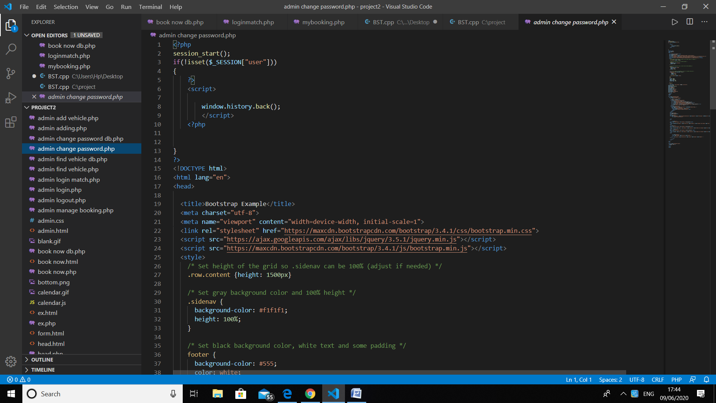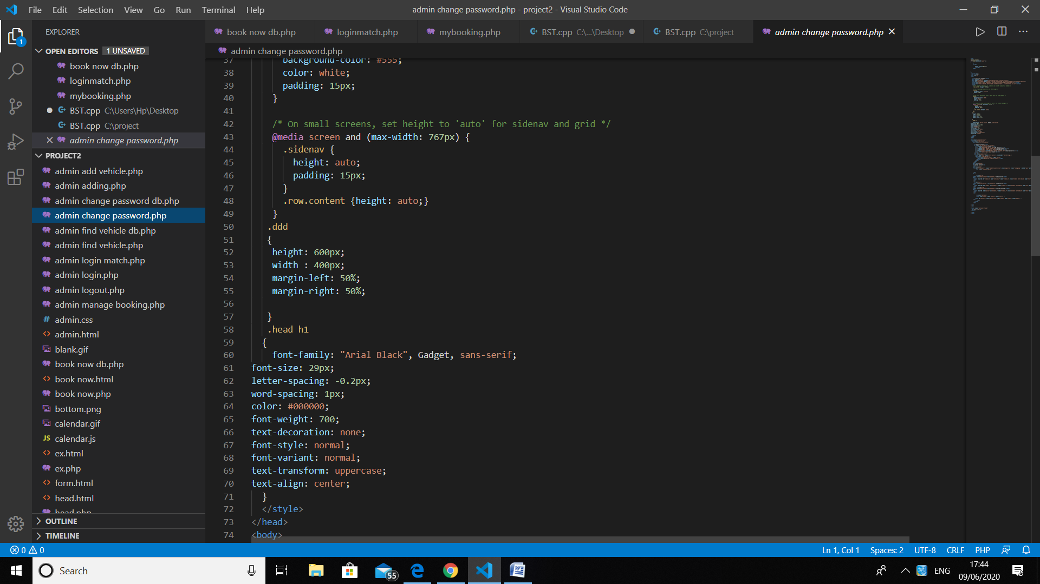

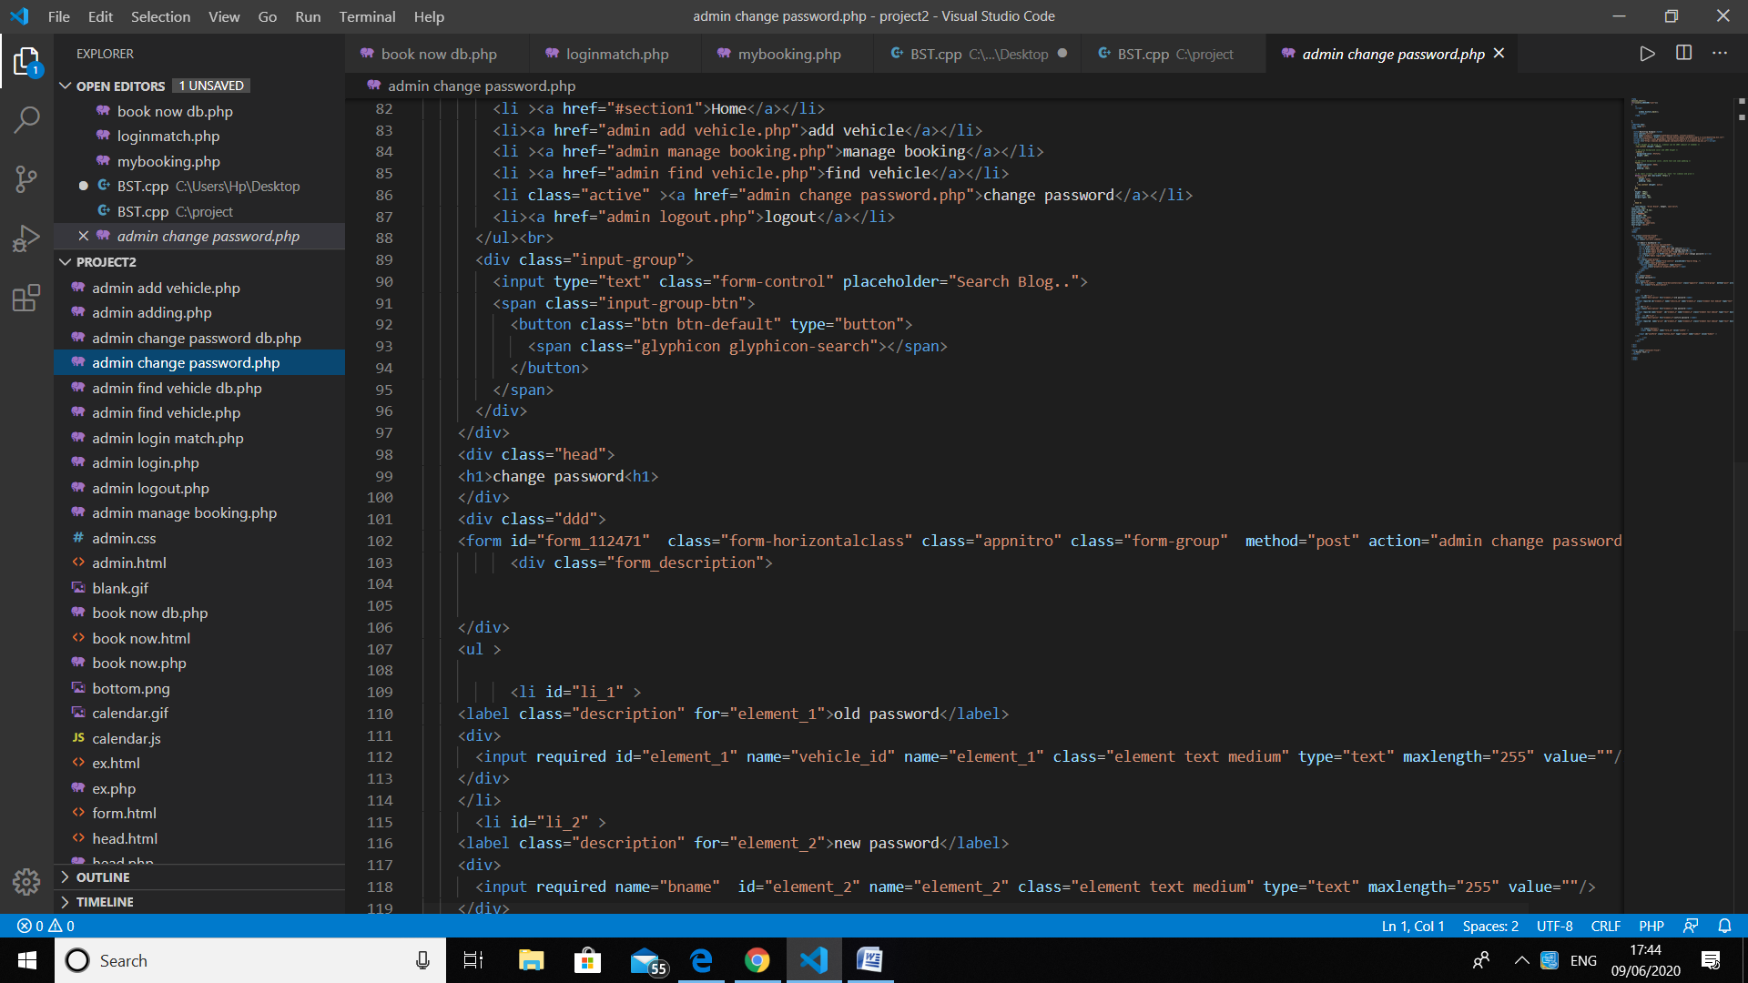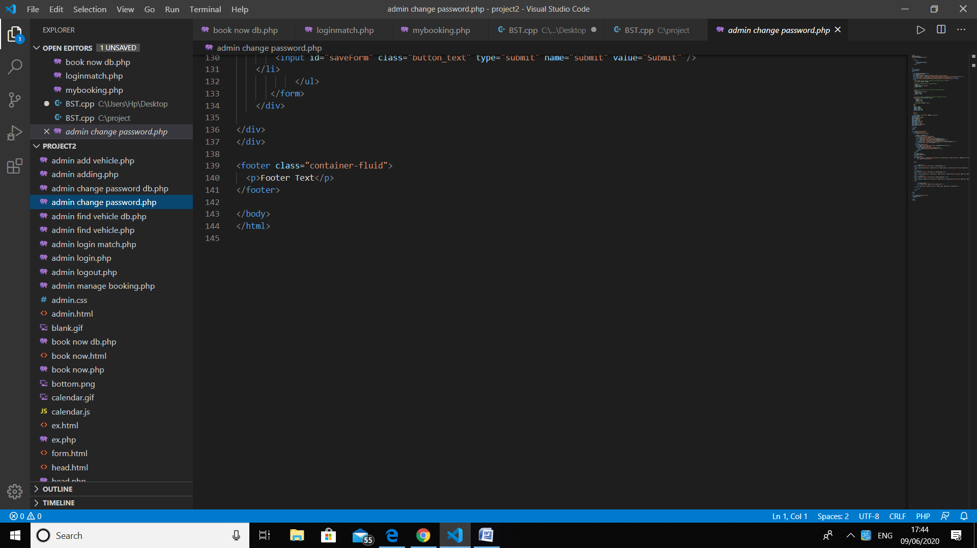

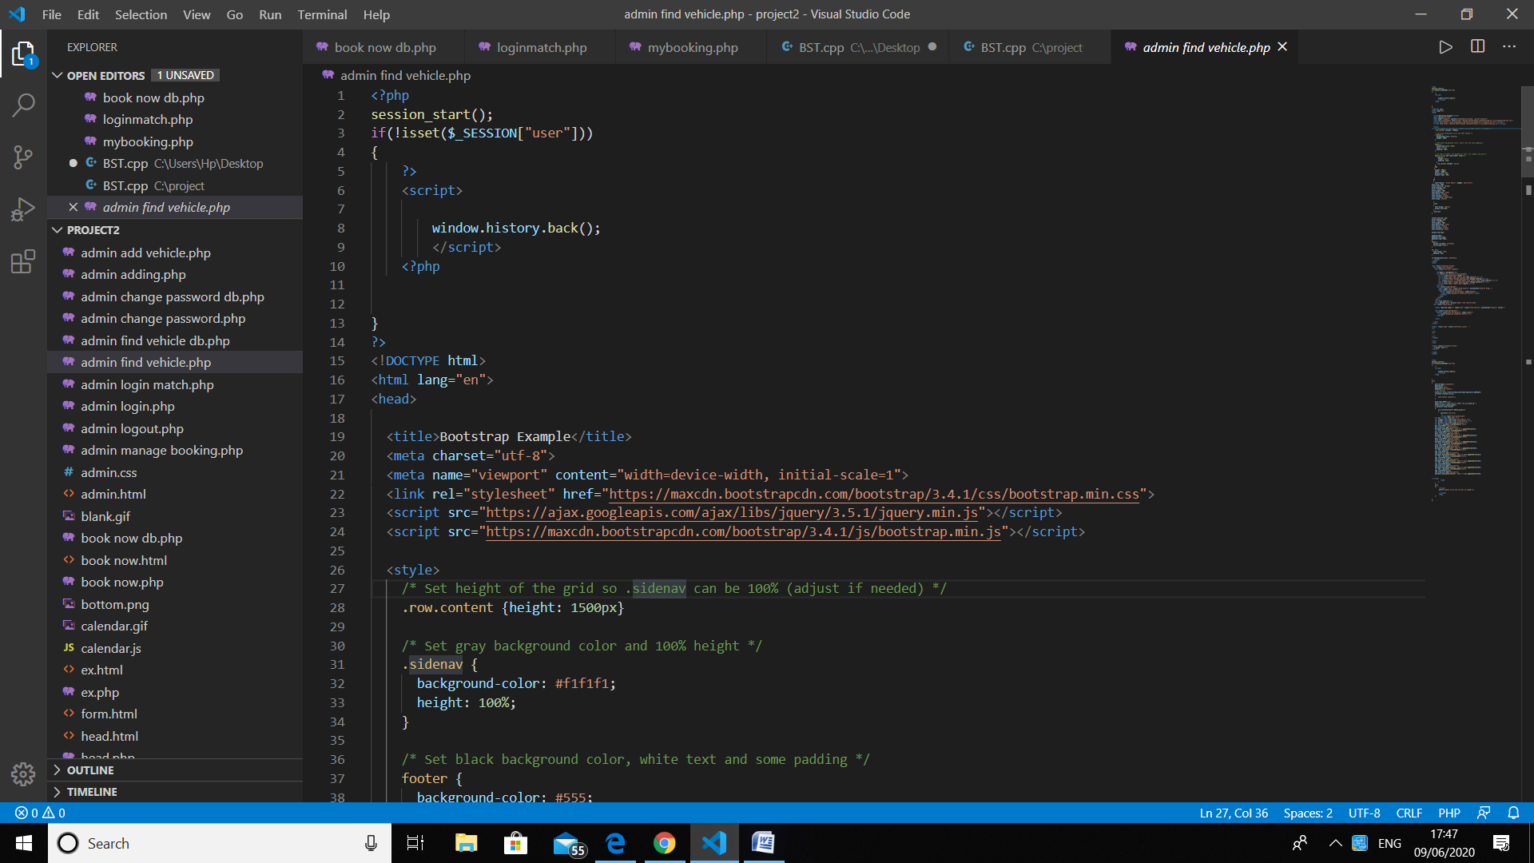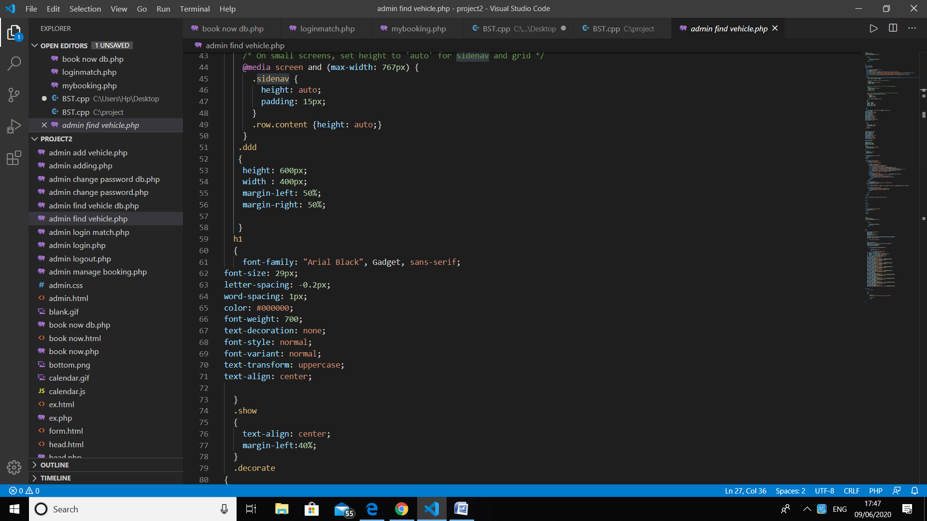

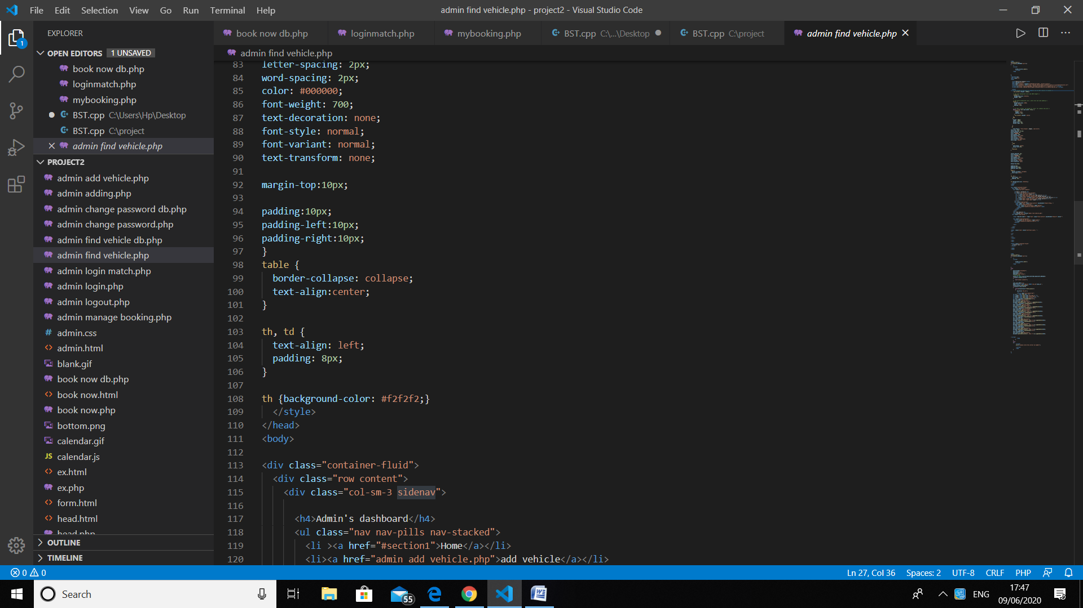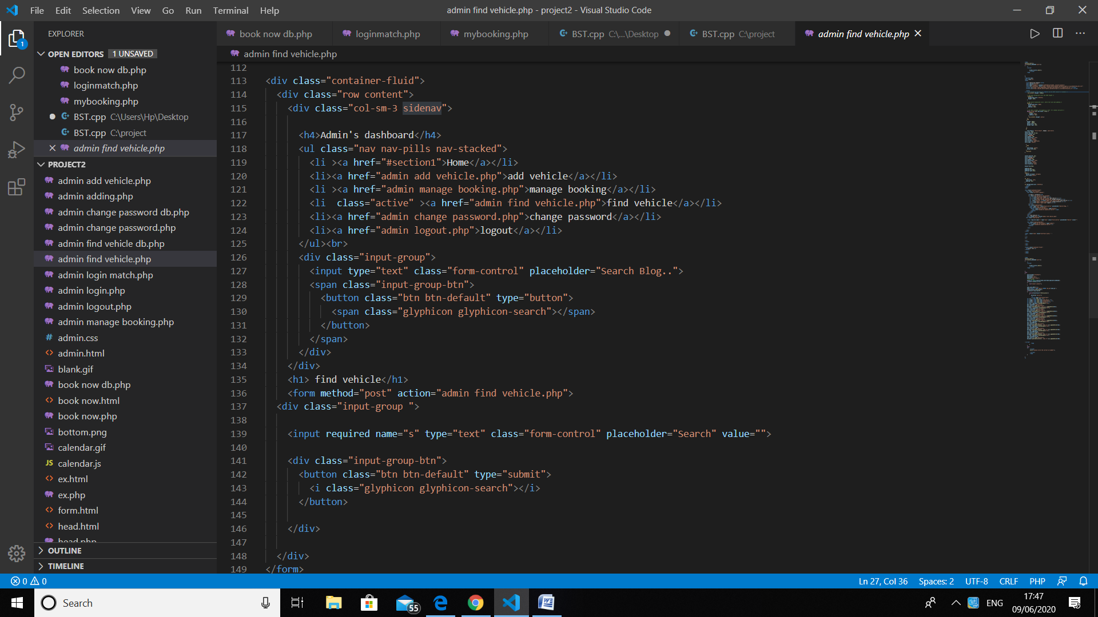

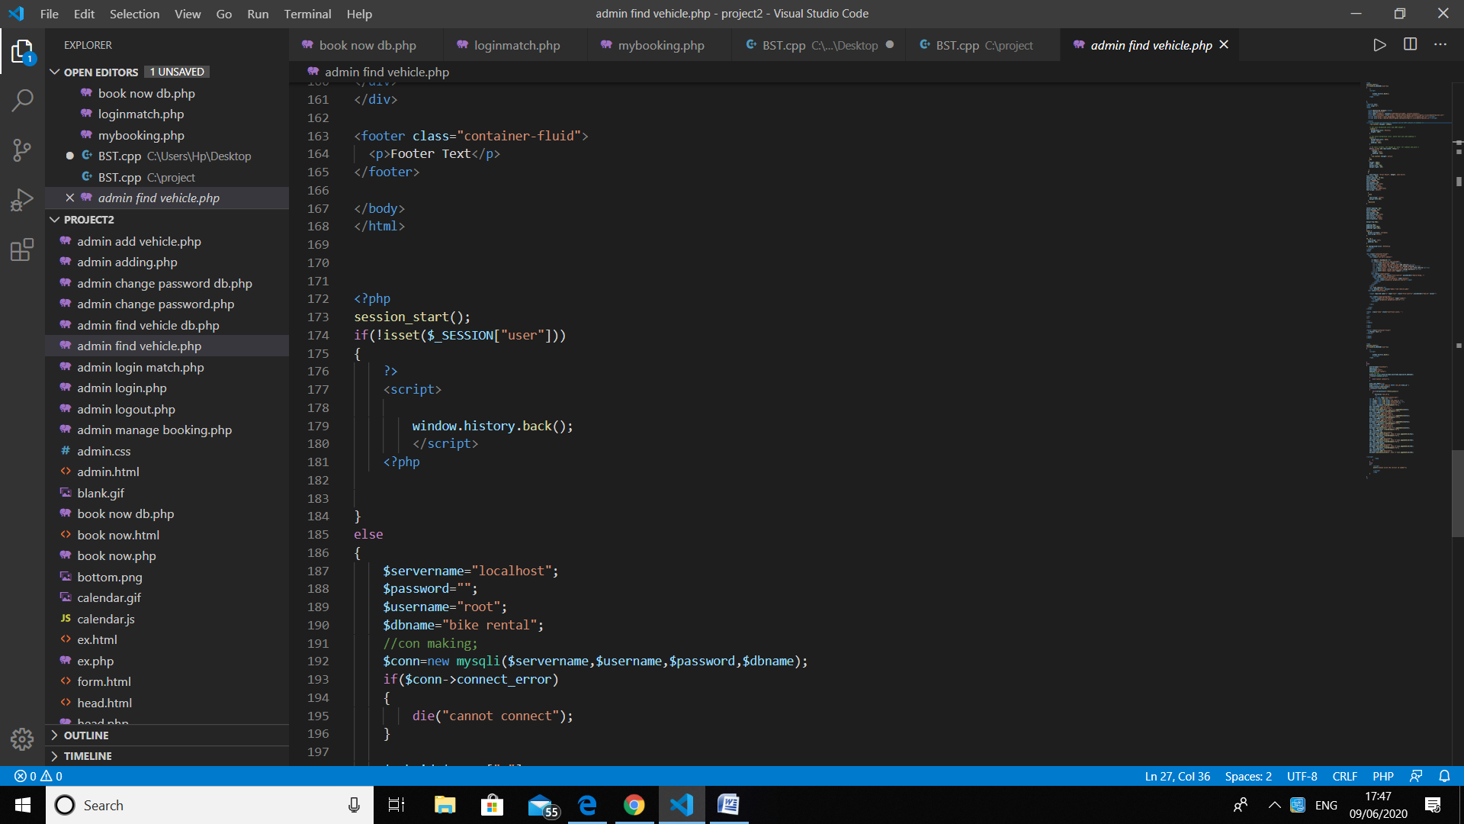

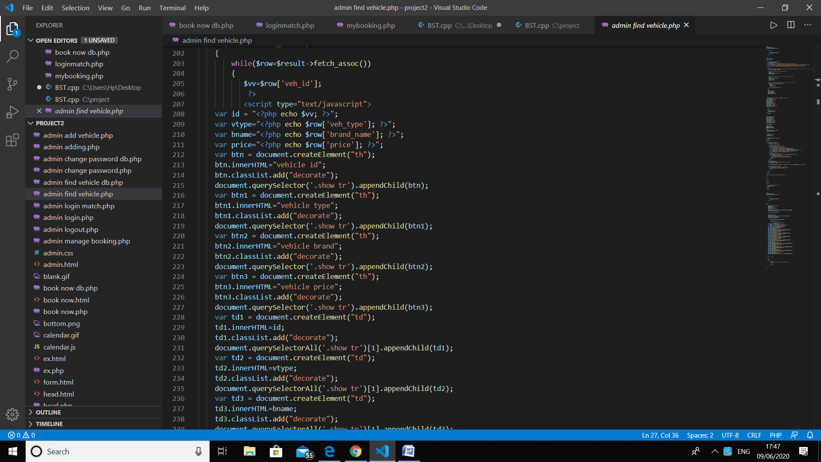

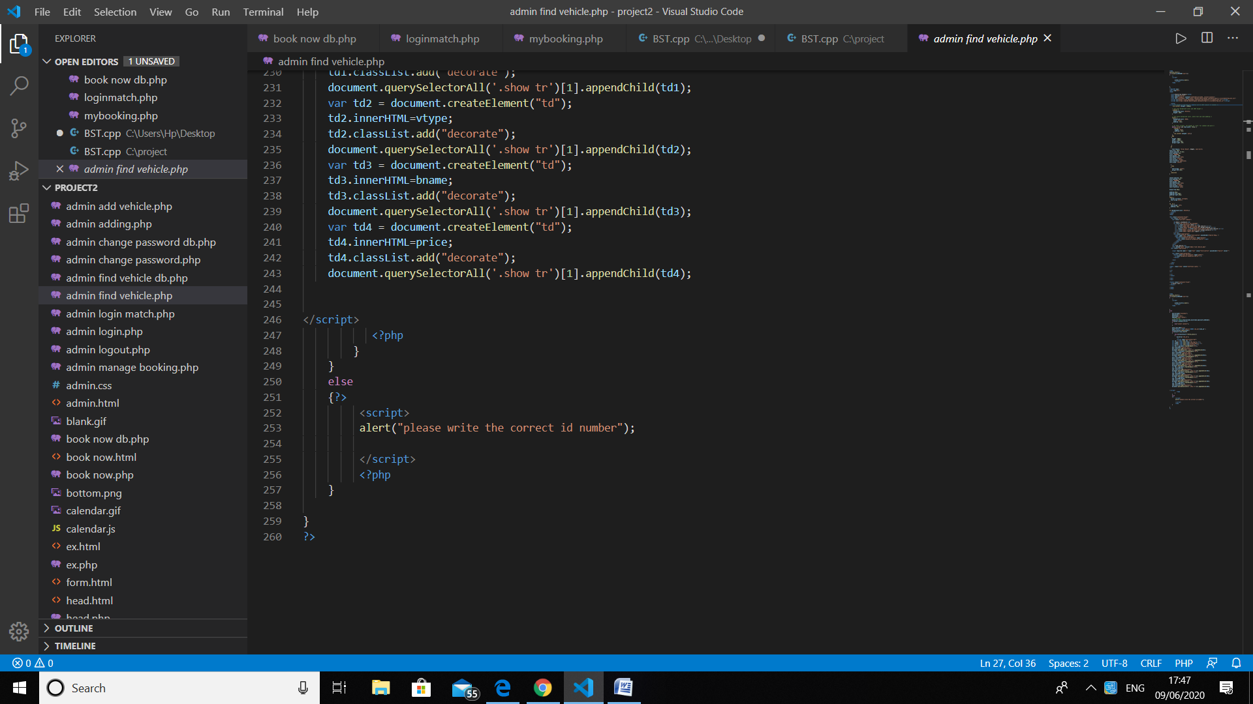

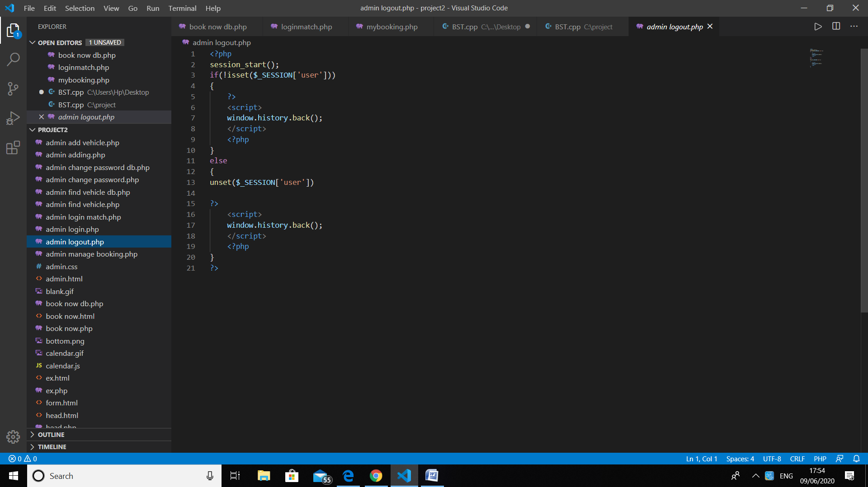

Admin panel output

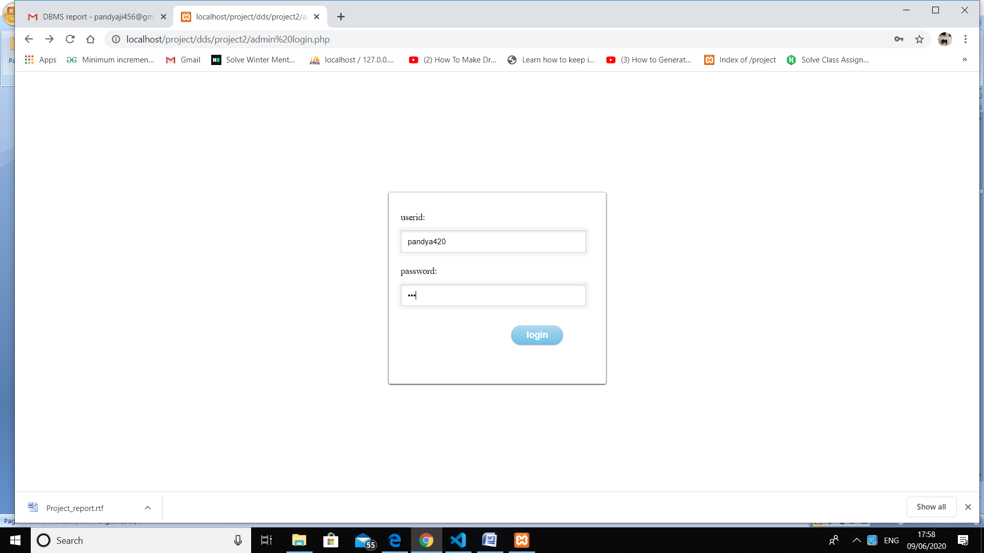

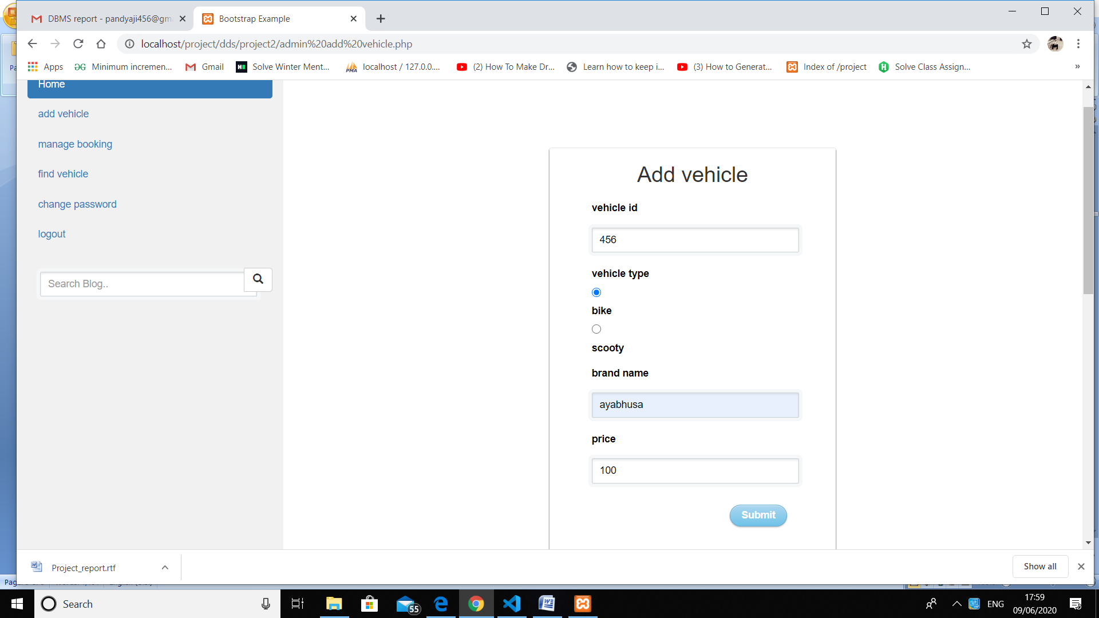

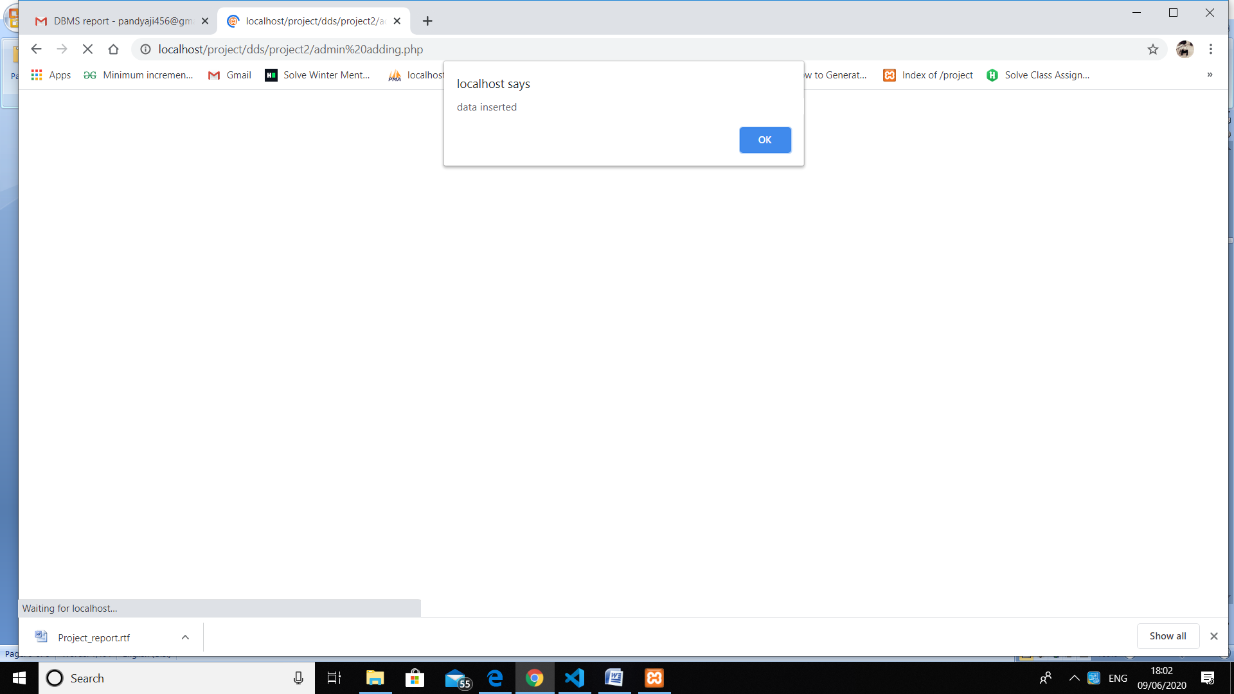

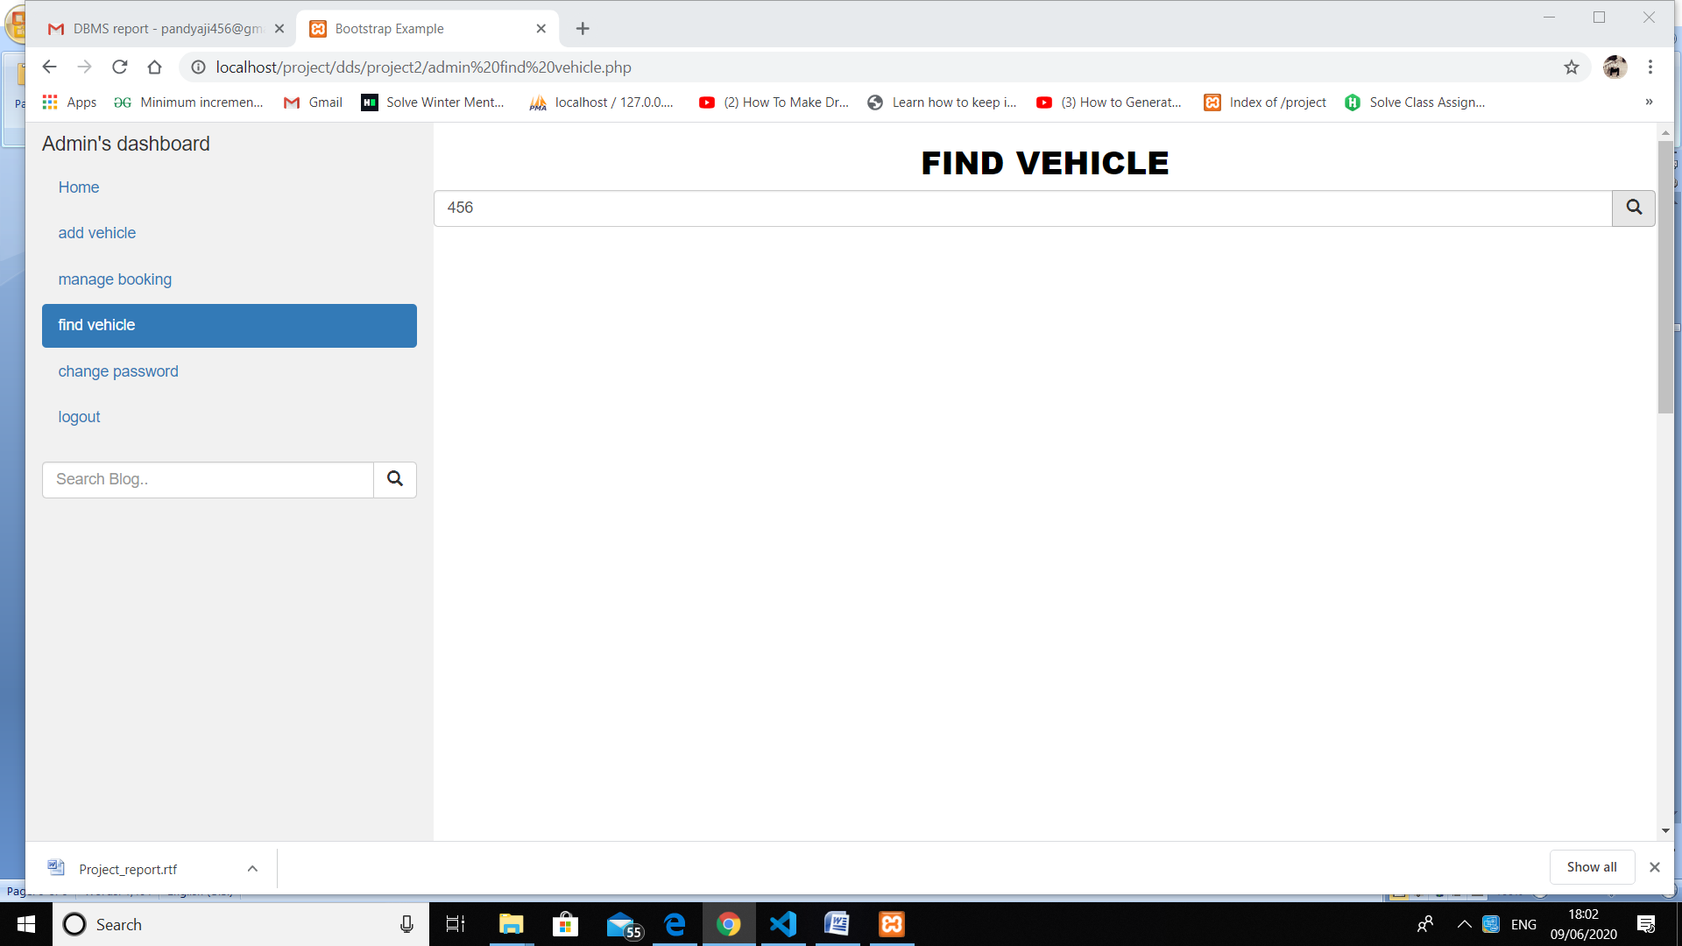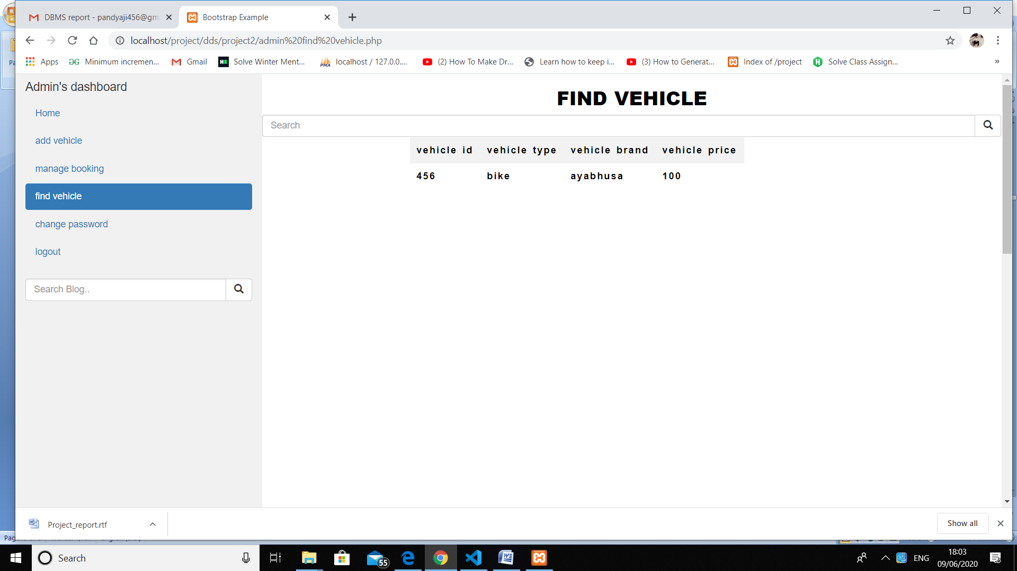

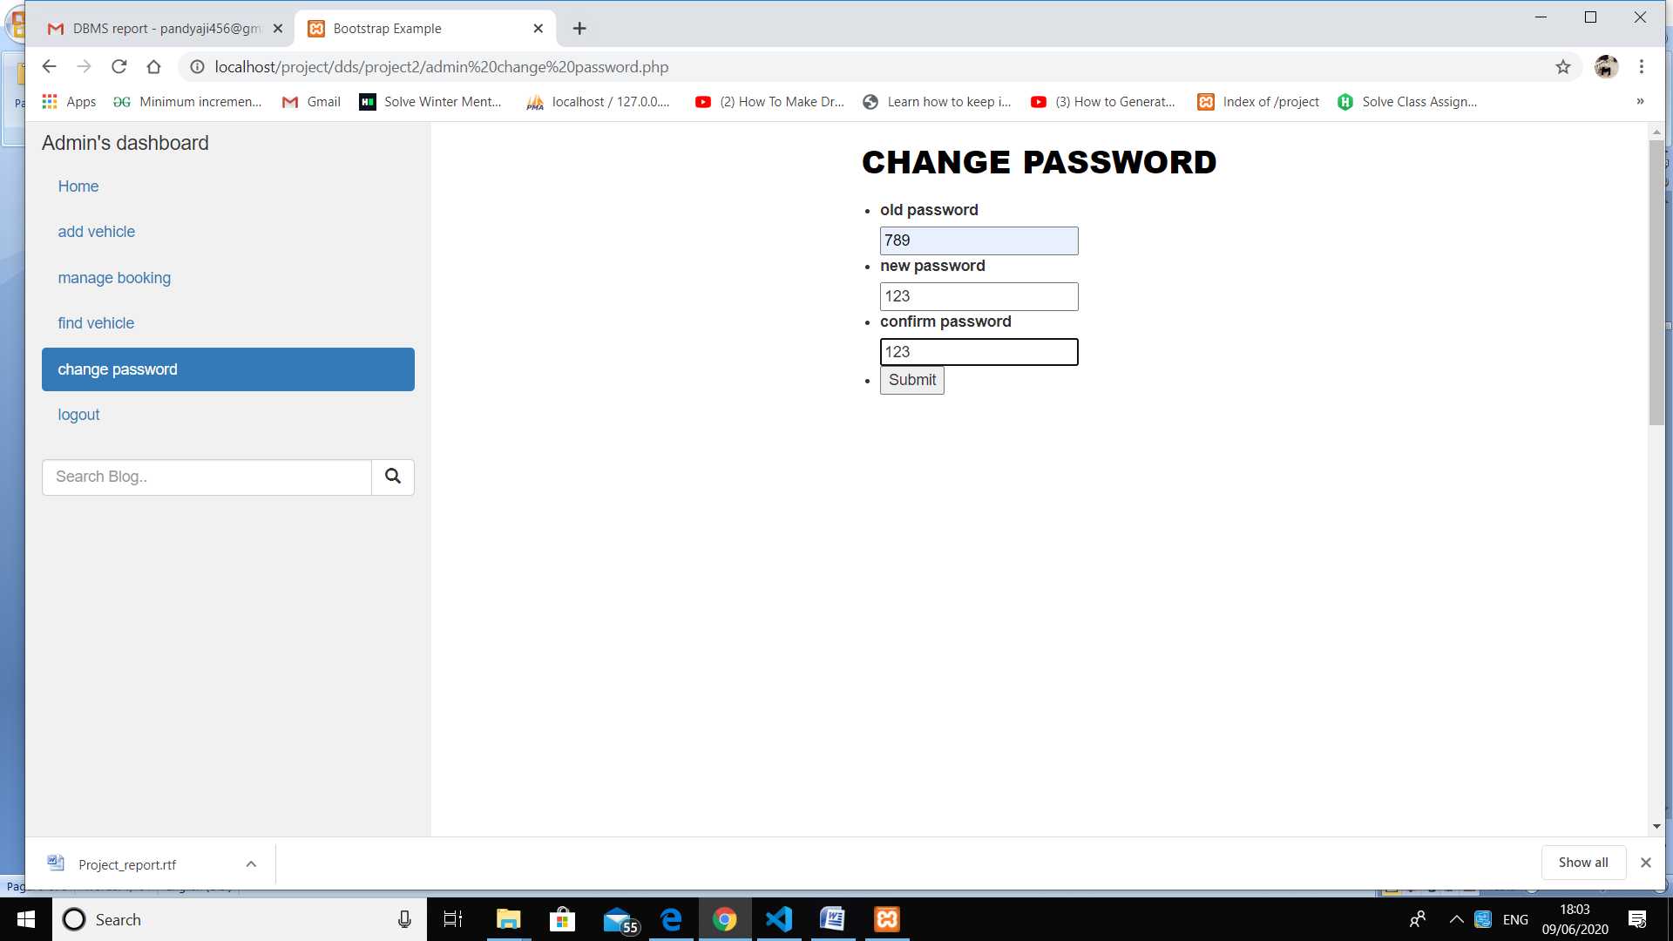

User panel code

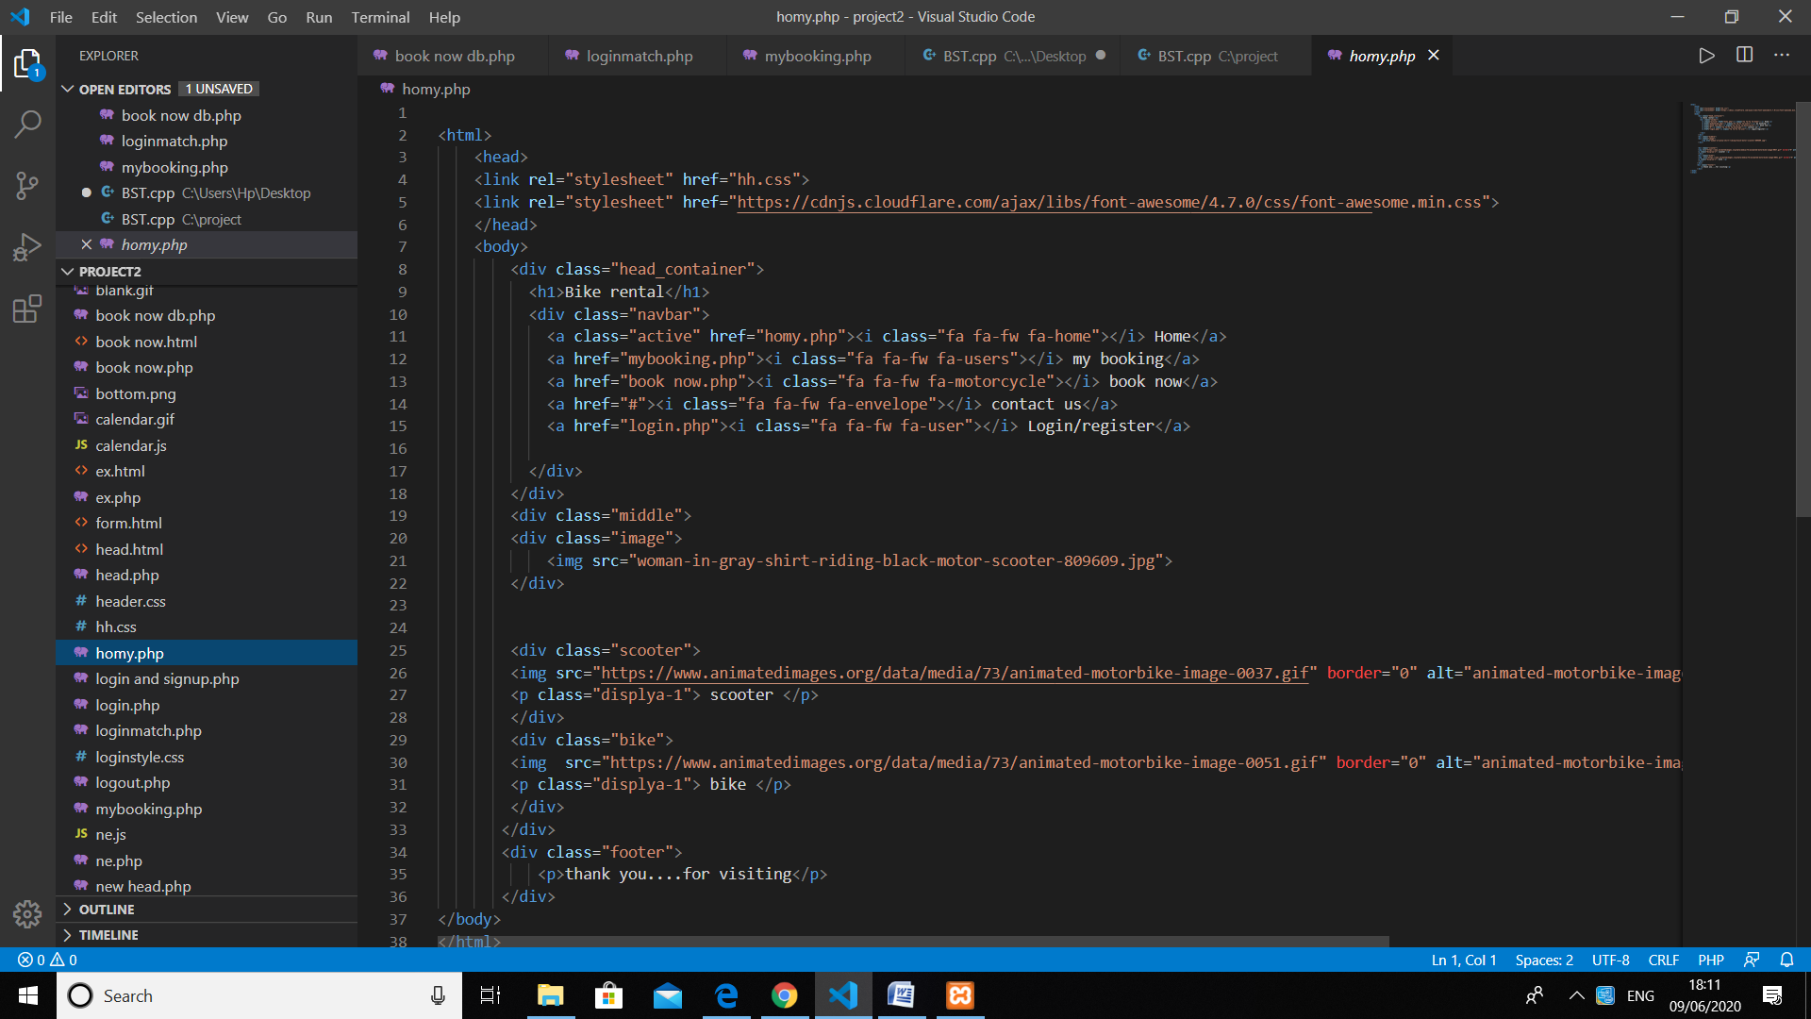

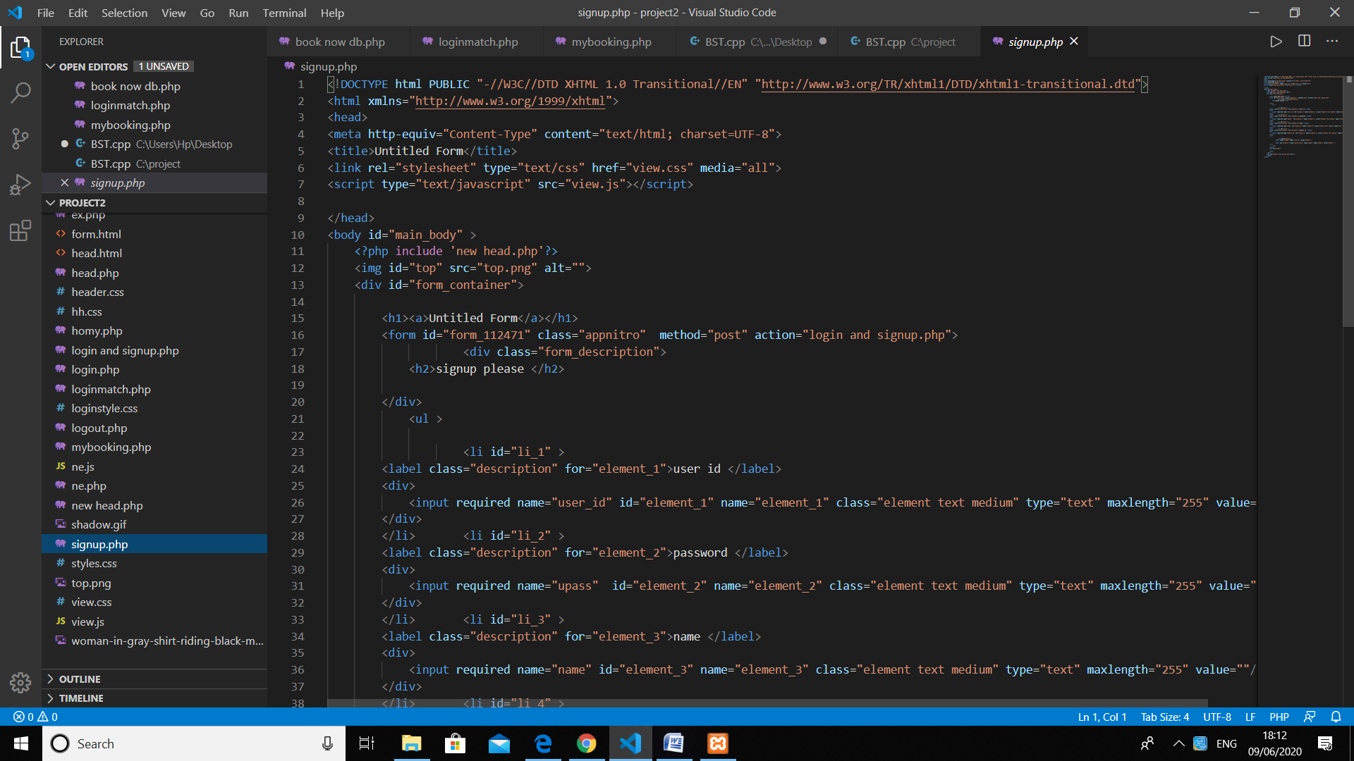

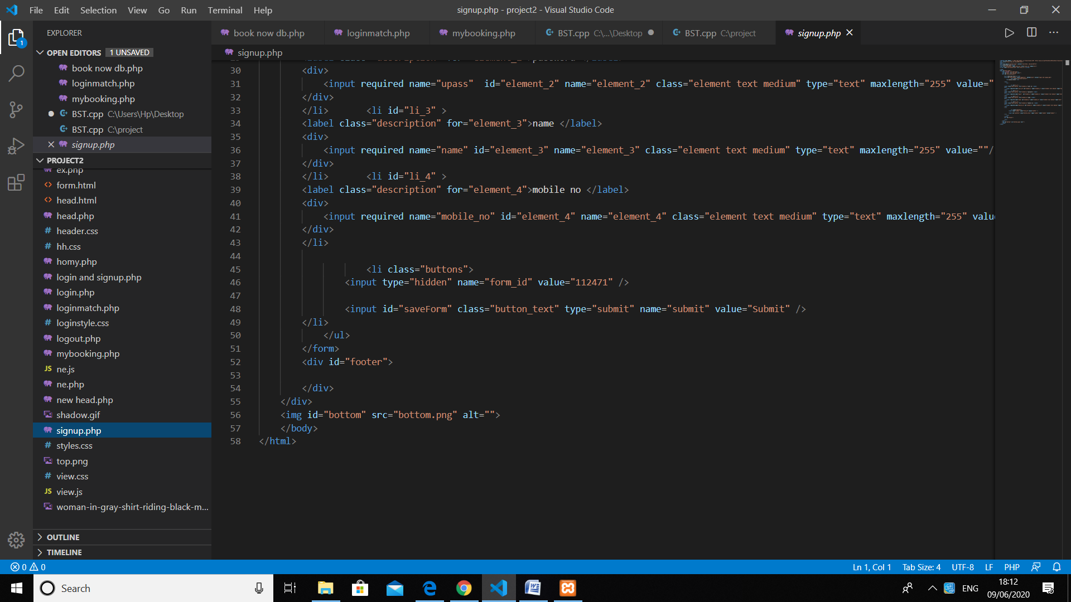

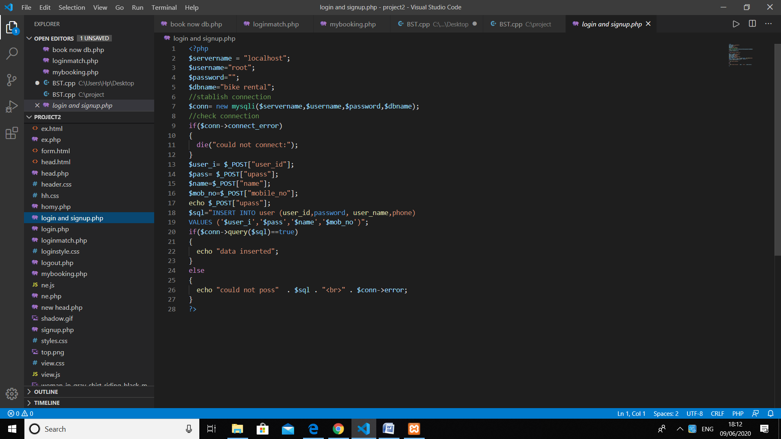

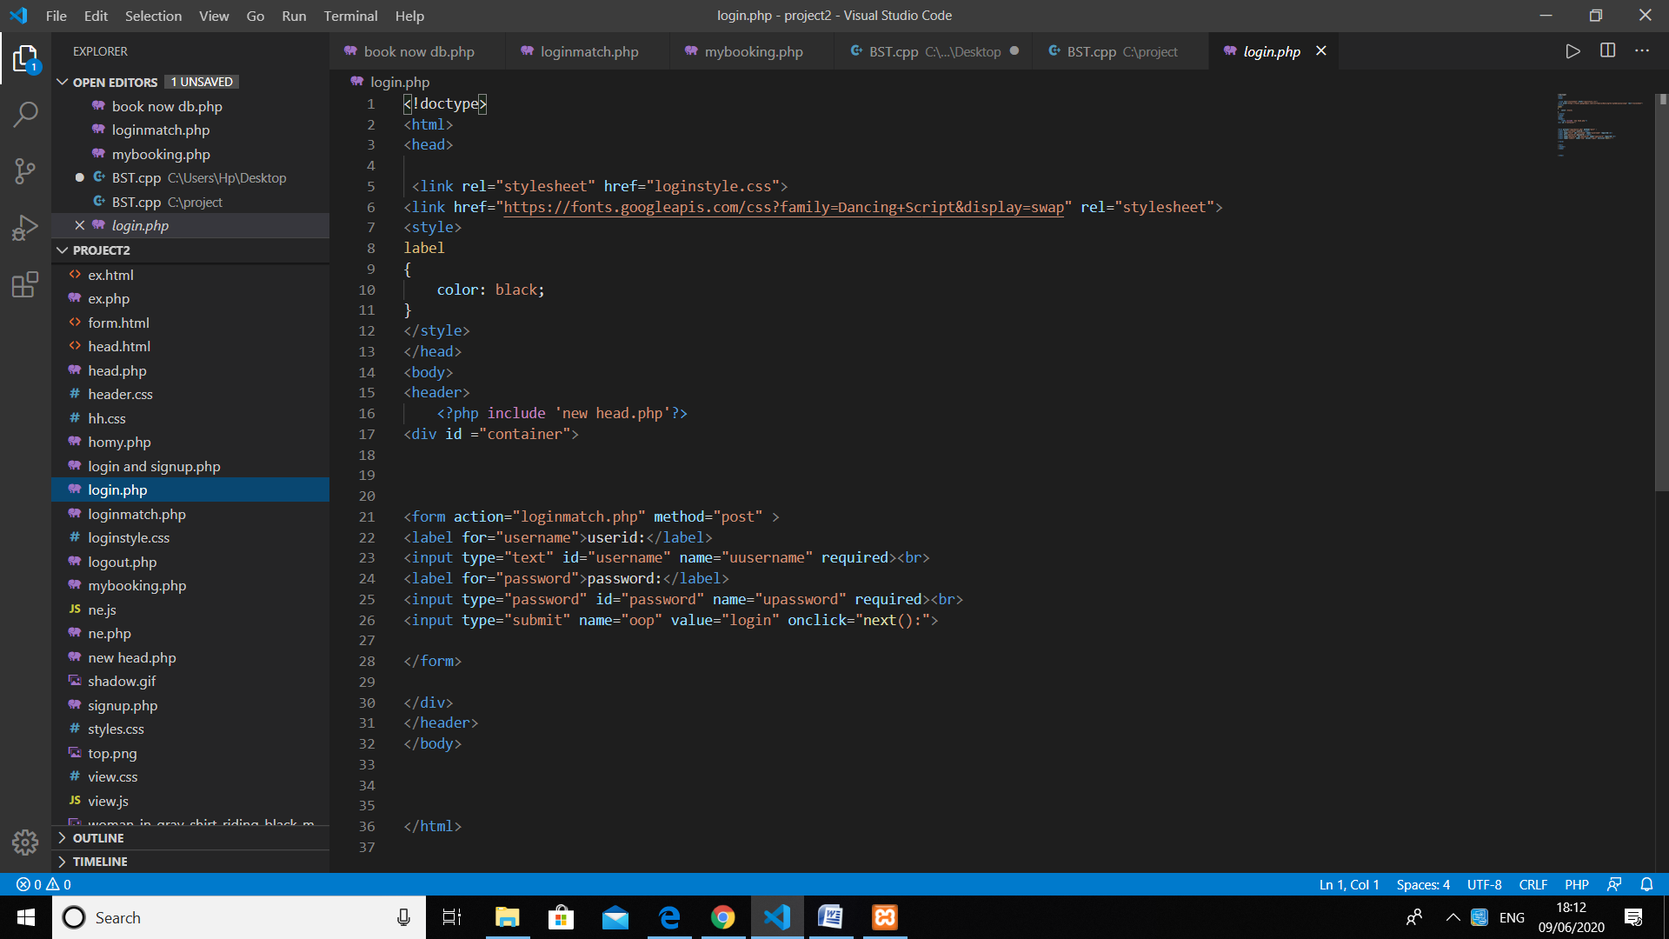

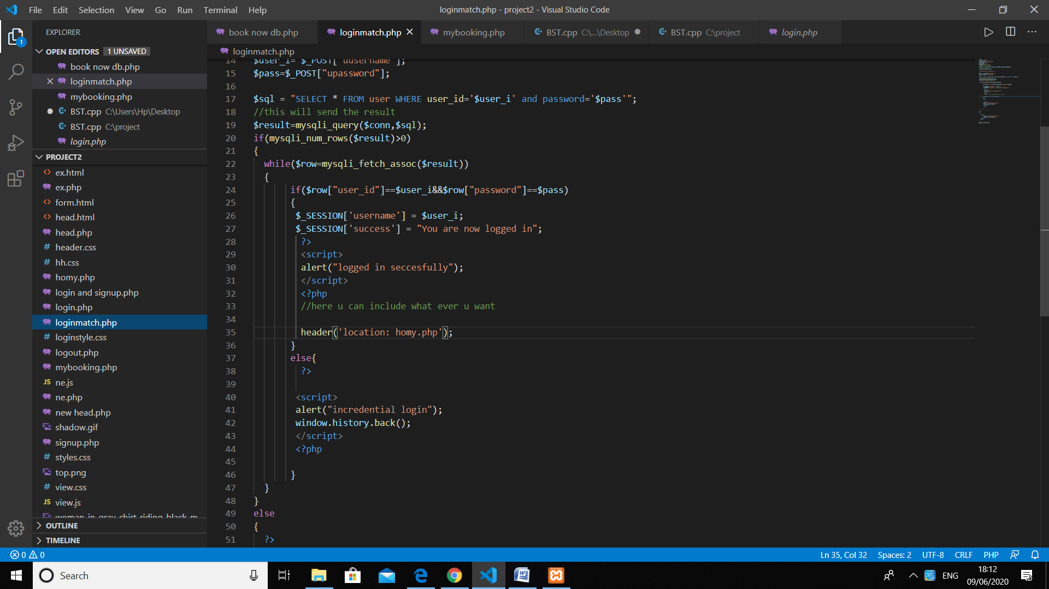

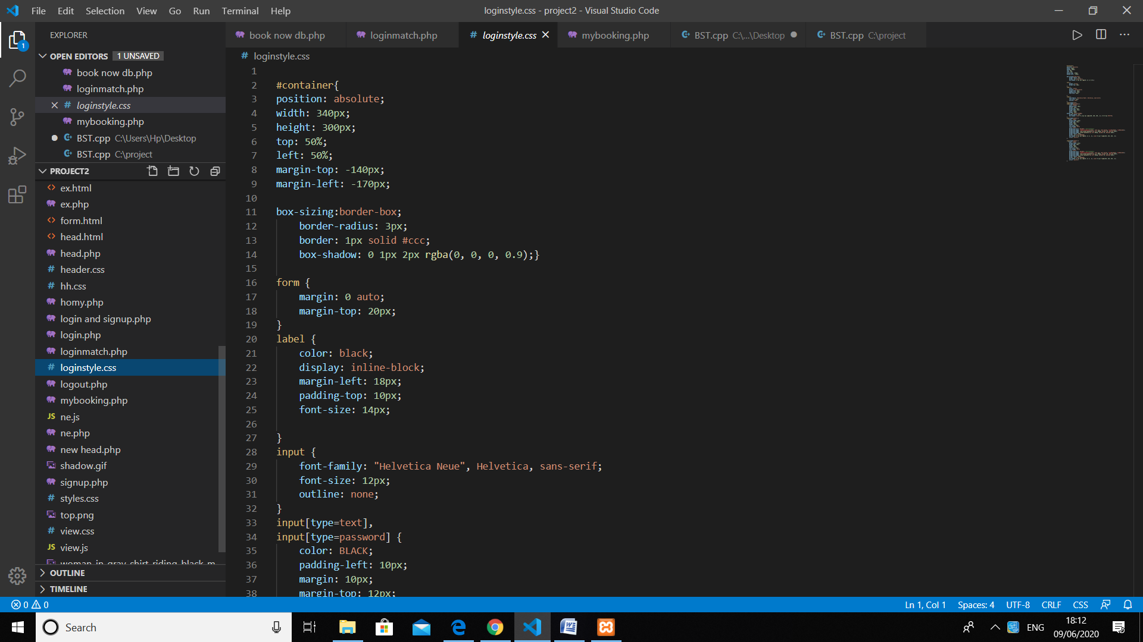

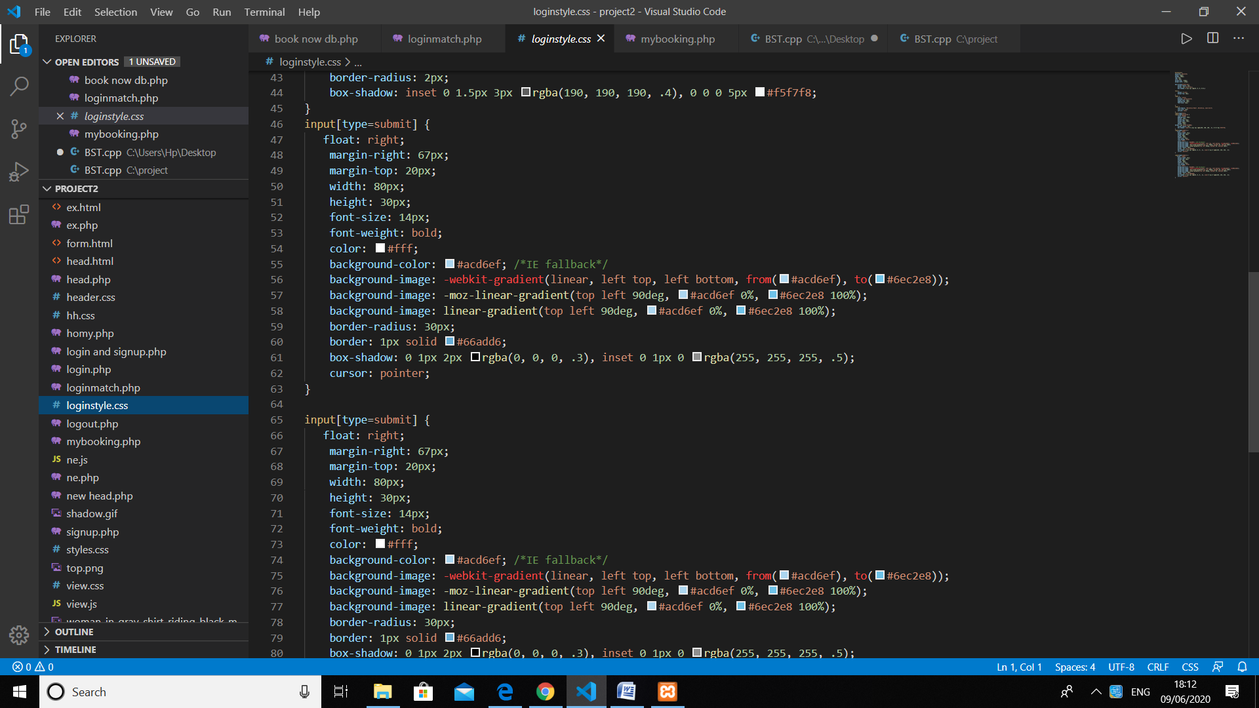

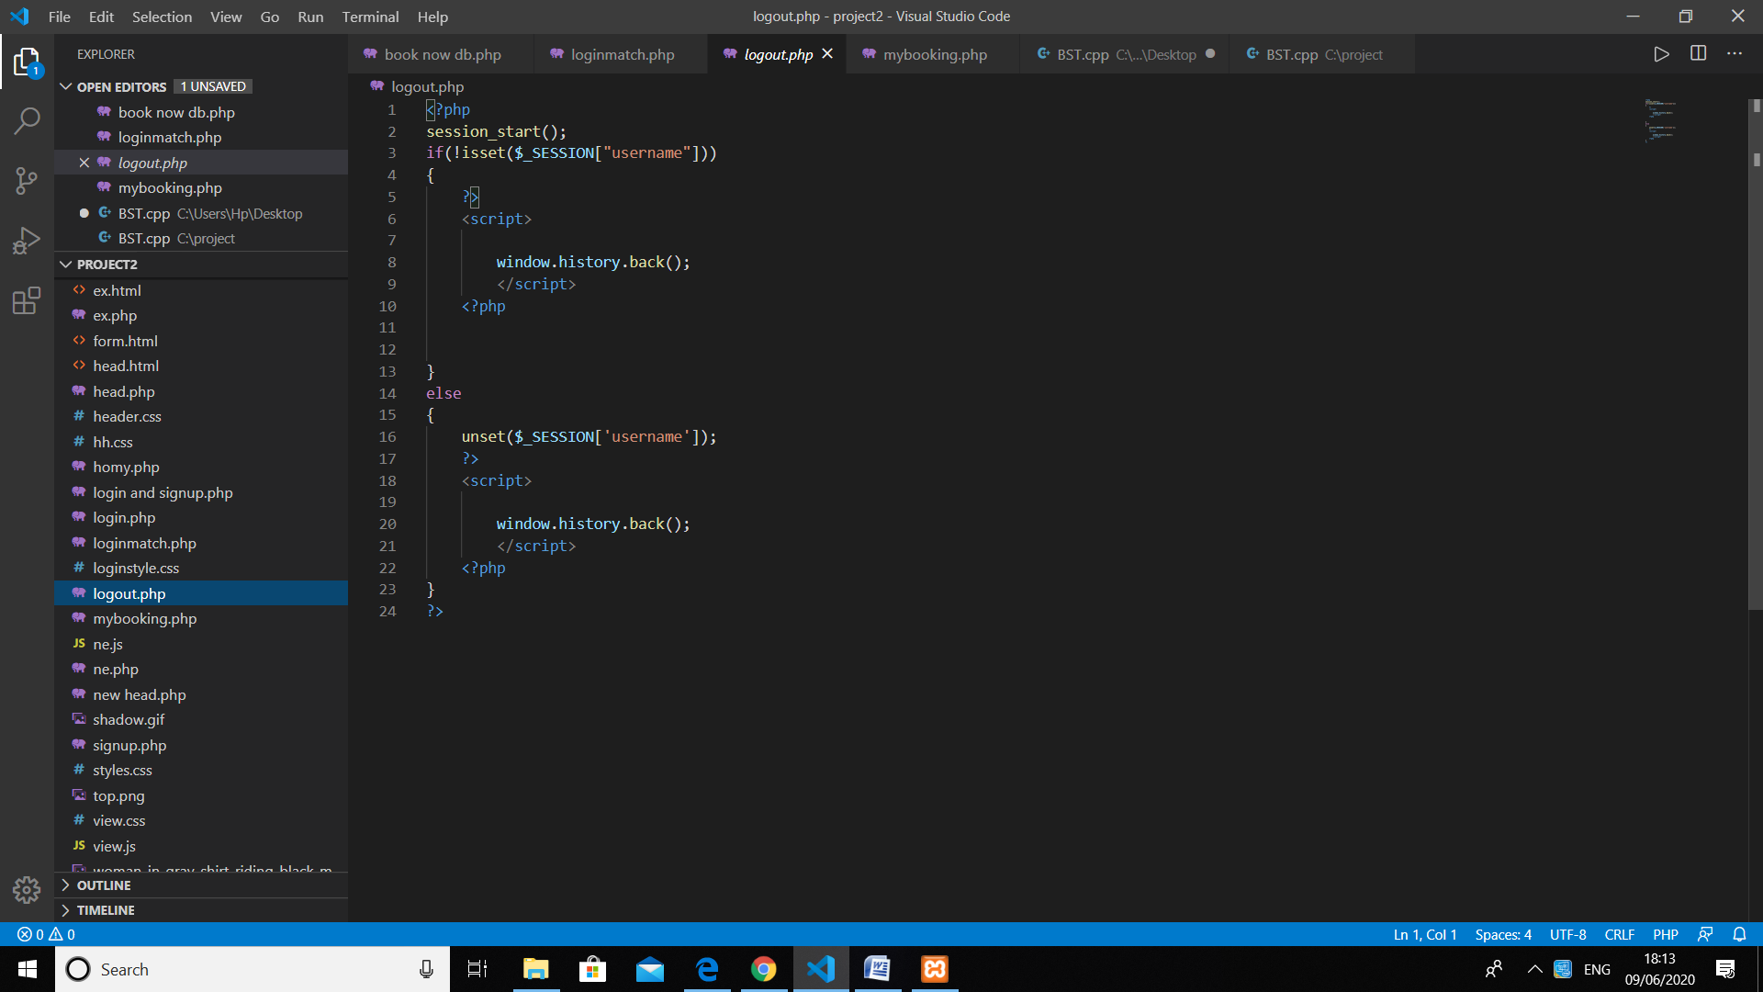

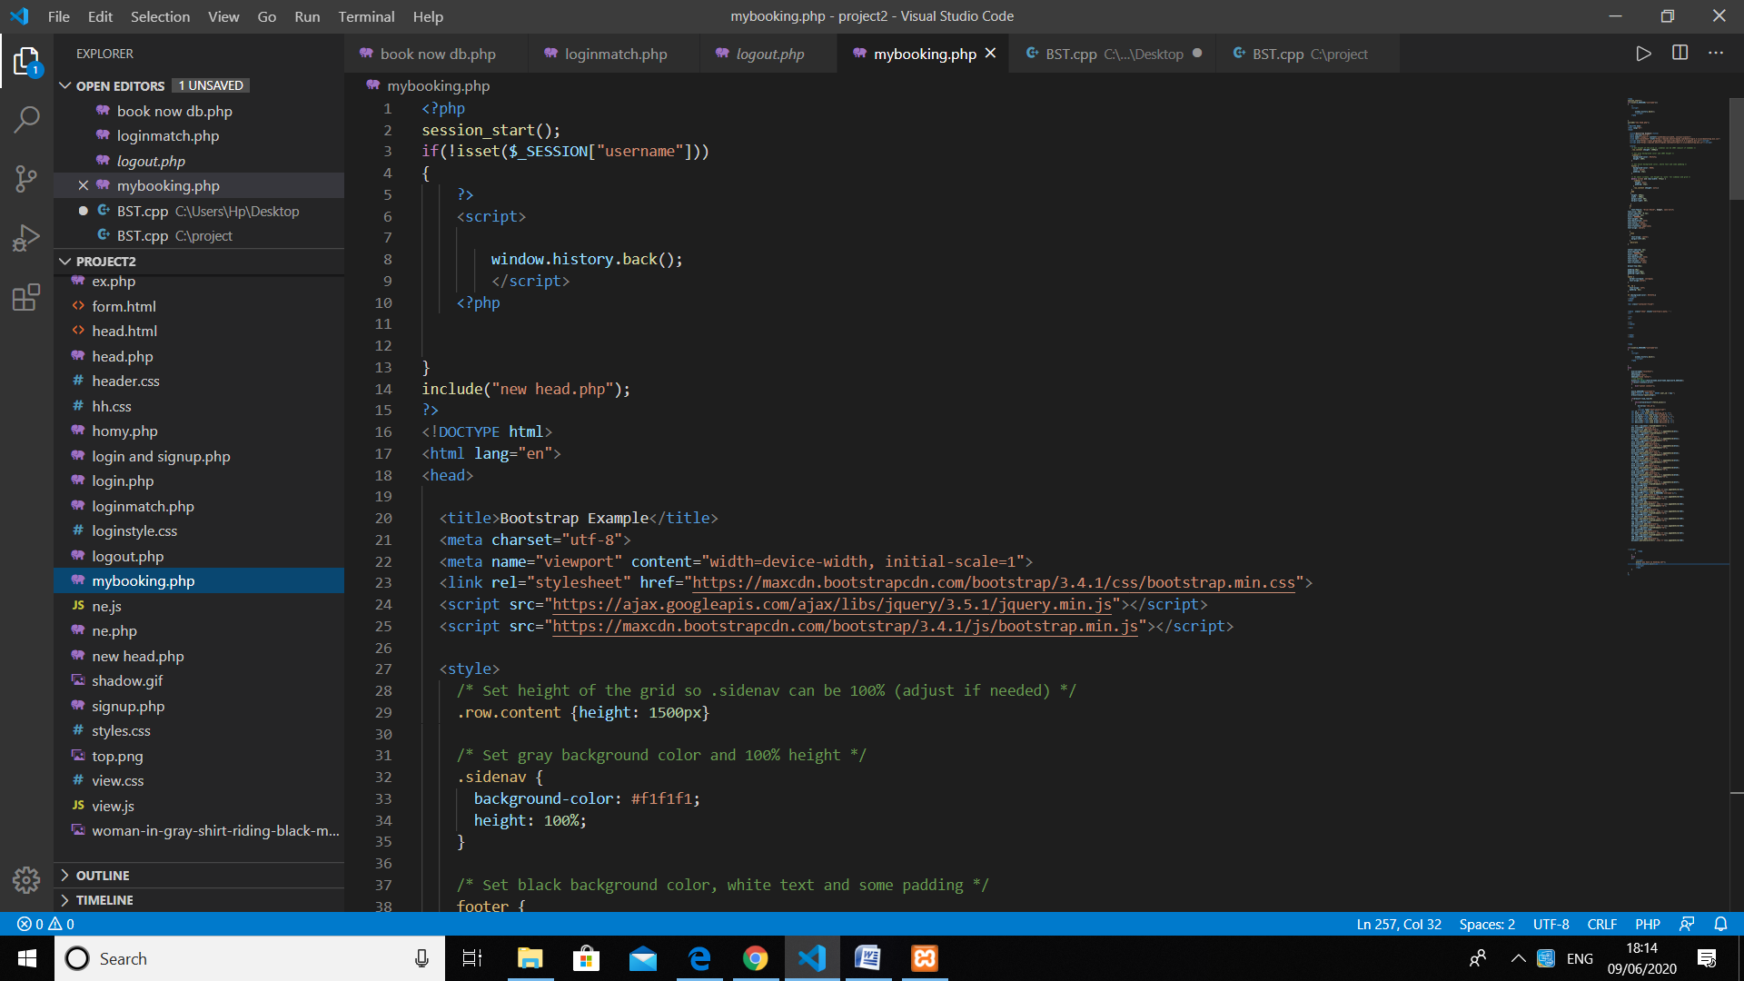

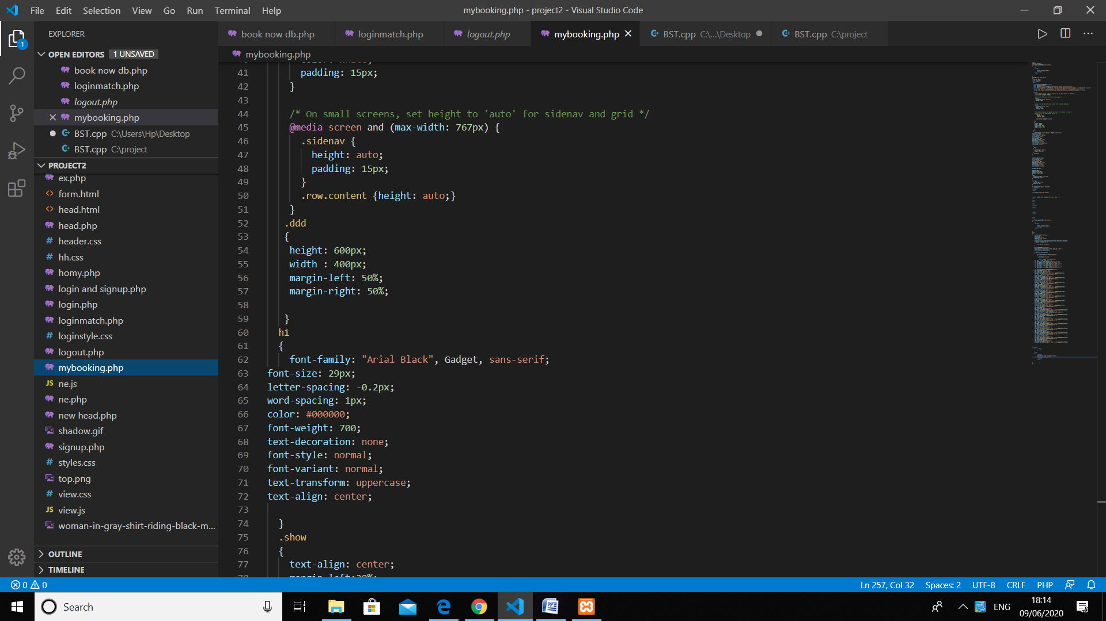

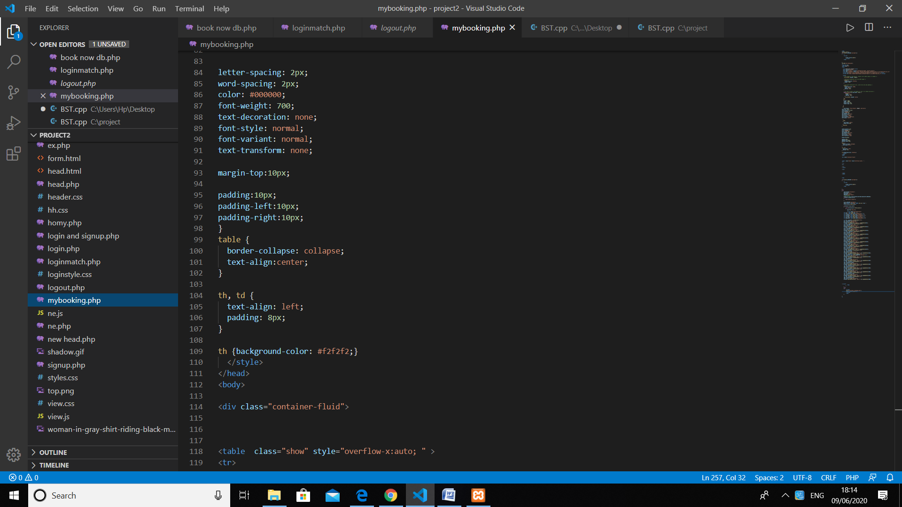

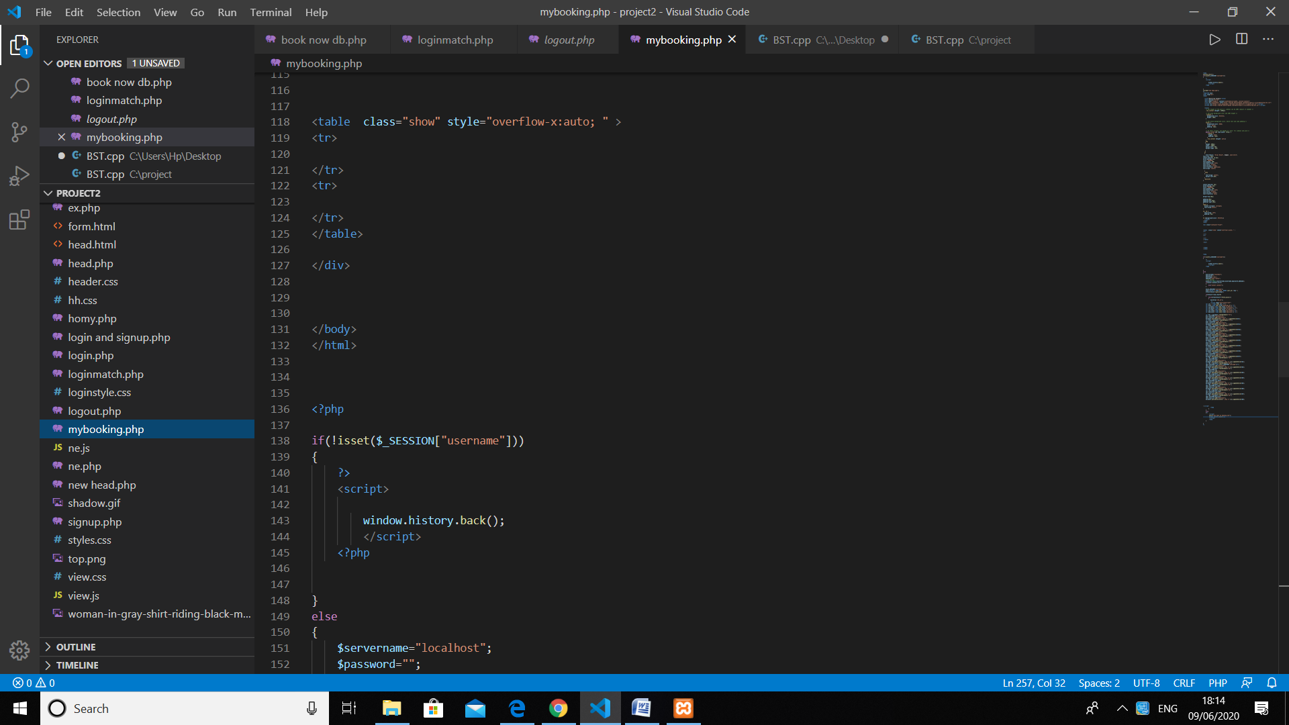

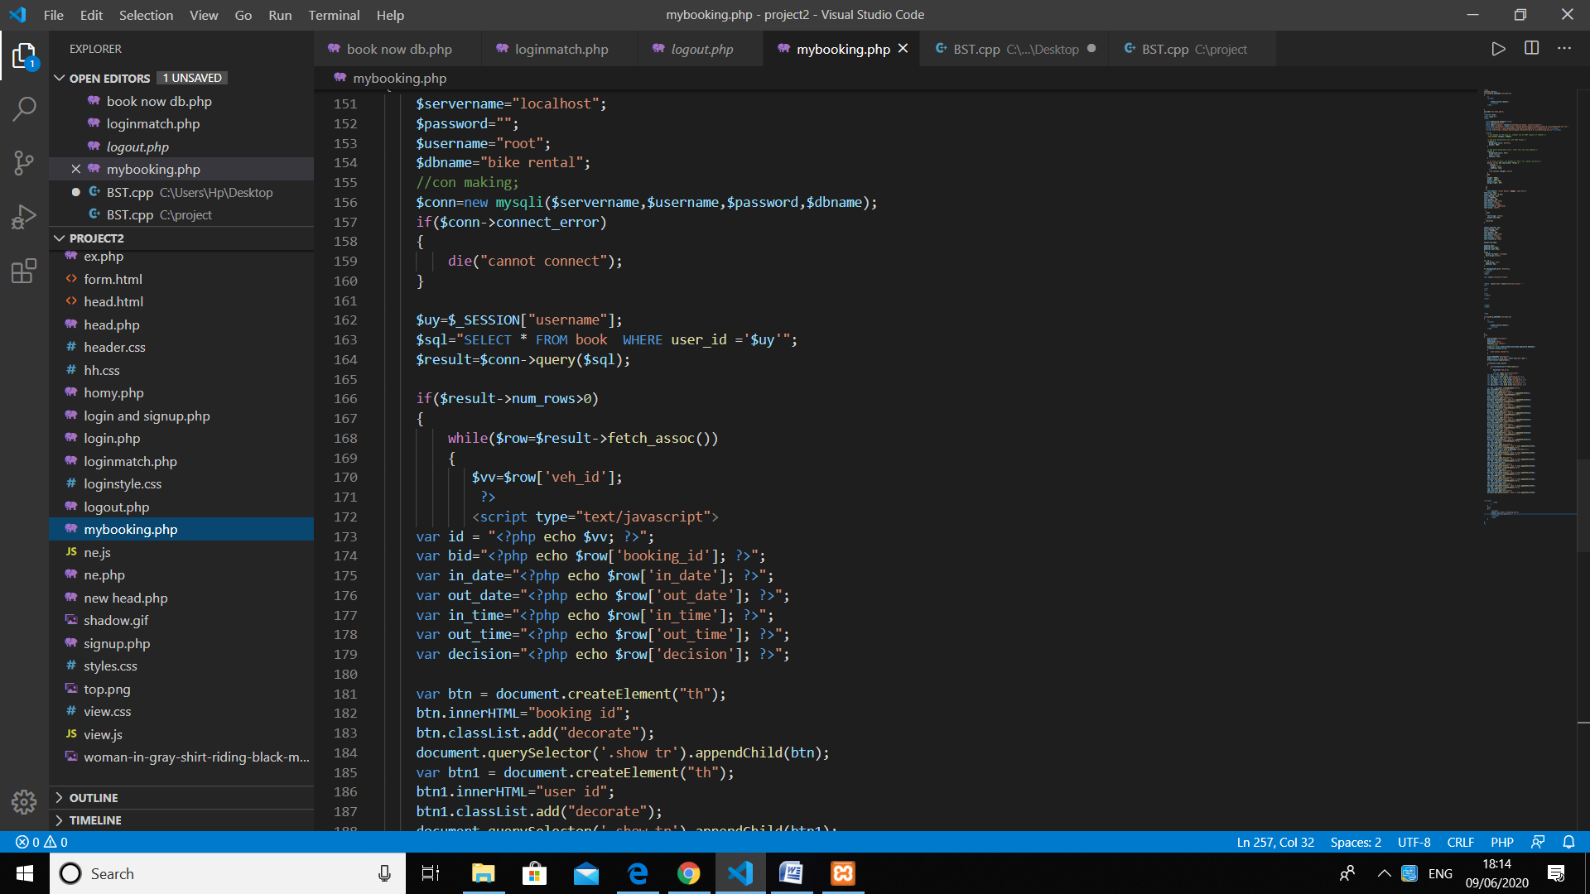

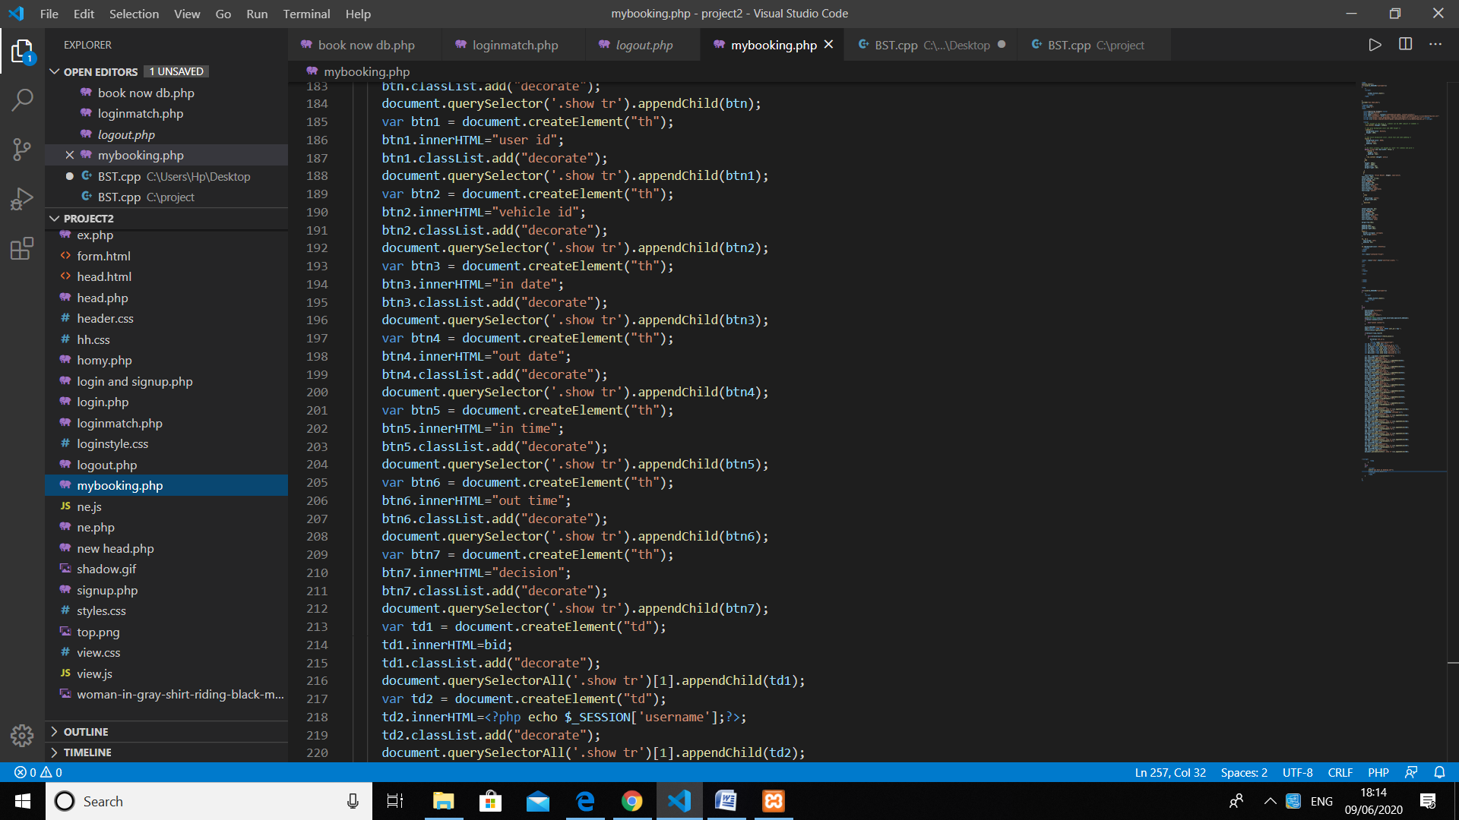

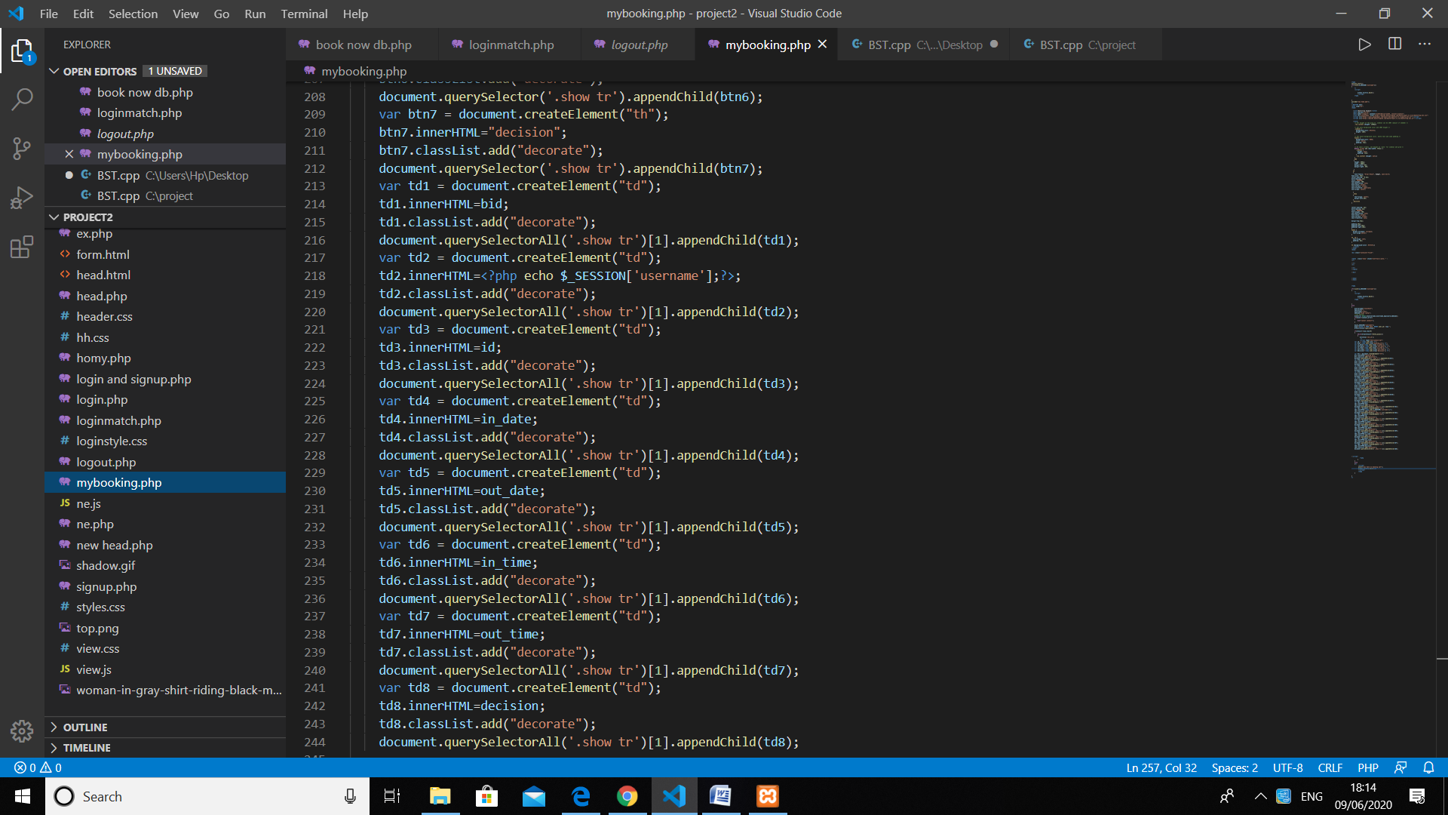

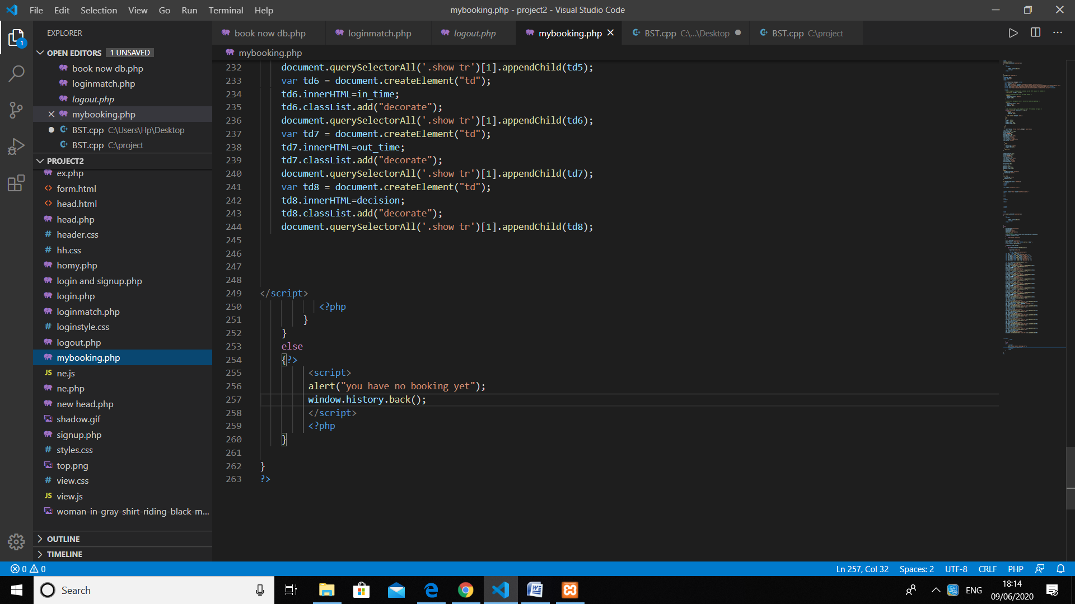

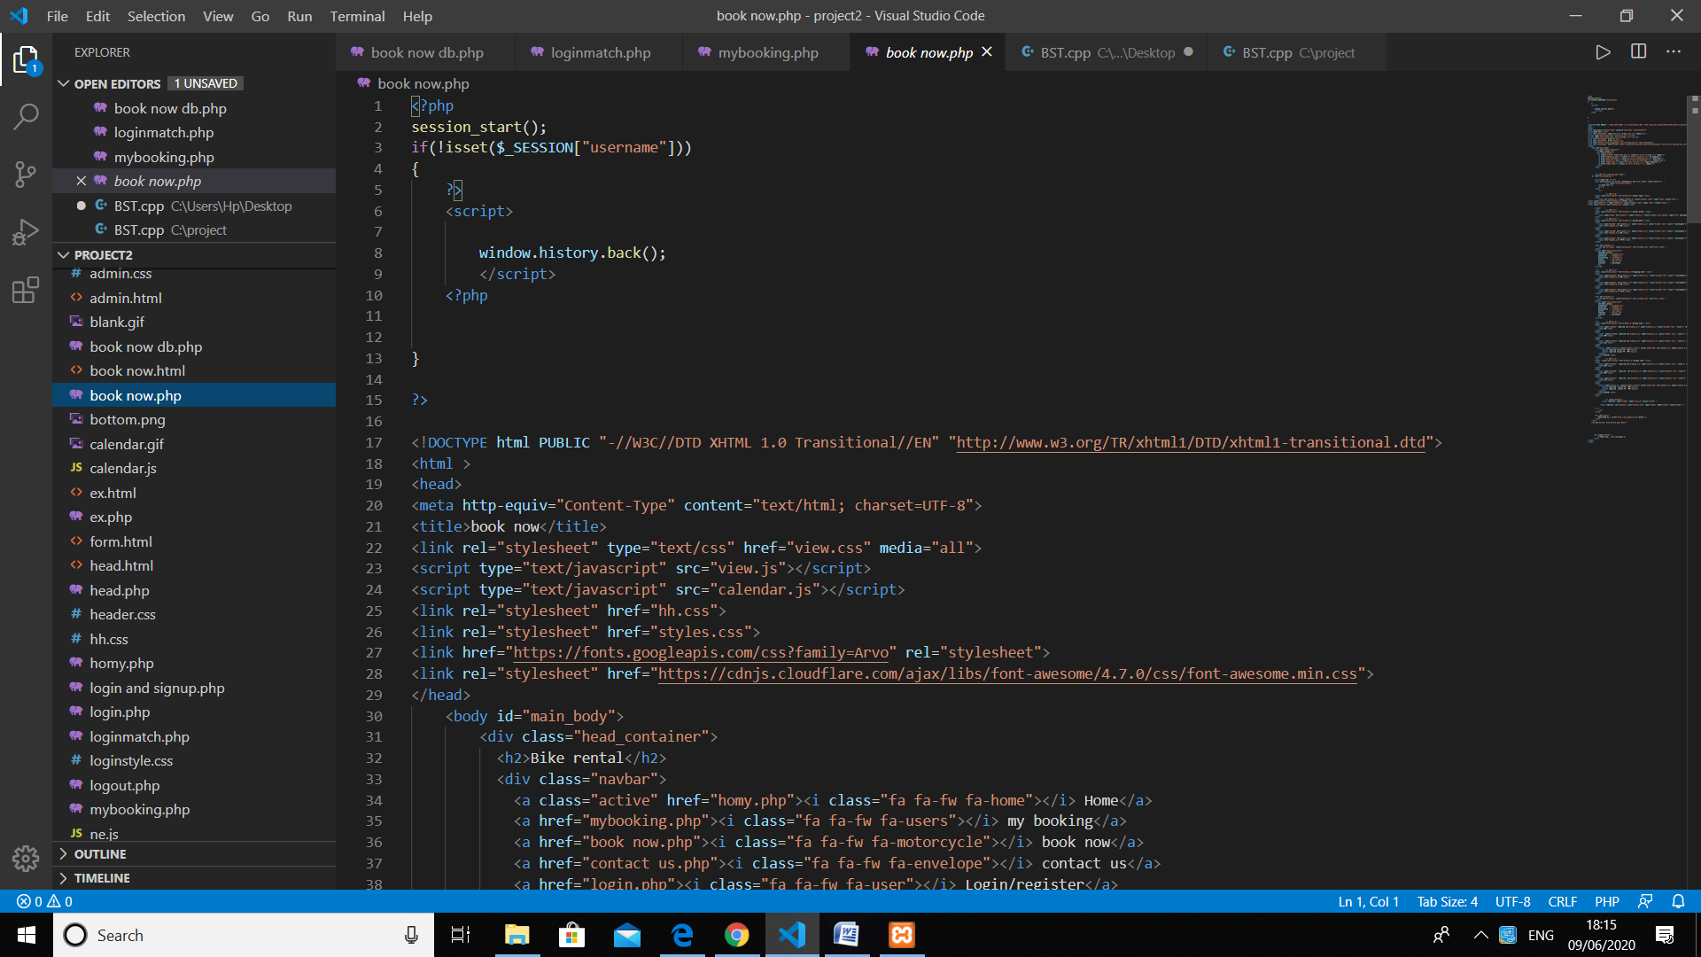

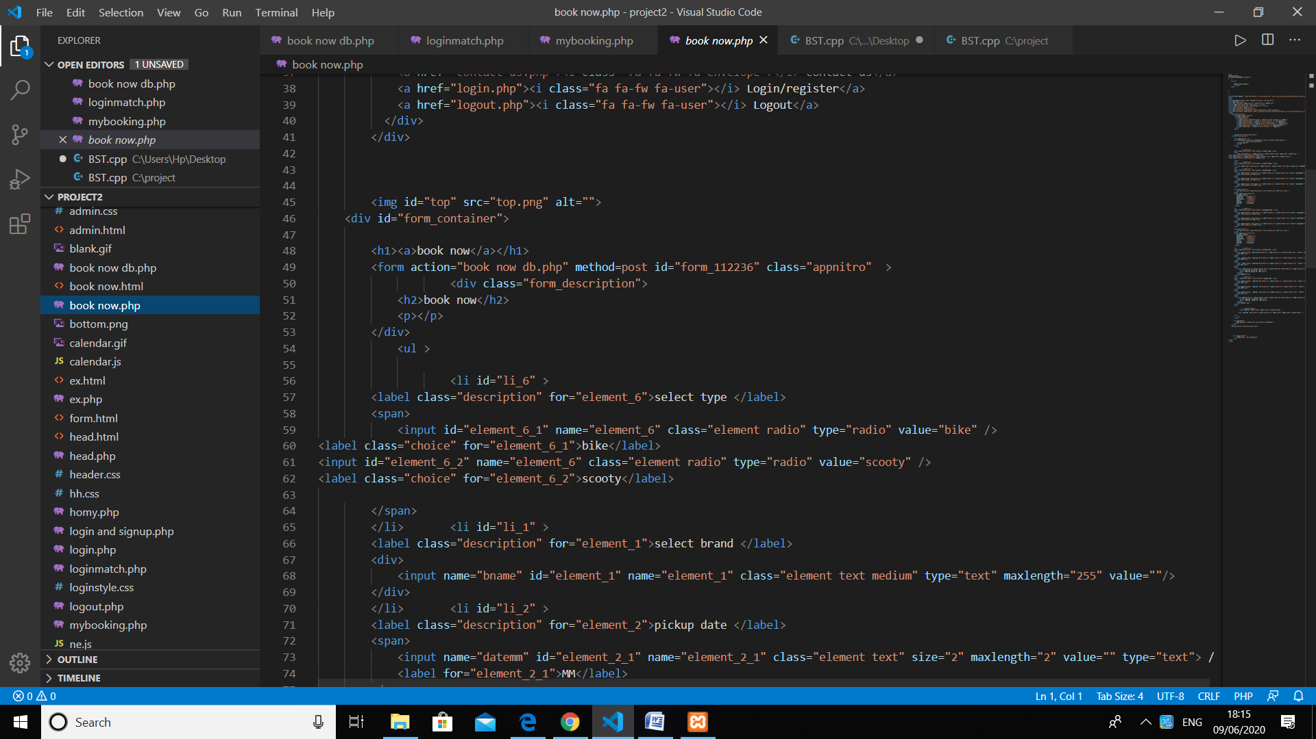

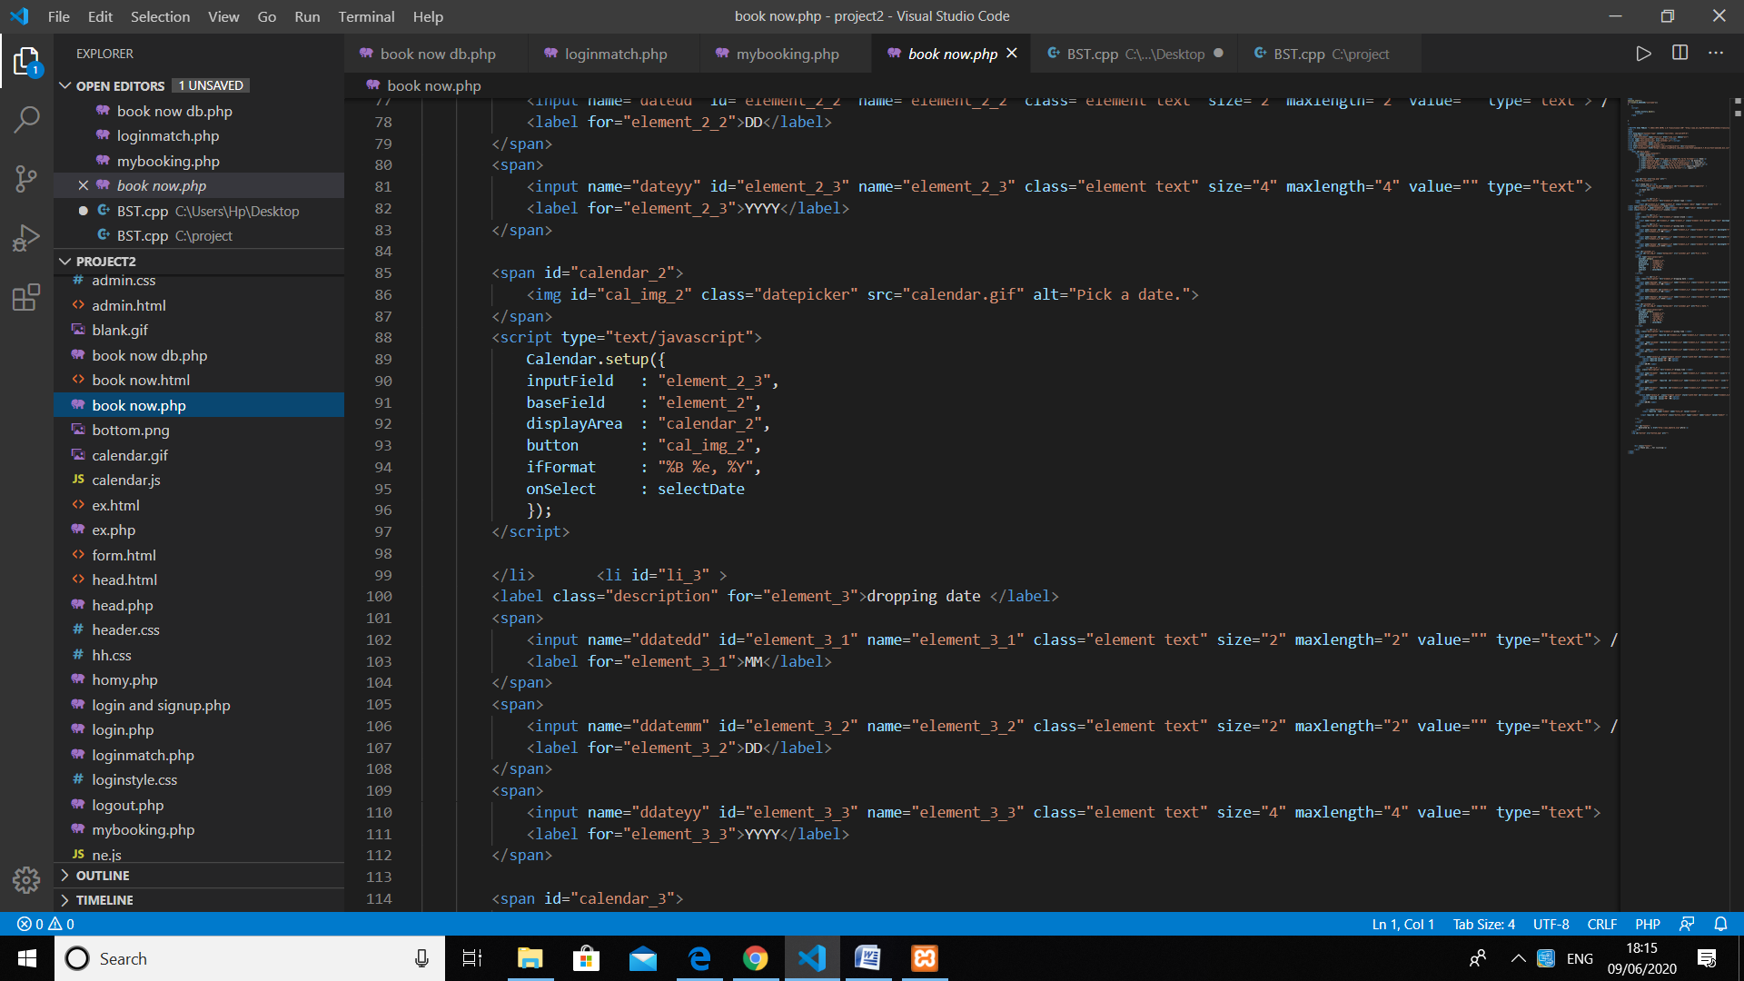

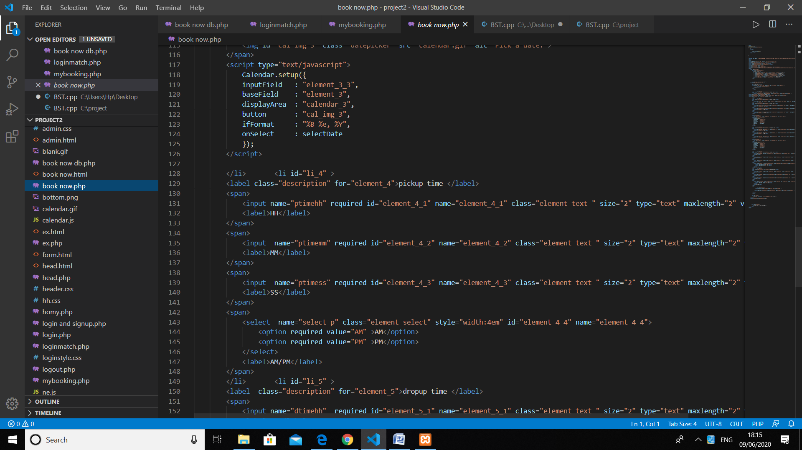

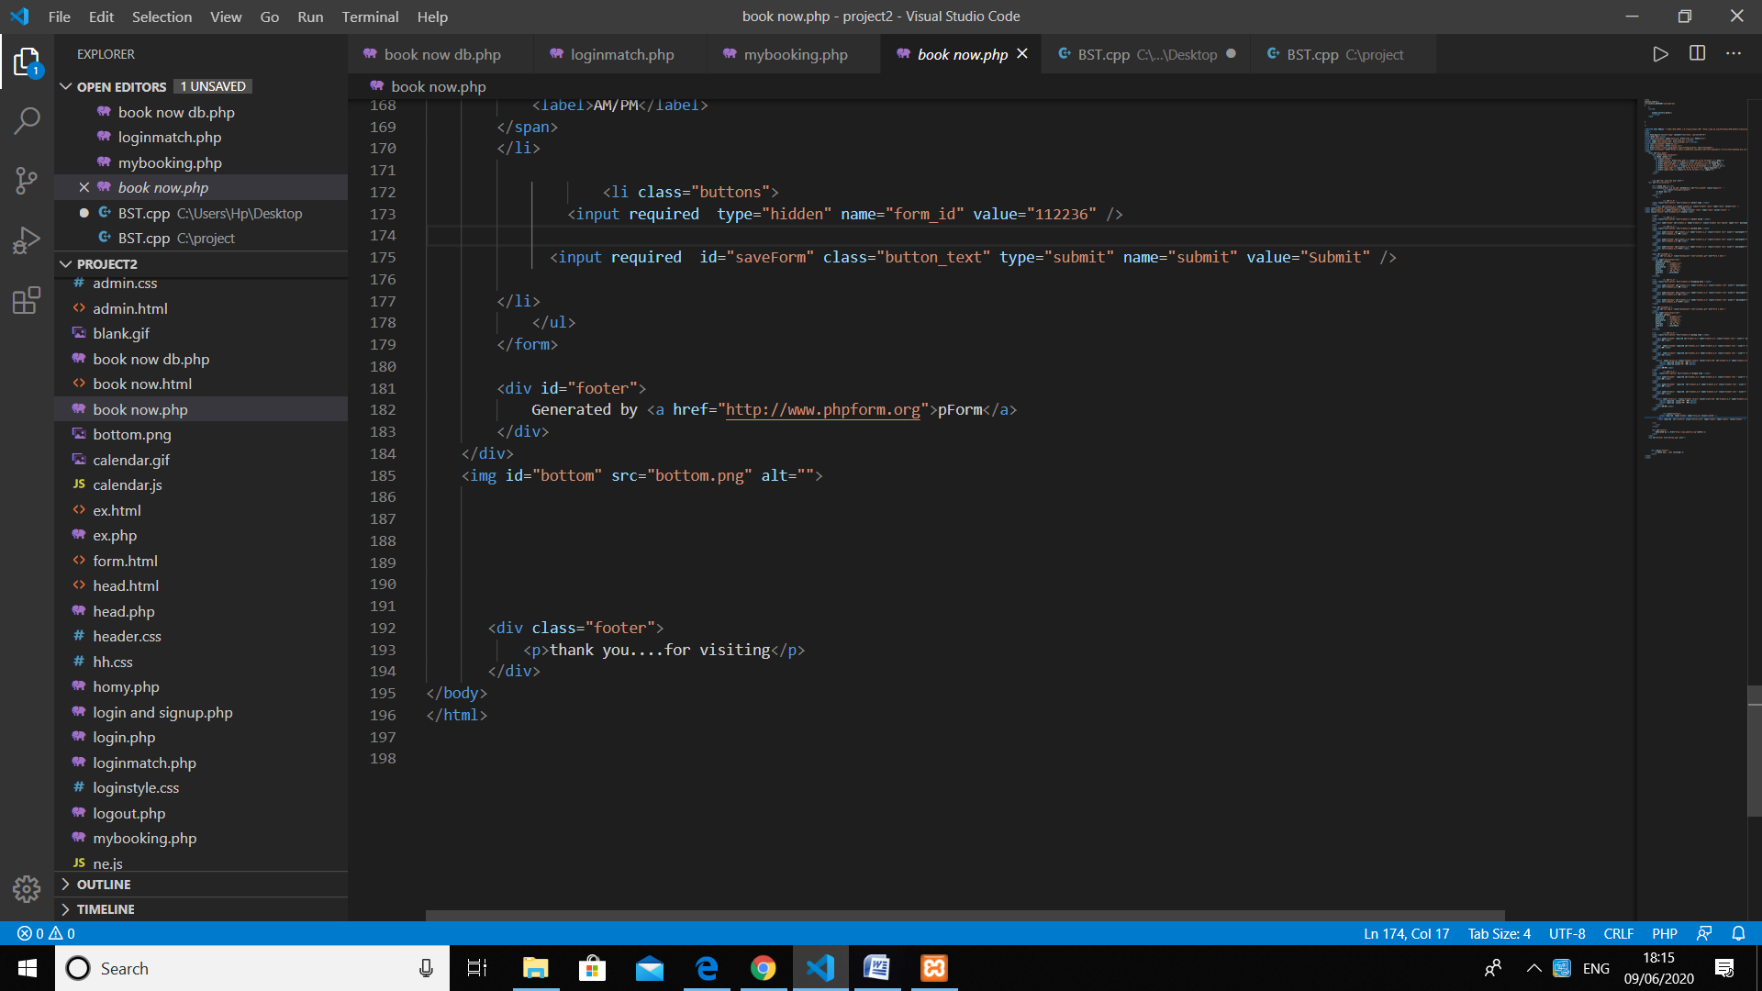

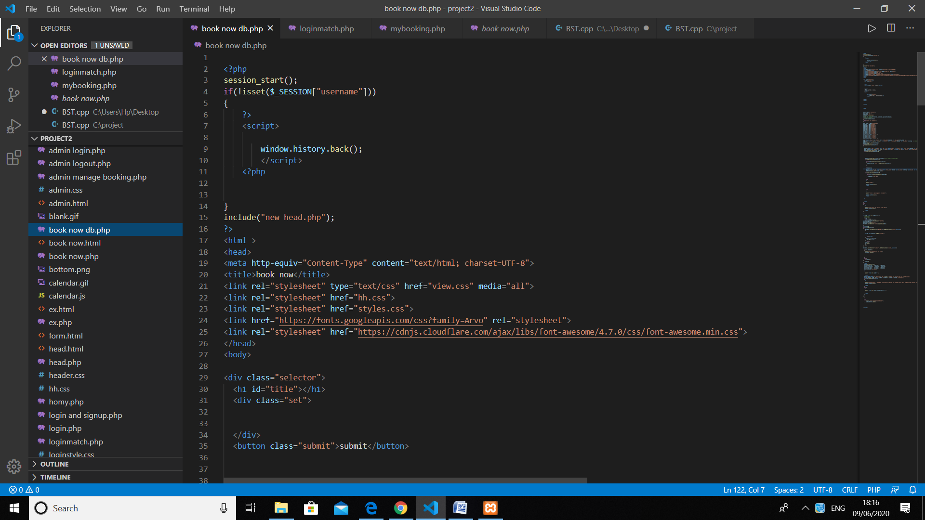

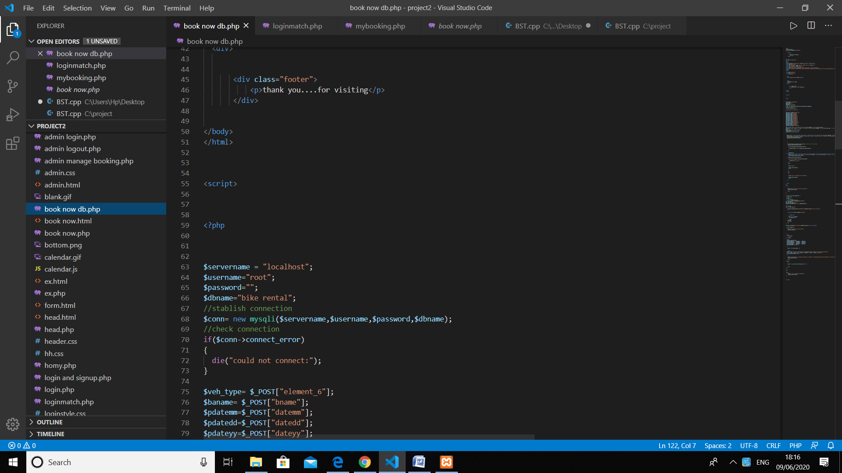

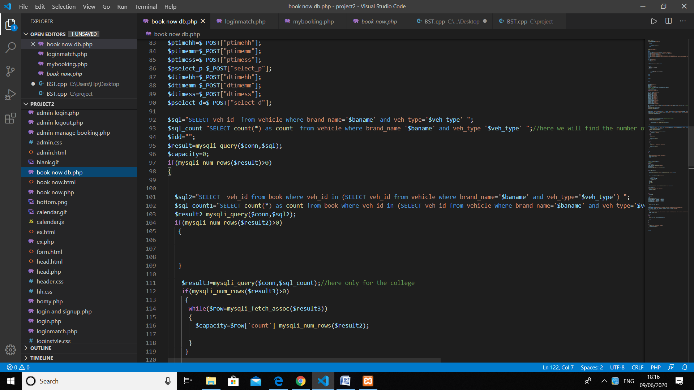

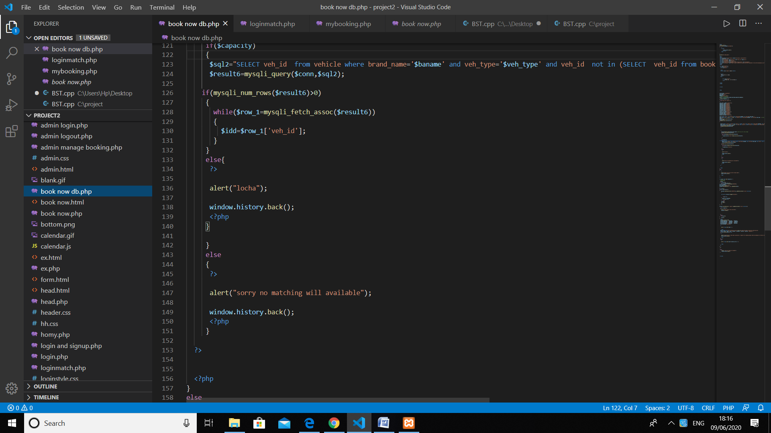

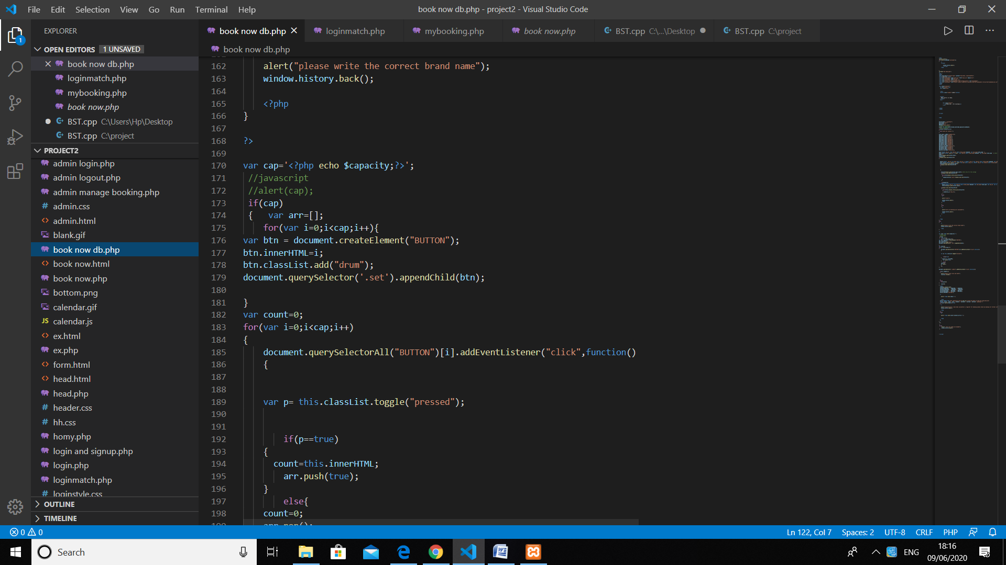

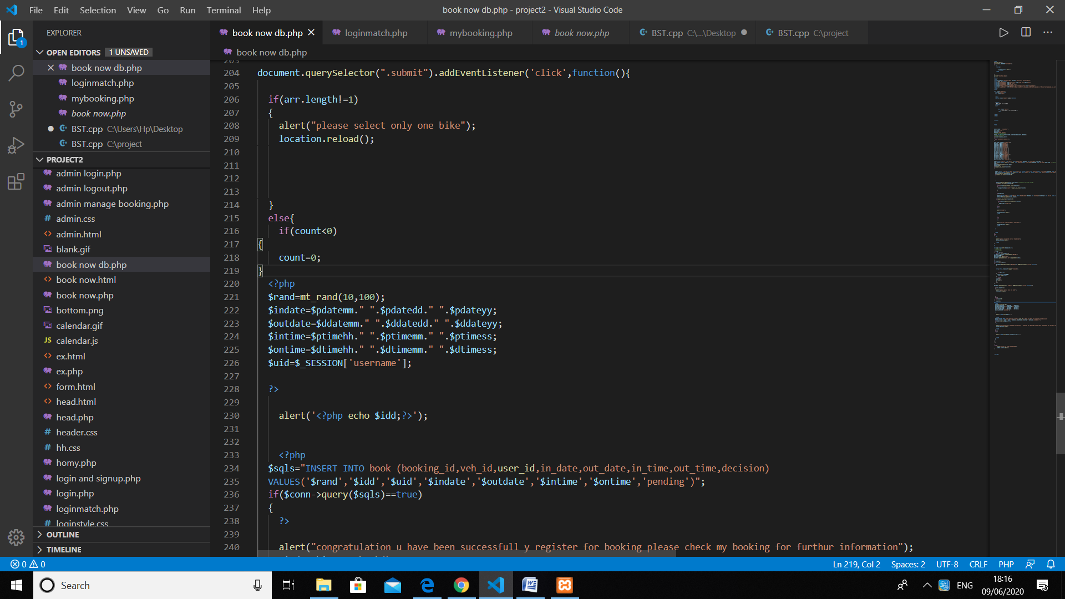

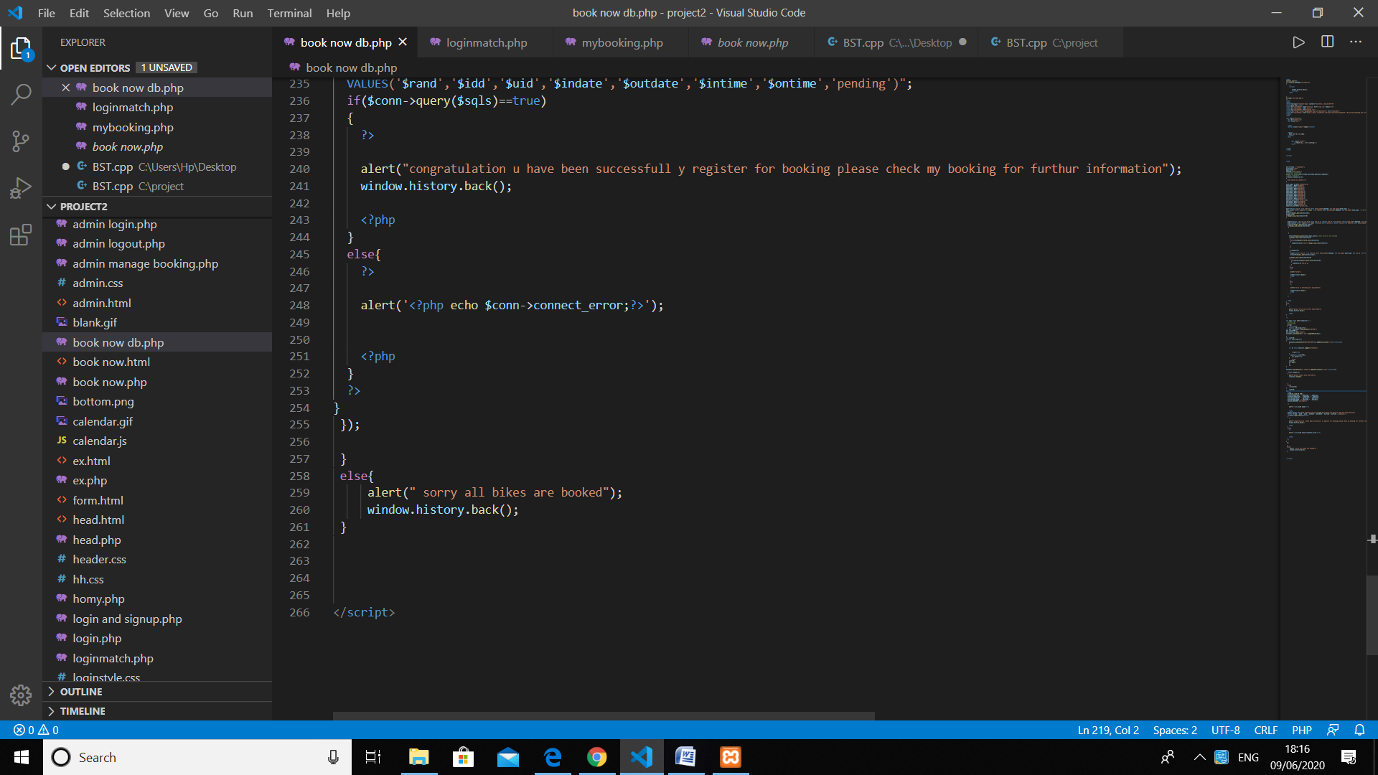

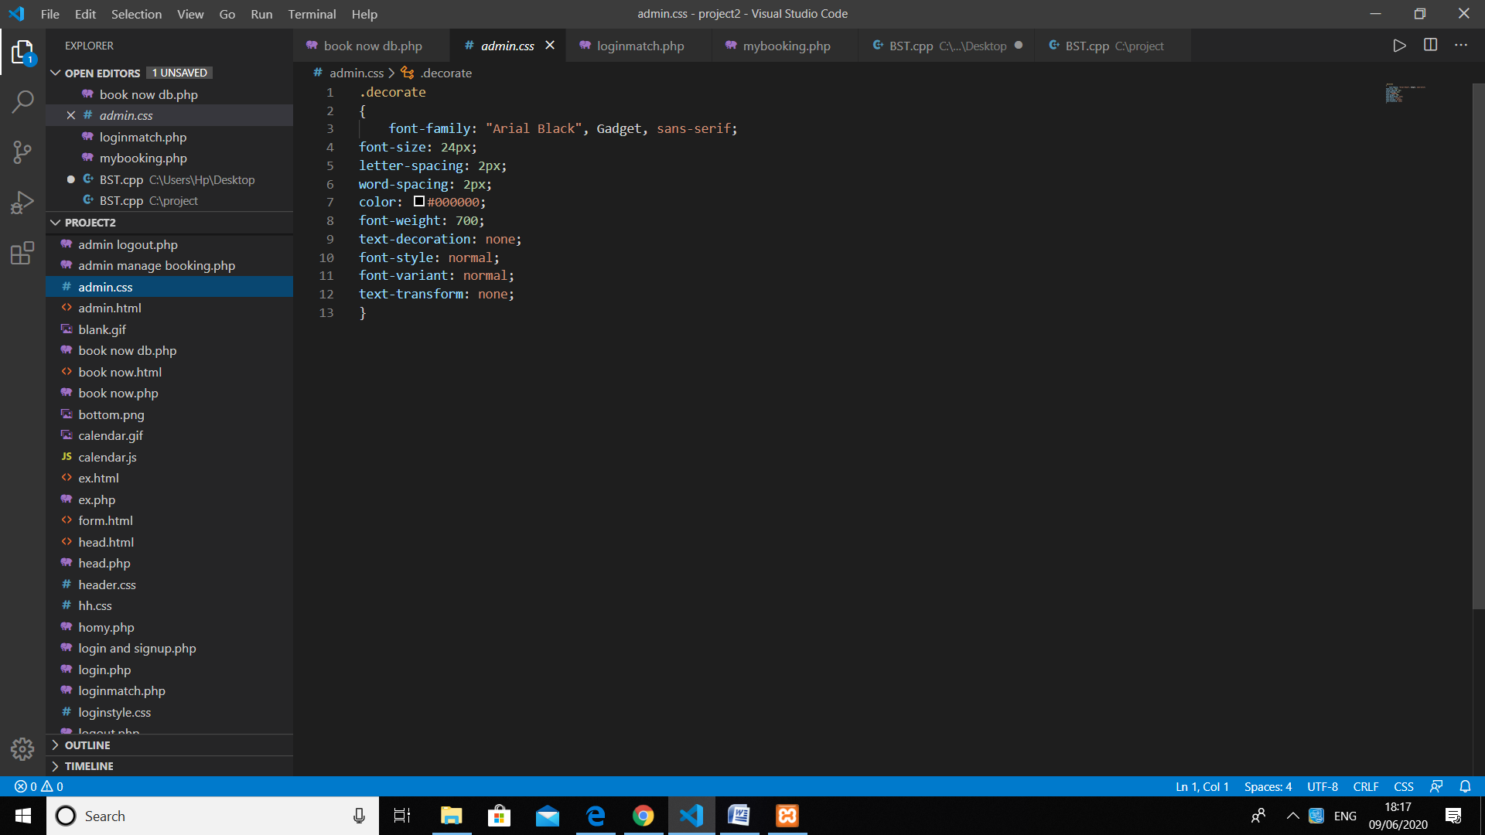

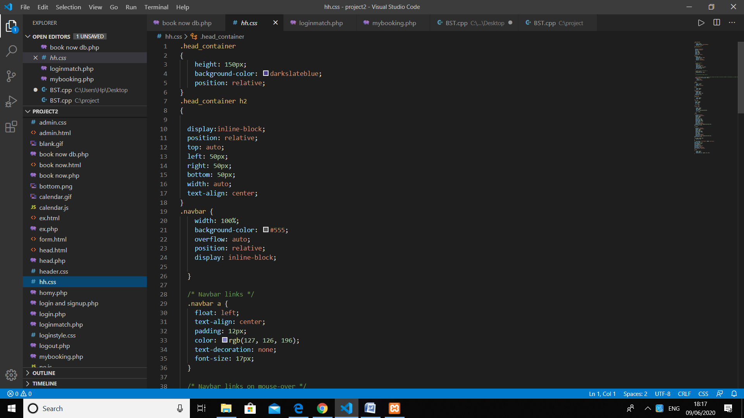

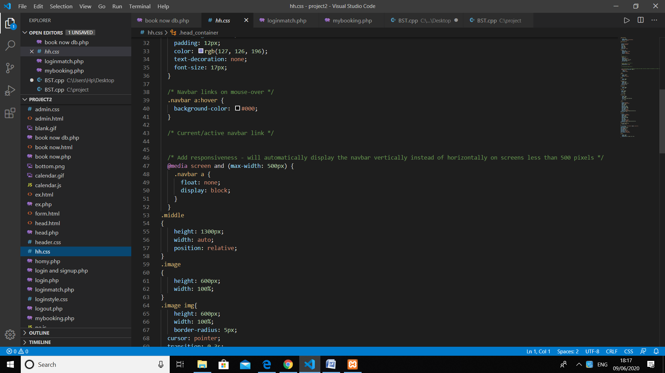

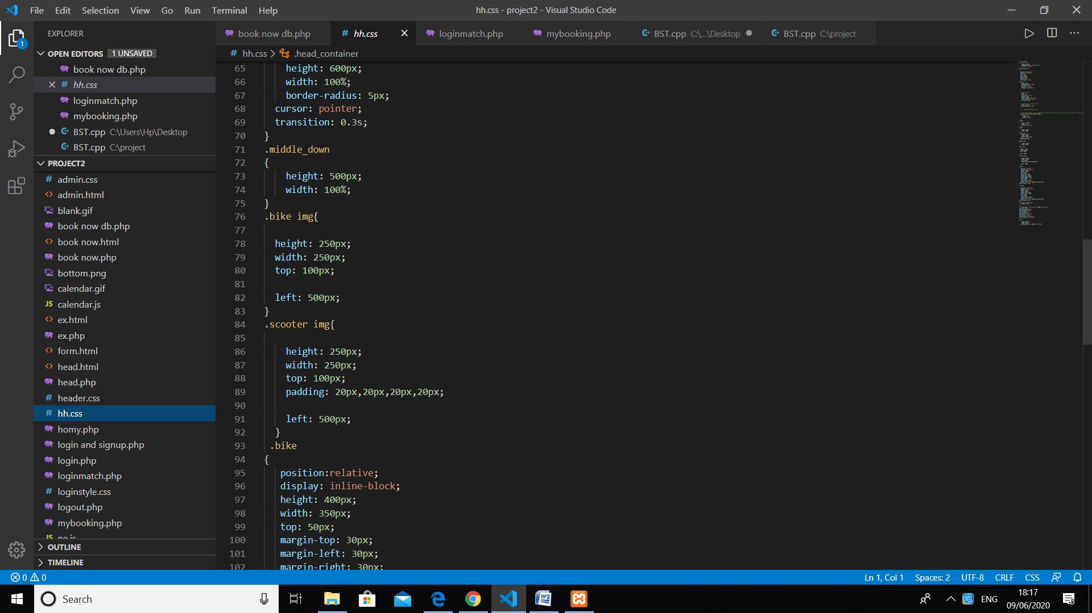

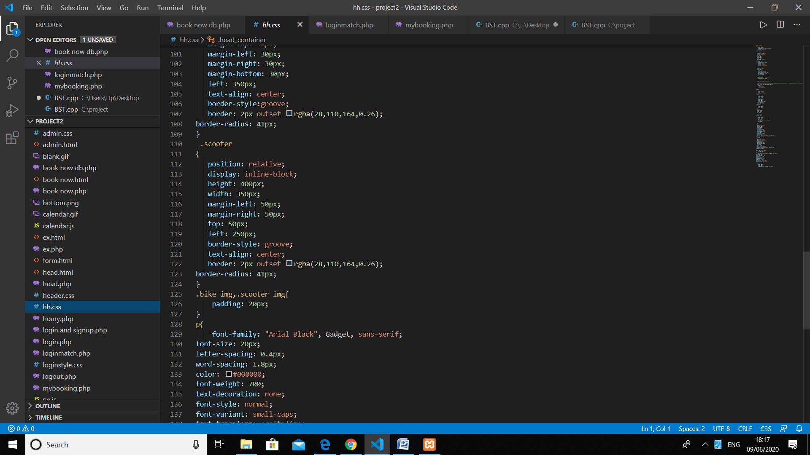

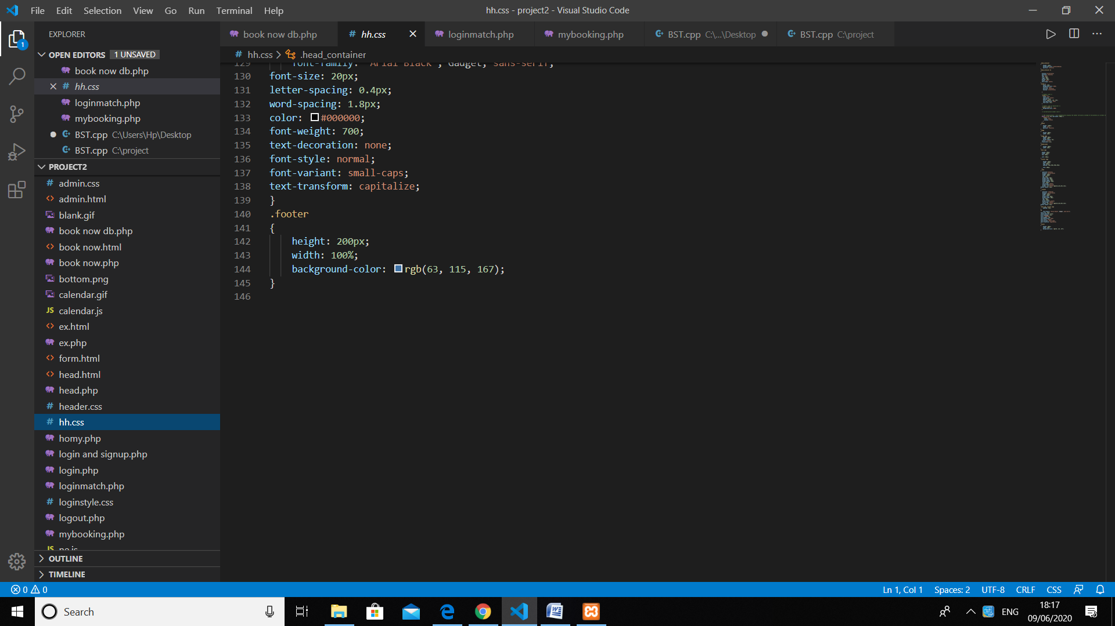

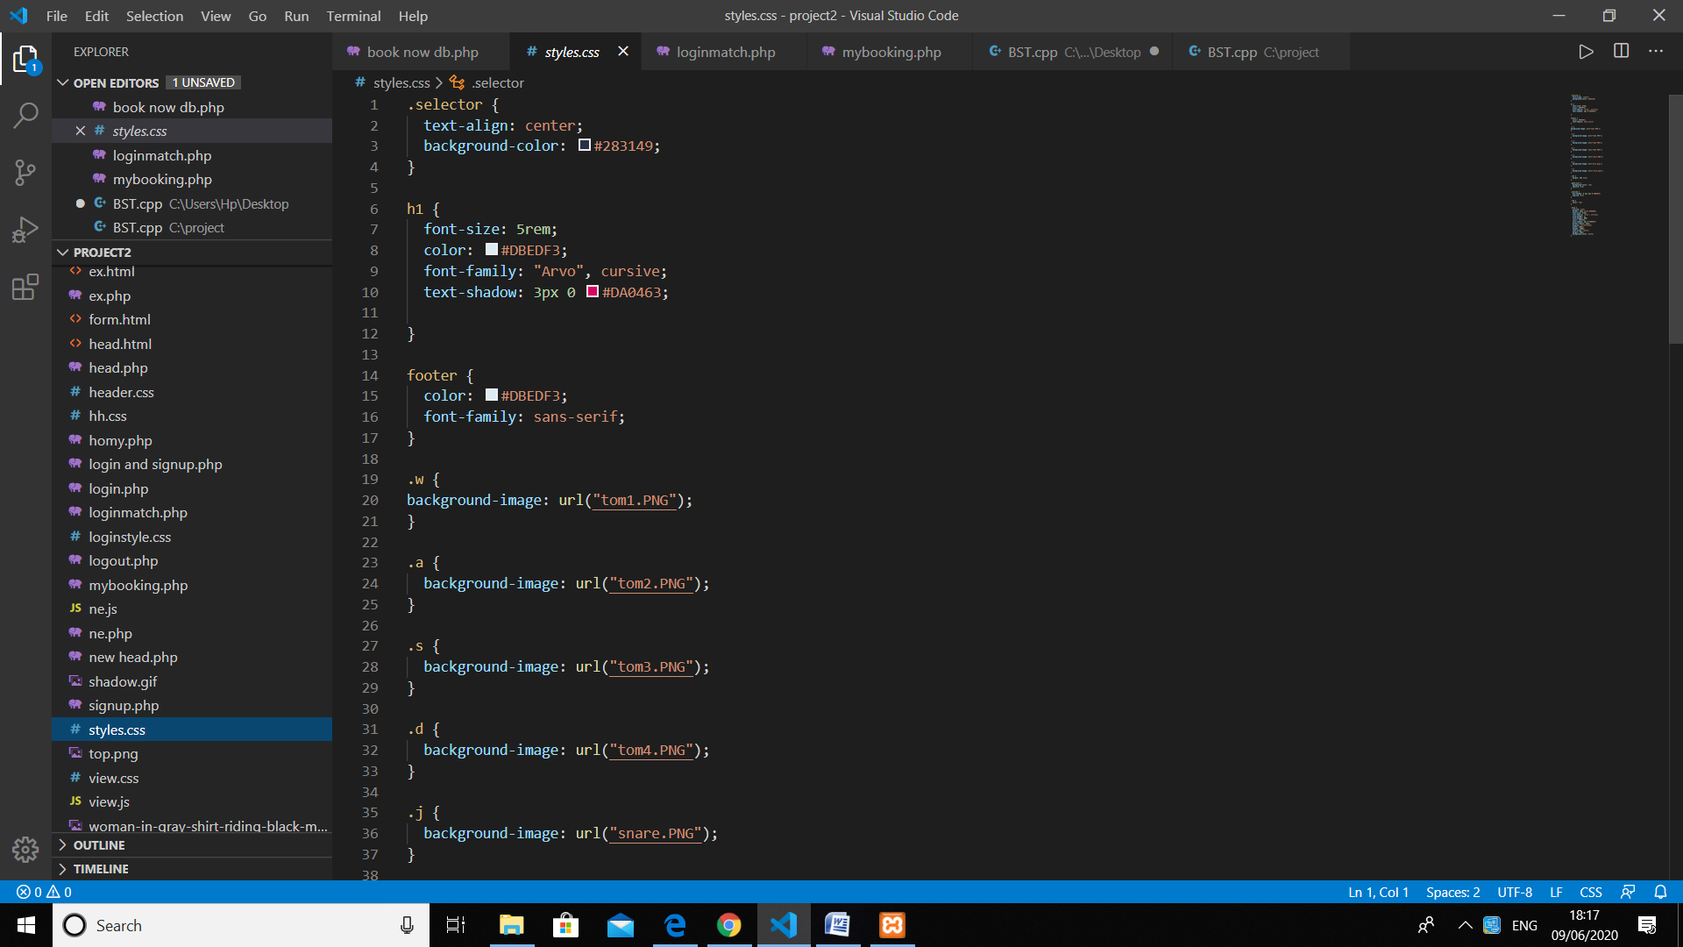

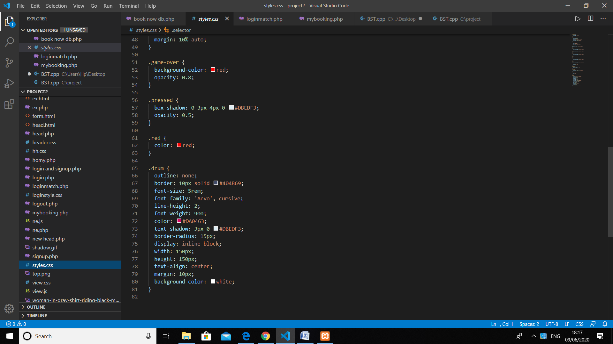

User panel output

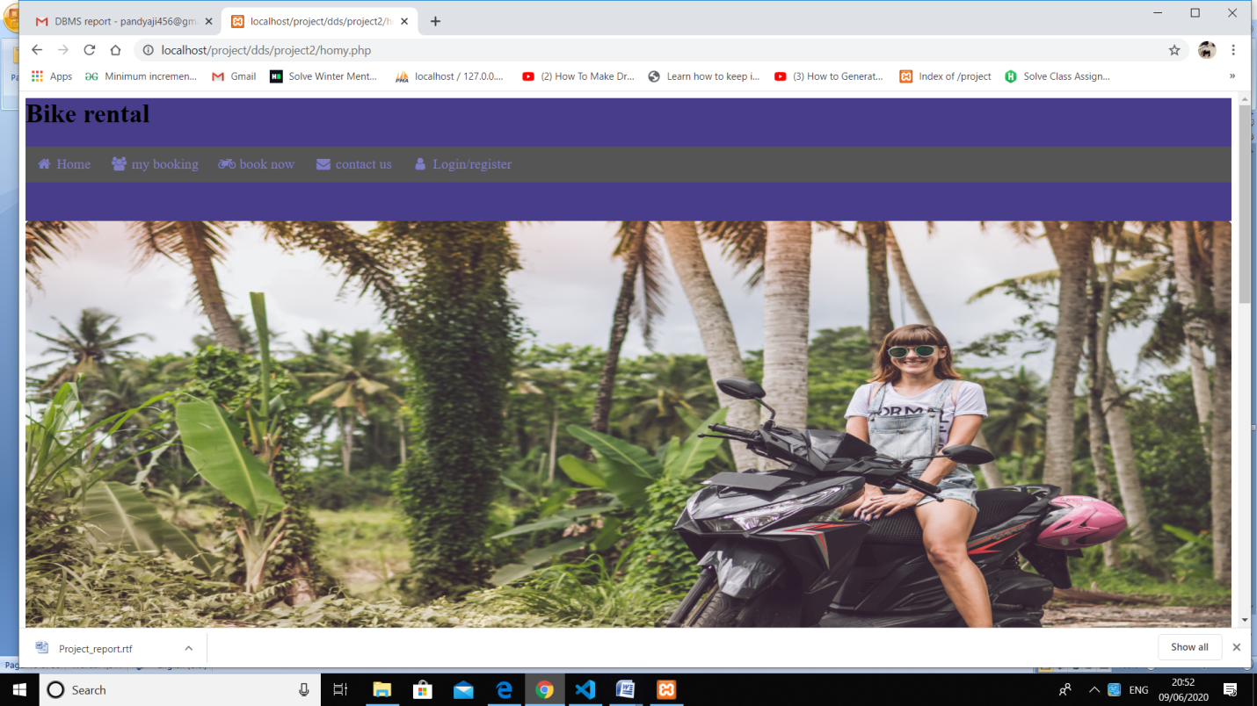

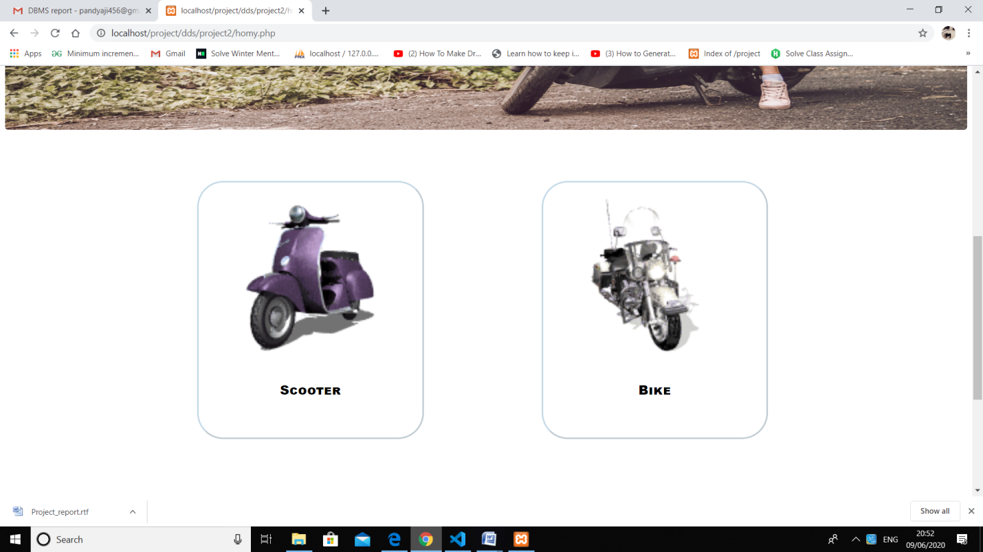

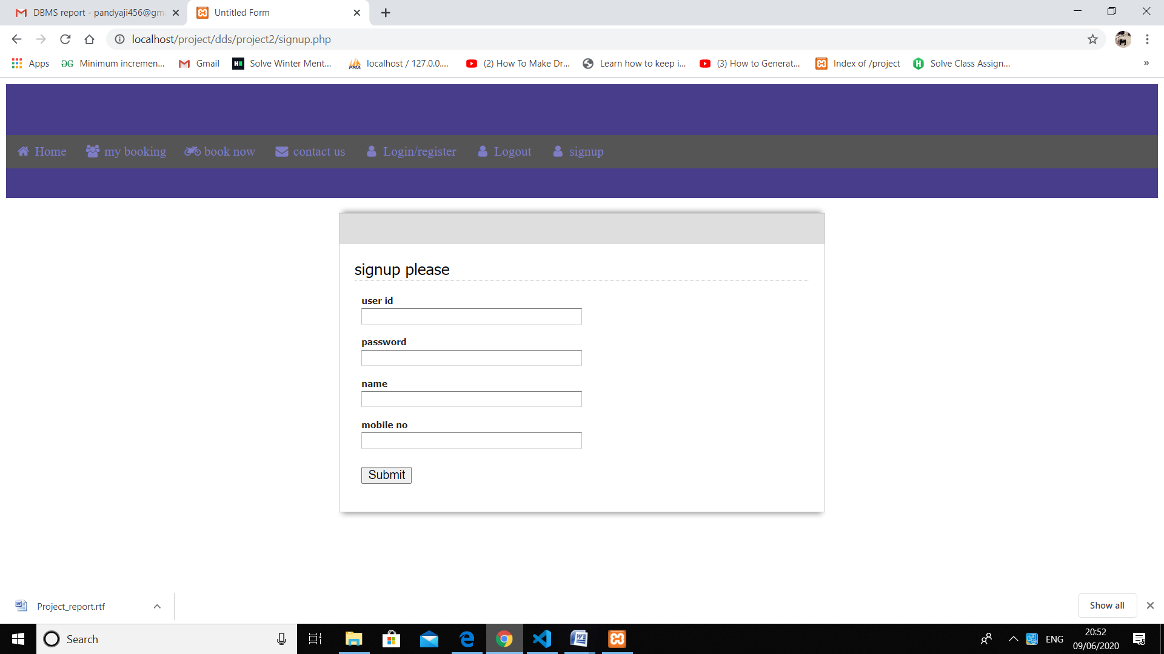

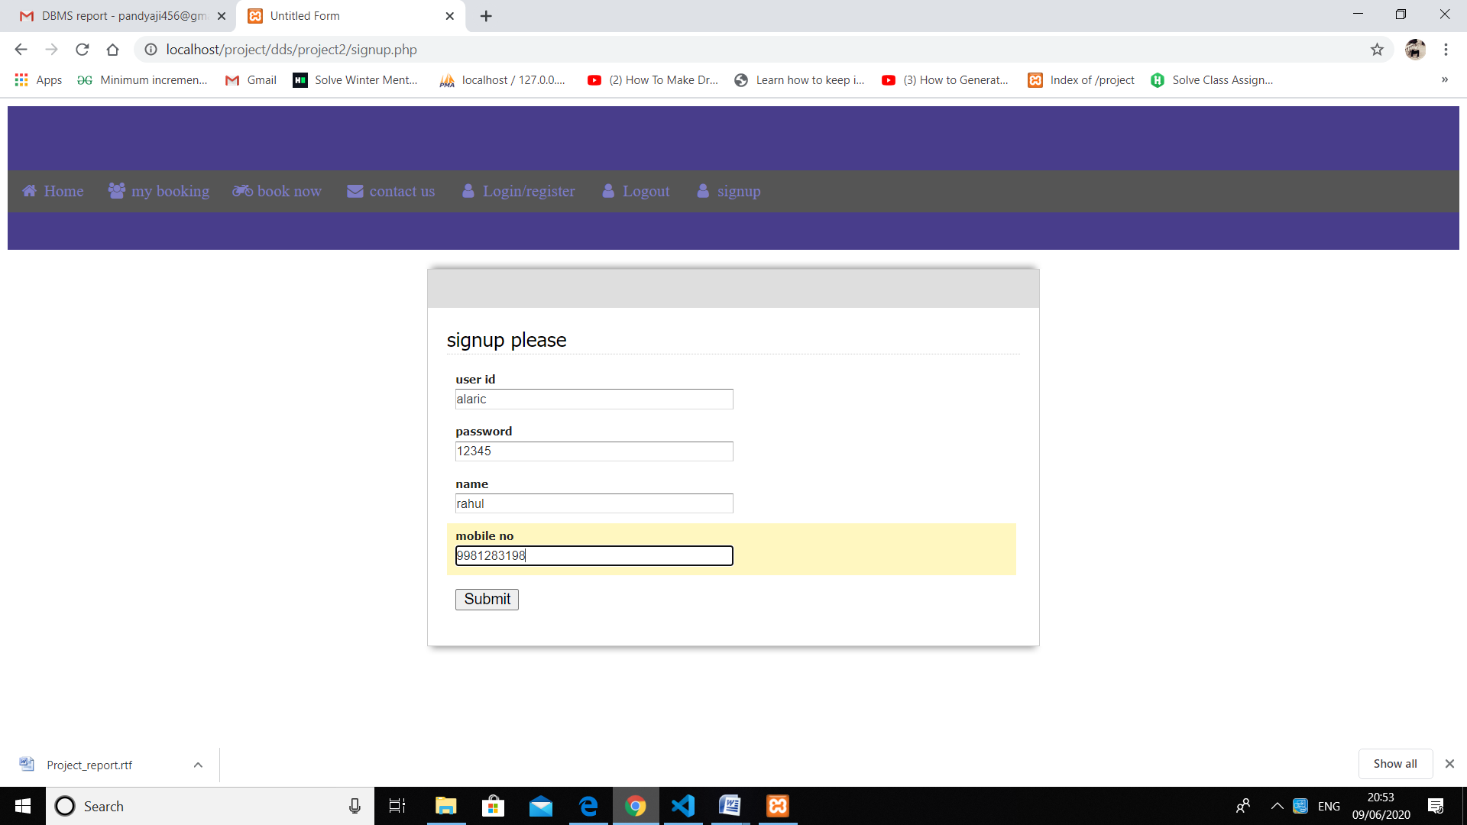

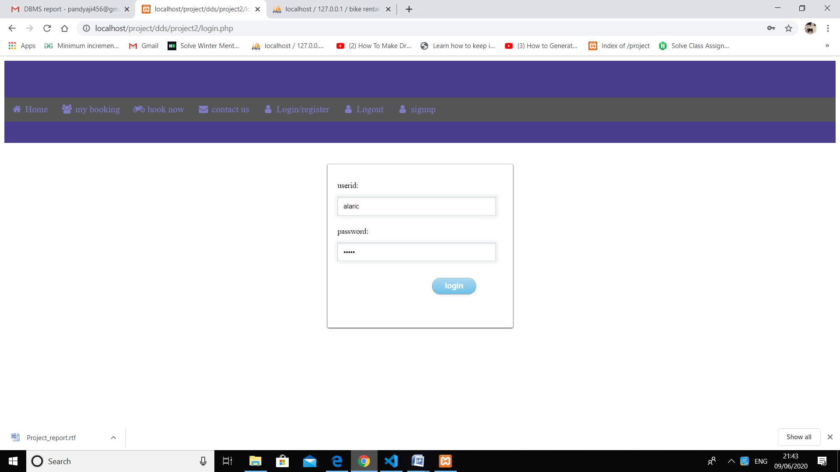

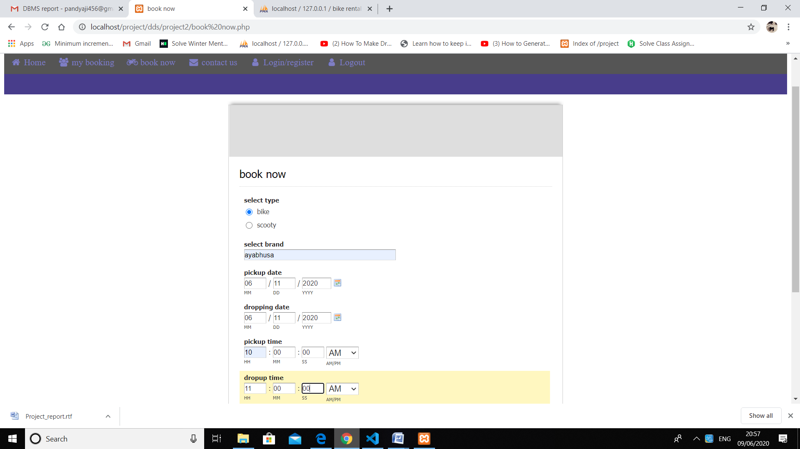

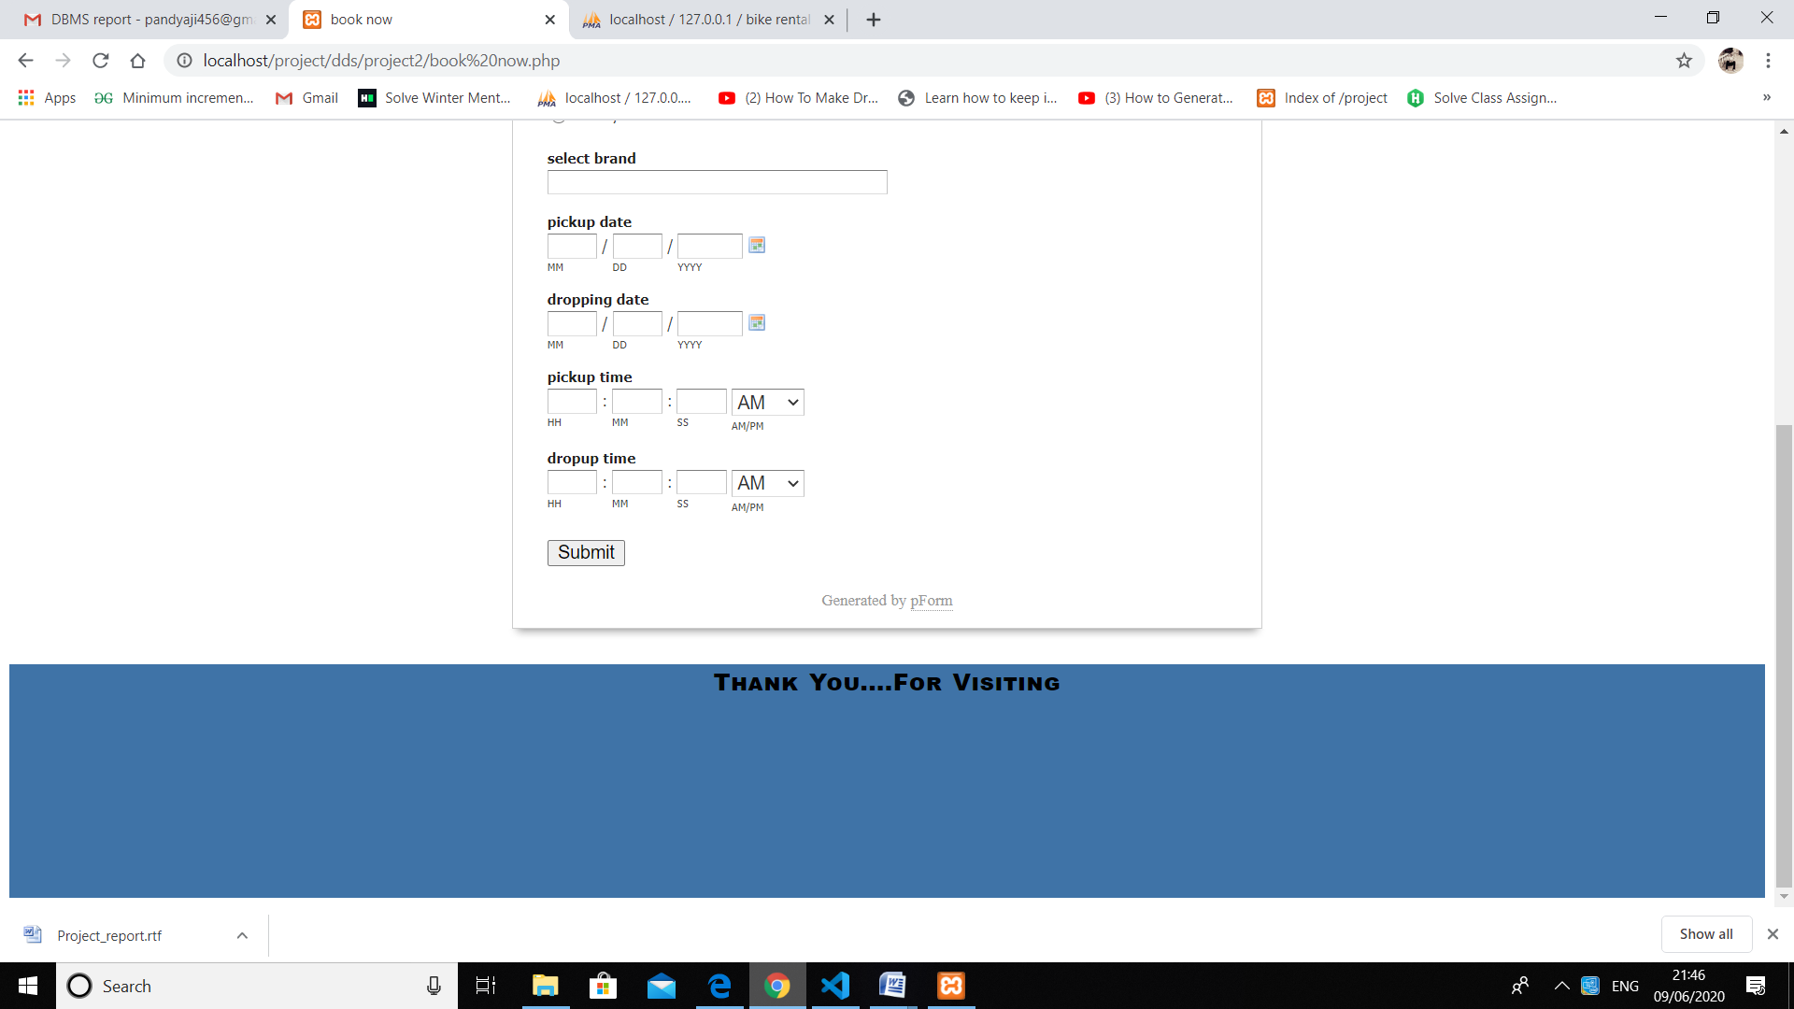

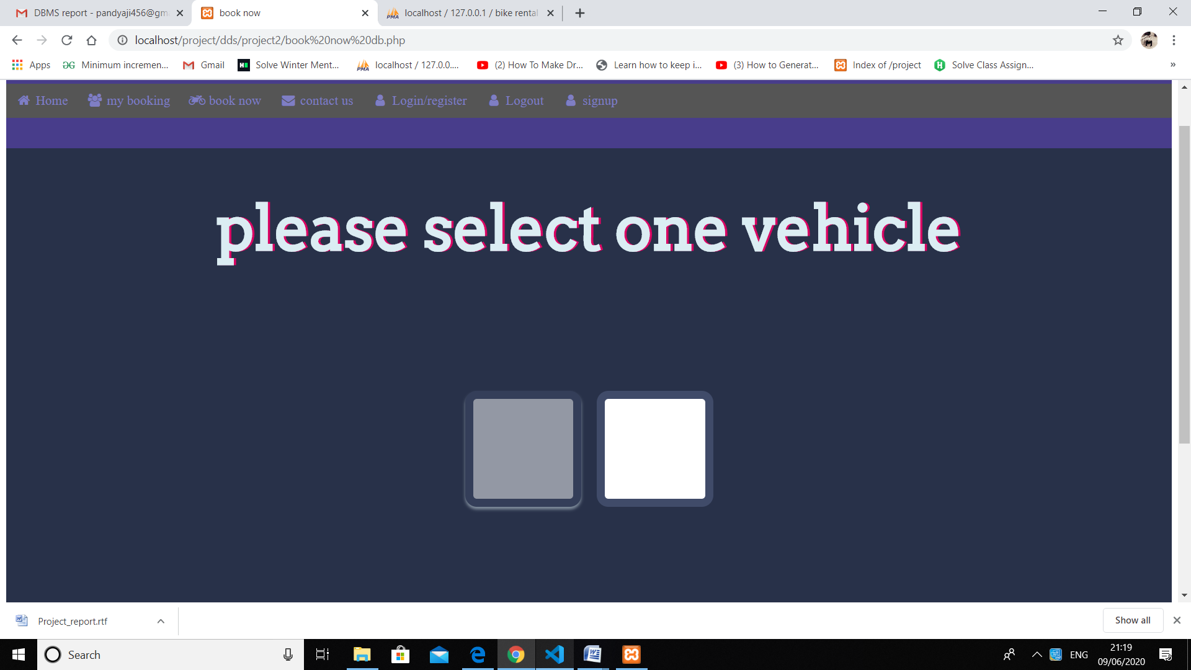

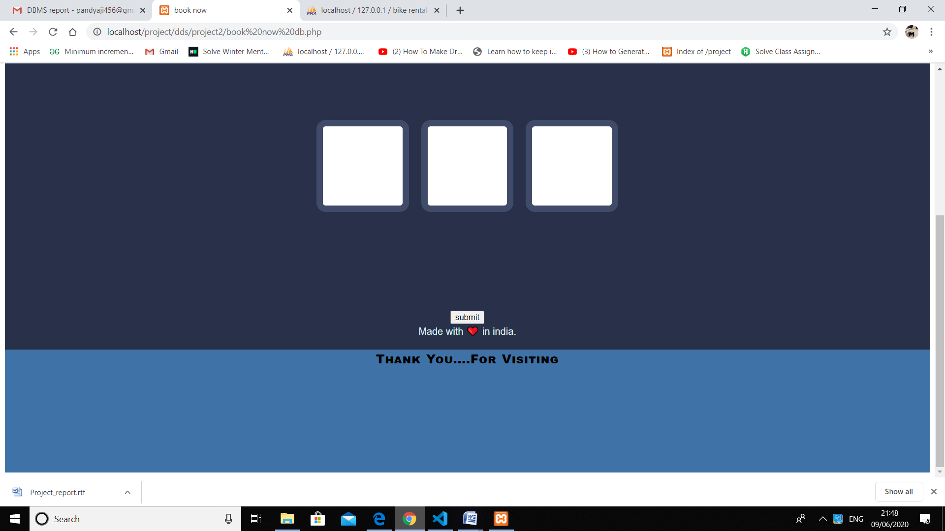

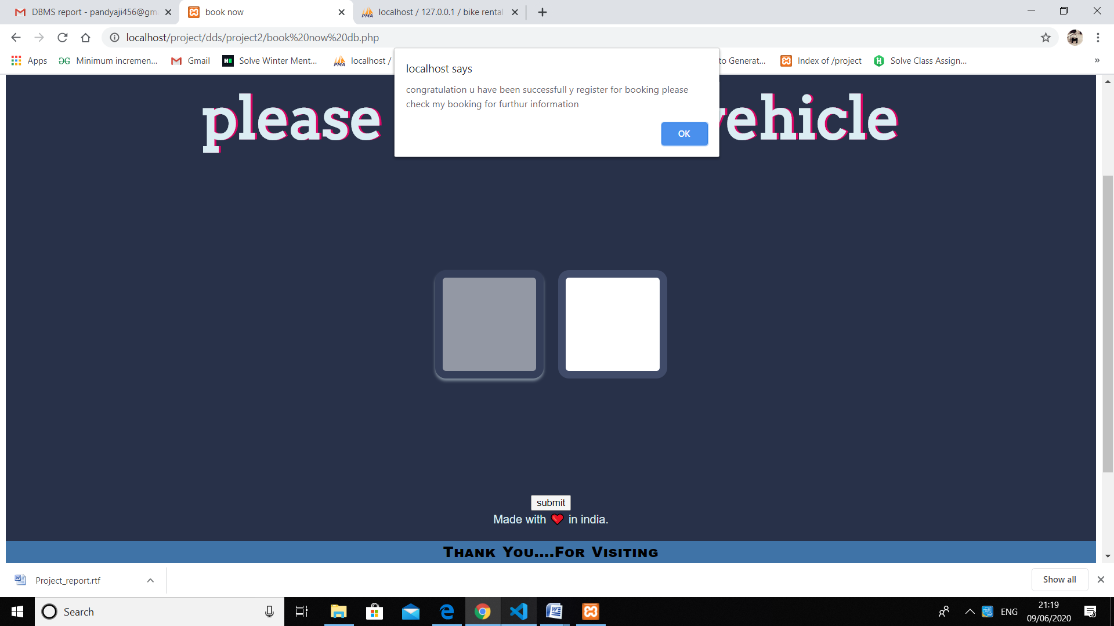

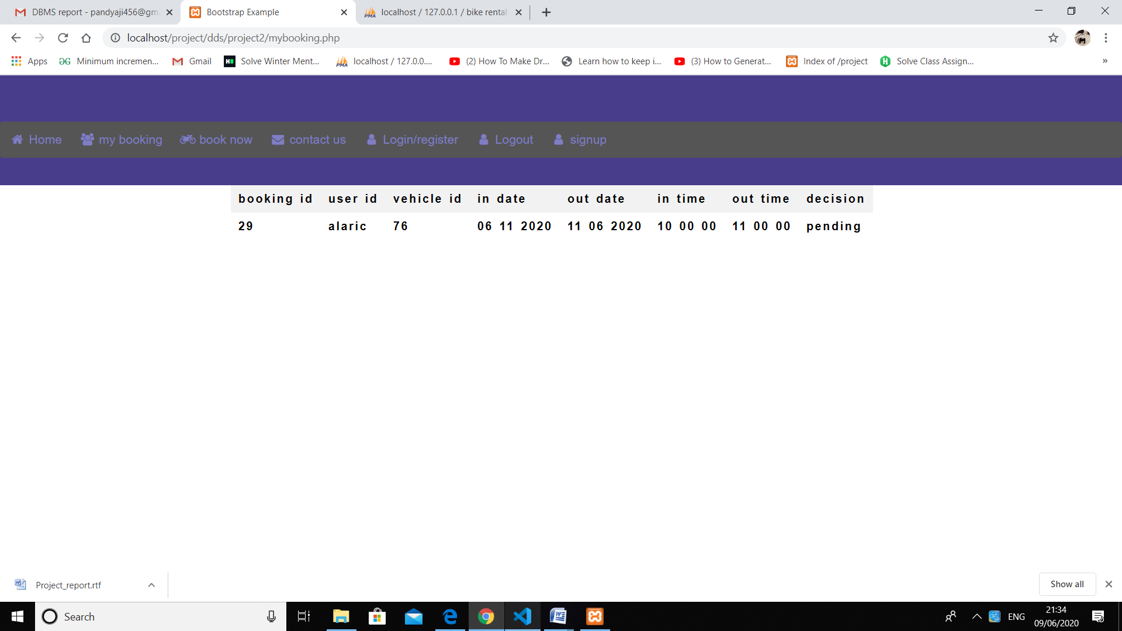

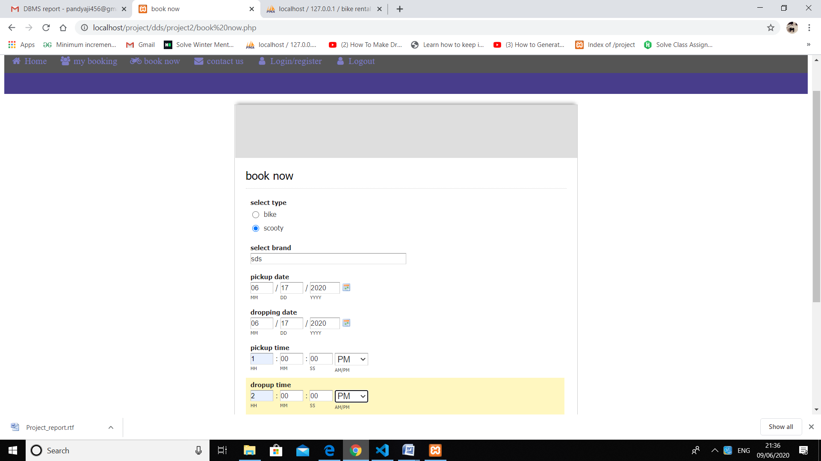



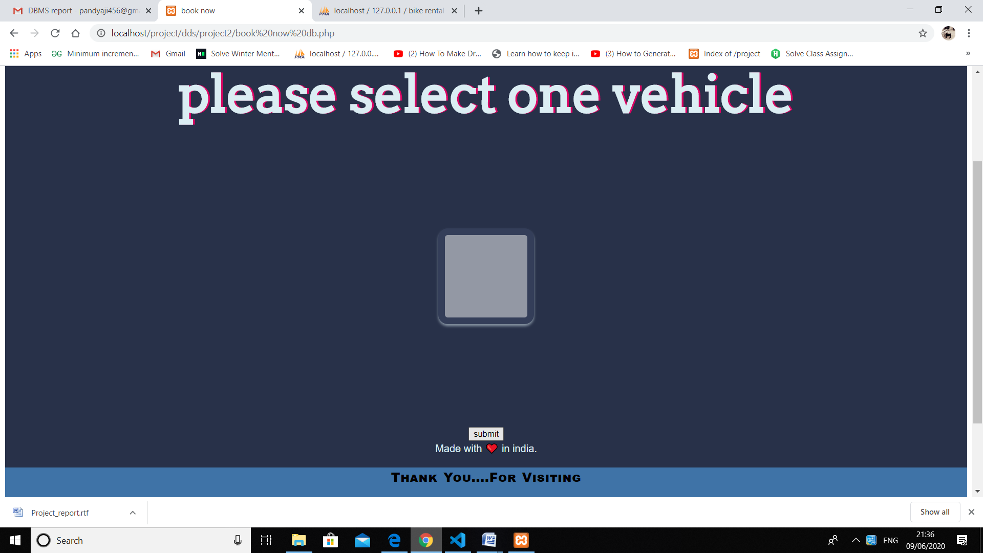

Chapter 7

FUTURE SCOPE

We can add another panel of center owner’s side so that we can add location of the nearest center from where we can pick or drop a vehicle. We can add a payment gateway so that the payment will be done online itself. We can add a tab for online verification of the documents of the user who wants to rent the vehicle and if there would be any issue it will be told to the user at that time itself and he/she will not have to go to the center so time wastage would not be there. We can add a GPS tracking system to the store owner’s and the admin panel so that the rented vehicle would be tracked time to time and this was prevent any misuse of the vehicle rented.

Chapter 8

REFERENCES

• Fundamentals of database systems by Ramez Elmasri, Shamkant B. Navathe.

• The Complete Reference, Fifth Edition. Thomas A. Powell.

• <https://www.w3schools.com/>

• <https://www.tutorialspoint.com/index.htm>

• <https://getbootstrap.com/>

• <http://ww25.php.org/>

• <https://www.phpmyadmin.net/>